

December 1, 2022
To: | UCR Emeriti & Retirees
From: | UCR Retirees’ and Emeriti Association Leadership
Re: | There are a Few Spots Available for Tomorrow’s Tour: The UCR Student Success Center and UCR Barn with the Interpretive Walks Club
Retirees and emeriti are cordially invited to register for the Interpretive Walks Club Activity: Tour of UCR’s Student Success Center and UCR Barn led by Assistant Dean of Students and Director of the HUB, Brendan O'Brien and UCRRA President, Andy Plumley on Friday, December 2, 2022 at 3:00 p.m. Space is limited and the meeting location will be at the front entrance of the Student Success Center. Make sure to wear good walking shoes and a hat, bring water and wear clothing appropriate for the weather.
Reserve Your Spot
Please email the UCRRA President, Andy Plumley at andy.plumley@ucr.edu by, December 2, 2022 at 1:00 p.m. to reserve your spot.
Please find the invitation flyer and reservation form pictured below (and attached).
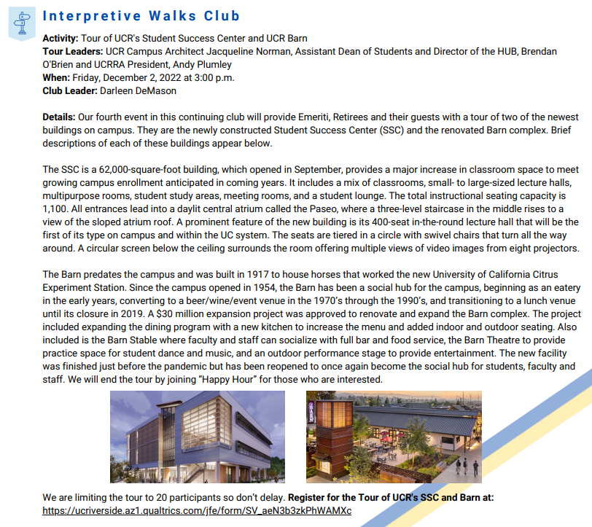

We hope you can join us!

UCR Retirement Center
retirees@ucr.edu

