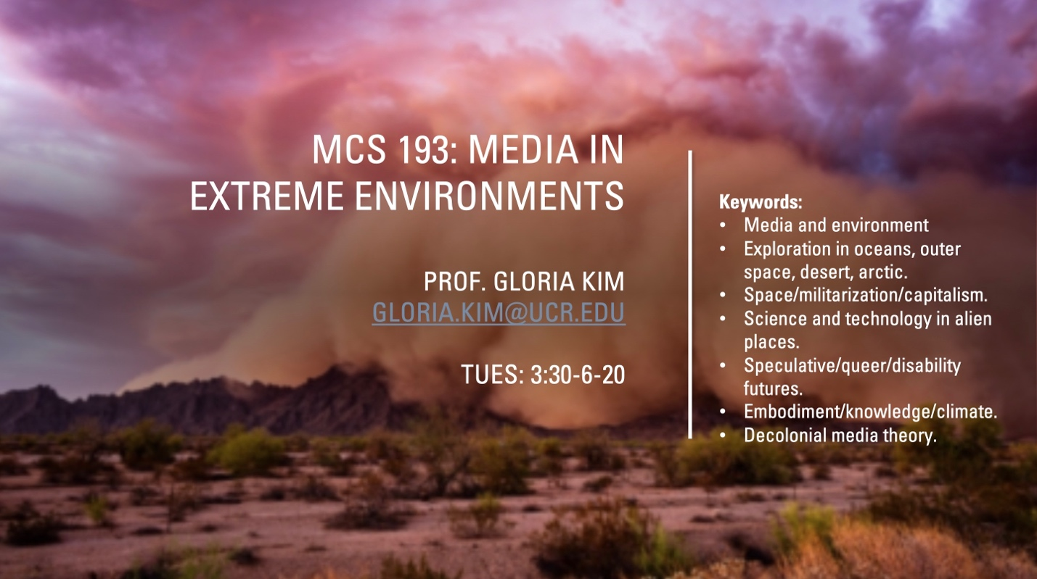

This course pursues the many questions posed by media when placed in extreme environments such as oceans, deserts, extra-terrestrial space, the frozen arctic, and the ruined landscapes of climate change. We explore cinema, military and scientific technologies, computational and artistic projects, as well as other media forms, to track the historical, social, cultural, and political implications of our mediated relations with these unstable spaces.

Conventional media theory considers the ways in which media operate in stable and predictable terrains. In extreme environments, in contrast, media are brought to their breaking points by elements such as heat, cold, contamination, opacity, and airlessness. Studying media in these contexts allows us to trace how such spaces are made available to new forms of colonialism and capitalism. Yet it also defamiliarizes media theory to open up possibilities for thinking black and indigenous futures and histories, while decolonializing dominant media concepts and methods.

The questions we examine include:
Why is data itself impossible outside frozen environments?
How can desert mirages help us rethink the meaning and structure of cinema?
How do technologies that se into ocean depths lead us to rethink familiar media concepts such as “screen” and “interface”?
How do technologies predicting destroyed climate futures change our ways of knowing, seeing, and living?

