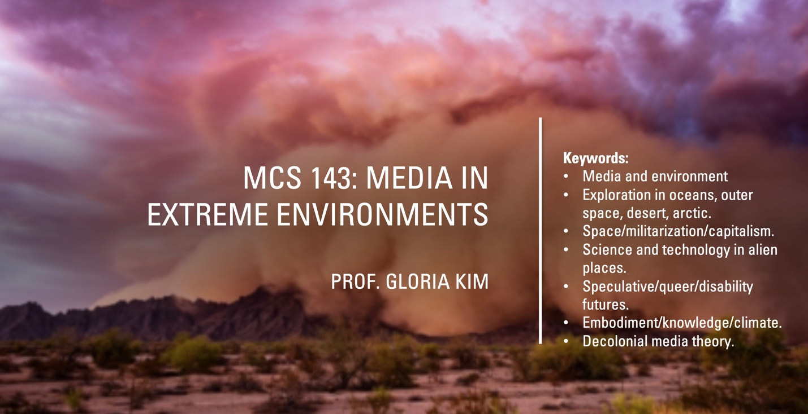
This course pursues the many questions posed by media when placed in extreme environments such as oceans, deserts, extra-terrestrial space, the frozen arctic, and the ruined landscapes of climate change. We explore cinema, military and scientific technologies, computational and artistic projects, as well as other media forms, to track the historical, social, cultural, and political implications of our mediated relations with these unstable spaces.

Conventional media theory considers the ways in which media operate in stable and predictable terrains. In extreme environments, in contrast, media are brought to their breaking points by elements such as heat, cold, contamination, opacity, and airlessness. Studying media in these contexts allows us to trace how such spaces are made available to new forms of colonialism and capitalism. Yet it also defamiliarizes media theory to open up possibilities for thinking black, indigenous, and disability futures and histories, while decolonializing dominant media concepts and methods.

The questions we examine include:
- Why is data itself impossible outside frozen environments?
- What can desert mirages teach us about the meaning and structure of cinema?
- How do technologies that see into ocean depths lead us to rethink familiar media concepts such as “screen” and “interface”?
- How do technologies predicting destroyed climate futures change our ways of knowing, seeing, and living?
Readings drawn from sources such as:
Melody Jue, Wild Blue Media: Thinking Through Seawater (Duke UP, 2019)
Lisa Messeri, Placing Outer Space: An Earthly Ethnography of Other Worlds (Duke UP 2016)
Christina Sharpe, In the Wake: On Blackness and Being (Duke UP, 2016)
Christopher Pinney, The Waterless Sea: A Curious History of Mirages (Reaktion, 2018)
Christopher Heuer, Into the White: The Renaissance Arctic and the End of the Image (Zone Books, 2019)
Rashida Phillips, Black Quantum Futurism: Theory and Practice V.1 (BQF, 2015)
Nicole Starosielski, Media Hot and Cold (Duke UP, 2021)

