UC Riverside Staff Conference

Zoom Events Instructions

  - STEP 1: REGISTER
- Navigate to the UCR Staff Conference webpage

- Click on Register for the 2026 Staff Conference
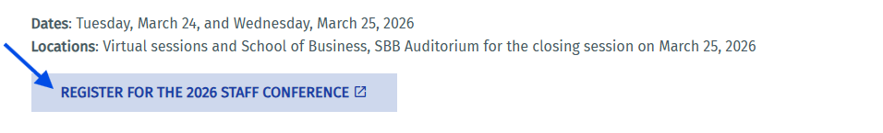
- Select Register with Zoom account OR Register with email button and complete the required information. 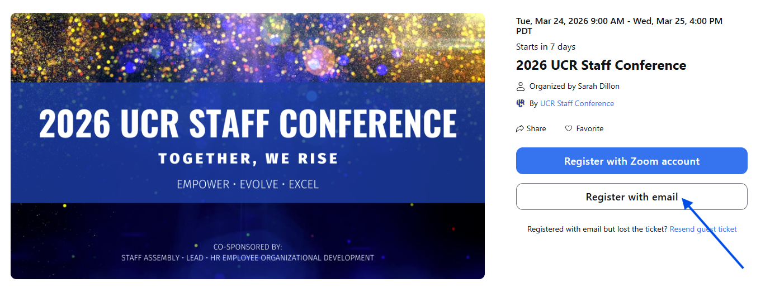
- Mark your calendar for March 24 & 25

  - STEP 2: SELECT YOUR CONFERENCE SESSIONS
- Navigate to Zoom Events and Sign in
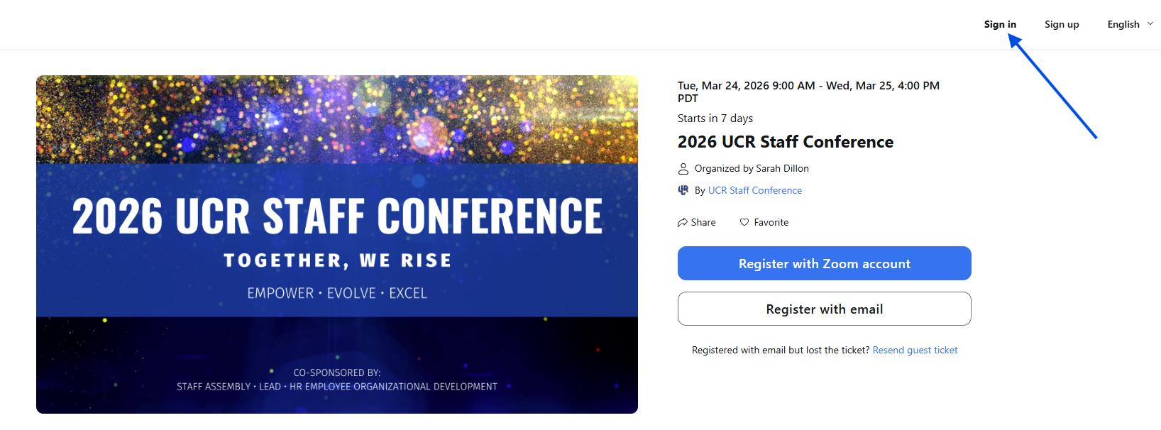
- Once logged in, select Join Lobby
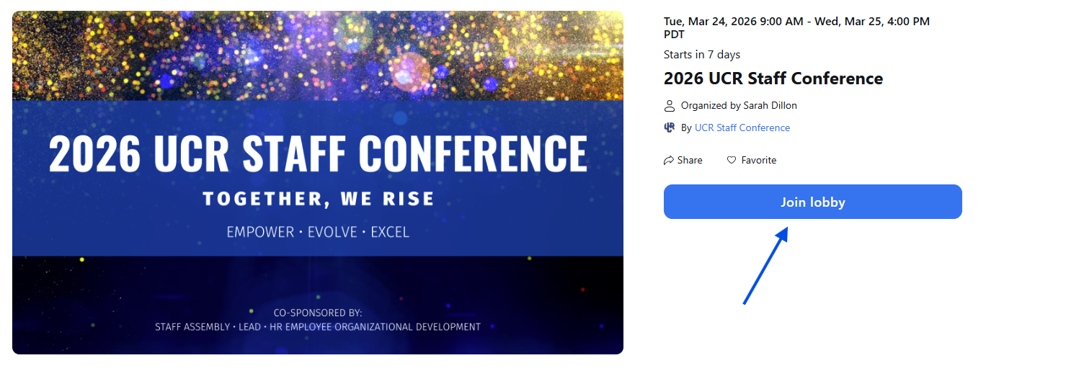
OPTIONAL: scroll down to view all conference sessions. Click the session title to view a description.
- Click the Sessions tab from the top right of the page
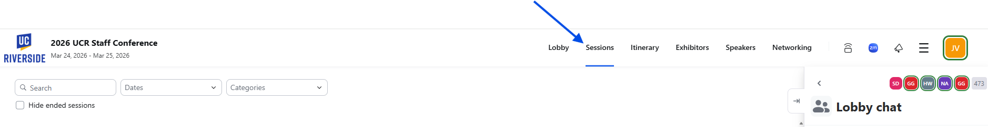

- Click Reserve a spot to add a session to your conference itinerary. Important Note: Zoom events will only allow one registration per time slot.


  - STEP 3: ATTEND YOUR SELECTED CONFERENCE SESSIONS
- Navigate to Zoom Events and Sign in.

- Select the Itinerary tab at the top right to view your selected sessions
- Hover over the session title and click to join.
NOTE: sessions will be open to attendees 10 minutes prior to the start time.
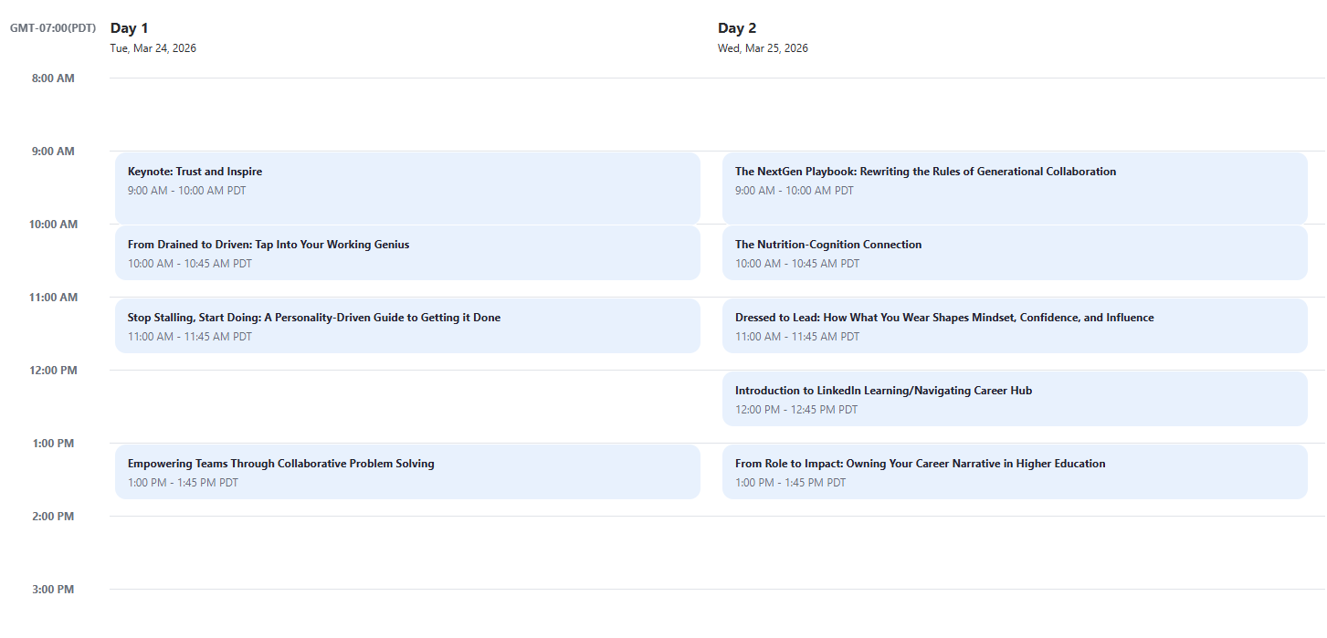

- To log out of Zoom Events, click the hamburger icon at the top right and select Sign out.
