
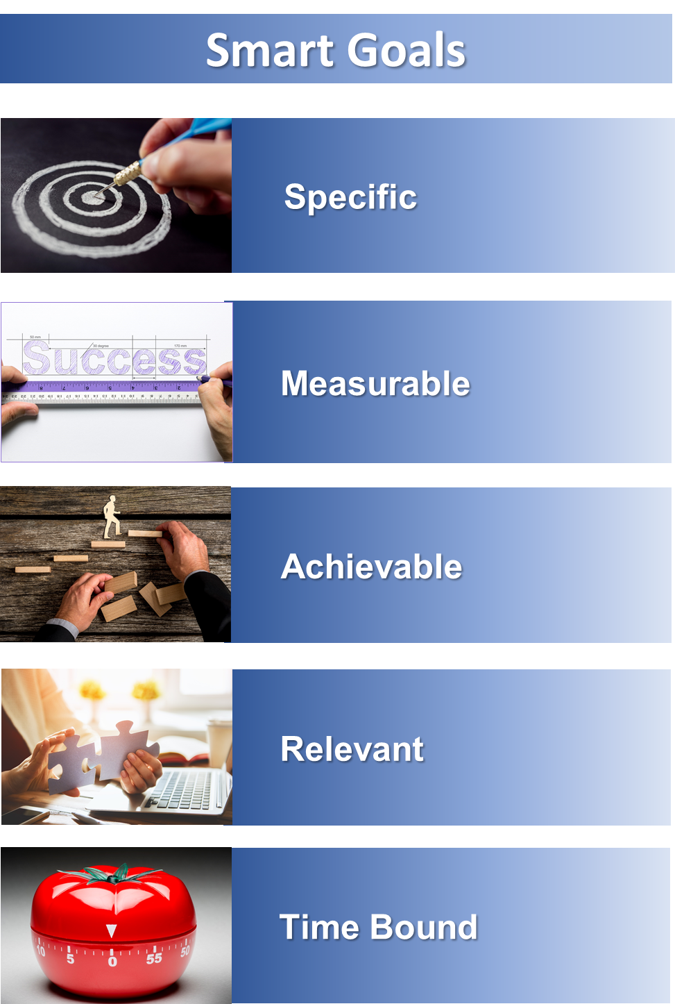
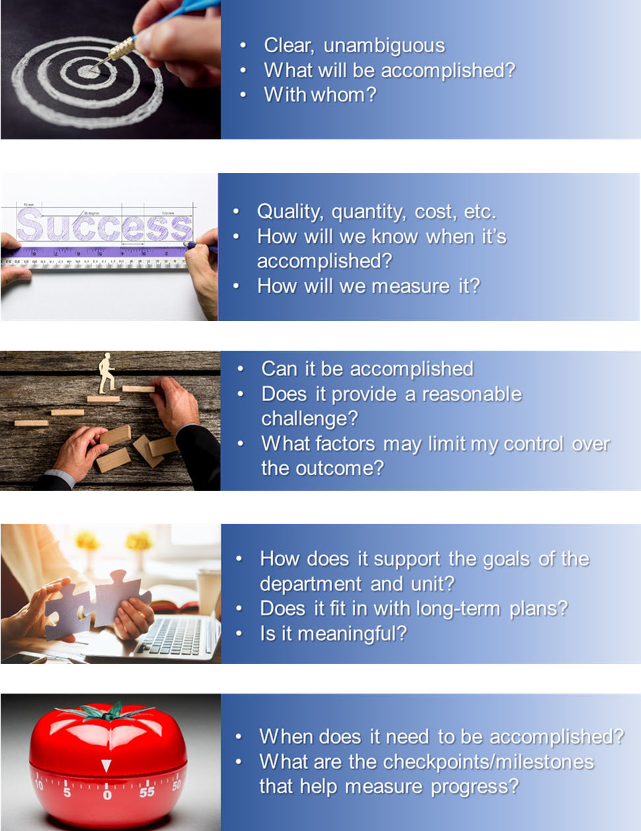

Setting Goals – Why SMART?

Carefully considered goals that are linked to the organization’s overarching strategic aims improve organizational performance and control, and individual achievement.

SMART Goals help individuals:

- Understand the connection between what they do and what the organization is trying to achieve.
- Allocate as much time, effort and resources as possible to high priority areas.
- Gain a sense of achievement.
- Gain new experiences, which helps them learn.

Action verbs for Writing Goals

There are four (4) key approaches to writing goals. These key approaches are stated below, along with a list of the types of verbs that can be used.

- I am expected to recall or recite certain facts, dates and labels.
Define  Describe (in writing)  Describe (verbally)  Designate  Identify  Itemize  Label  List  Name | Recite  Recount  Relate  Retell  Specify  Spell Out  State  Term  Write
- I am expected to use a method or procedure to demonstrate a mental skill.
Analyze (verbally)  Analyze (in writing)  Apply (a rule)  Catalog  Categorize  Classify  Define  Demonstrate  Derive  Diagnose  Differentiate  Discriminate | Distinguish  Evaluate (in writing)  Exhibit  Explain  Generate (solution)  Interpret  Organize  Prioritize  Prove  Sketch  Support  Solve

- I am expected to use a physical or manipulative skill.
Articulate  Adjust  Administer  Align  Alter  Arrange  Assemble  Build  Calibrate  Change  Construct  Erect | Execute  Fabricate  Fashion  Form  Handle  Inspect  Regulate  Remove  Repair  Replace  Service  Set
- I am expected to demonstrate a behavior.
Accept  Advocate  Agree  Allow  Approve  Attend  Choose  Collaborate  Comply with | Conform  Cooperate  Decide  Defend  Endorse  Recommend  Support  Tolerate  Volunteer

Goal Setting Guidelines
Goal setting allows us to turn ideas into success stories. Goals should be realistic, manageable and achievable. Use this information as a guide in setting future goals.
- Set goals at the right level
Set goals so they are slightly out of your immediate grasp but not so far that there is no hope of achieving them. No one will put serious effort into achieving a goal that they believe to be unrealistic.

- Set performance not outcome goals
Set goals over which you have as much control as possible. There is nothing as dispiriting as failing to achieve a goal for reasons beyond your control such as bad business environments, poor judging or just plain luck.

- Express goals positively
For example, “learn this technique well” instead of “don’t make any more mistakes doing…”

- Set priorities
When you are setting several goals, give each a priority. This helps to avoid feeling overwhelmed by too many goals and also helps to direct attention to the most important one.

- Keep operational goals small
Keep immediate goals small and achievable. If a goal is too large it can seem that progress is not being made. Keeping goals small and incremental gives more opportunities for reward.

- Use reminder signs
If we are constantly reminded of what our major goal is, the odds of losing sight of it in a whirlwind of activity are reduced, if not eliminated. Write it down and post it on a bulletin board or carry it in your wallet.

- Make an action plan
This step is often missed in the process of goal setting. We get so focused on the outcome that we forget to plan all of the steps that are needed along the way. By writing out the individual steps and then crossing each one off as you complete it, we realize that we are making progress towards the ultimate goal.

Linking Goals to the Mission

This worksheet can help you ensure that your goals are in line with the goals and mission of your department and of the university.

- What is the goal of the university?
Enter university goal
- What are the goals of the unit?
Enter unit’s goal
- How does my job support the goals of the unit?
Enter how your unit goals are supported
- How does my job support the university’s mission?
Enter how the university’s mission is supported
- Who are our customers?
Enter who your customers are
- What are the top three (3) most important priorities of our unit?
Enter your unit’s top 3 priorities

