

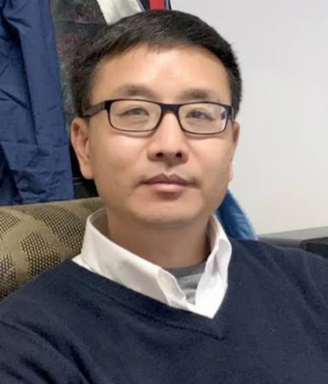

IIGB Special Seminar

Dr. Xuelu Wang

Vice President of Henan University

Friday, August 28th 3:00 pm

Genomics Auditorium 1102A

Prof. Xuelu Wang received his Ph.D. from the University of Arizona in 2000 and completed his postdoctoral training at the Salk Institute with Prof. Joanne Chory. He became a professor at Fudan University in 2006 and was appointed Dean of the College of Life Science and Technology at Huazhong Agricultural University in 2014. He then moved to Henan University in 2019 and was appointed Academic Vice President of Henan University in 2020.
Prof. Wang has long been engaged in research on soybean biology and plant hormone signaling networks, particularly the mechanisms regulating plant growth and development, energy sensing, biological nitrogen fixation, and soybean–microbe interactions. He discovered mechanisms underlying light-induced regulation of soybean symbiotic nodulation and the molecular mechanism by which nodule energy-status sensors regulate nitrogen fixation. His related findings have been published in leading journals, including Science, Developmental Cell, and Nature Plants. His research has provided important theoretical foundations and innovative approaches for the development of sustainable agriculture. He has received numerous awards and currently serves on the editorial boards of several internationally recognized journals.

Contact Hailingj@ucr.edu if you are interested in meeting with him
“Integrated Regulation of Carbon Metabolism and Nitrogen Fixation in Soybean”

