***Dear Faculty, Postdocs, Students, and Friends:  
  
You are cordially invited to attend a seminar presented by***

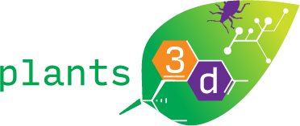

**Markita del Carpio Landry**

***Dept. of Chemical and Biomolecular Engineering  
University of California, Berkeley***

**Title:**

**“Nanomaterials Enable Delivery of Genetic Material Without Transgene Integration in Mature Plants”**

**DATE:** **Friday, January 8, 2021**

**TIME: 12:00 pm PST**

**ZOOM MEETING ID: 929 1247 4758**

**PASSCODE:** **644865**

**Host: Harvey Blanch**