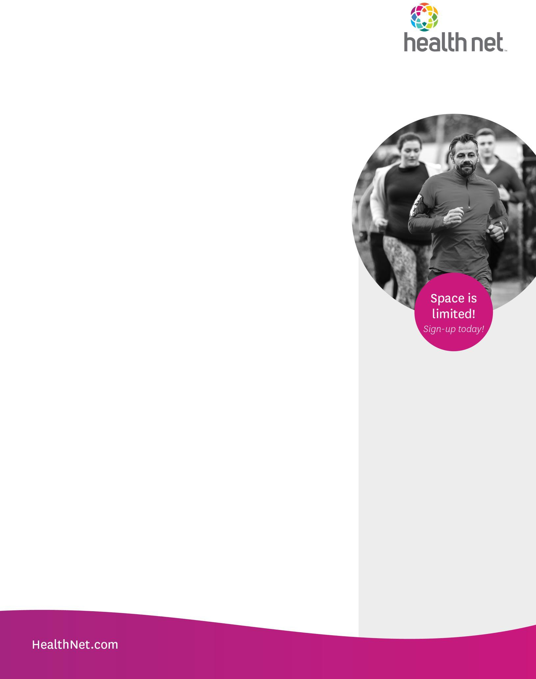

You’re Invited to a Wellness Webinar!

August Topic: Positive Thinking: A New Attitude

It’s important approach positivity with realistic eyes. There’s growing evidence that humans are optimistic by nature, but that doesn’t mean it’s all sunshine and roses all the time. Experts say the key to living your best life is finding the right balance between being positive and practical. Those who approach life with an optimistic attitude are more resilient. They make better entrepreneurs, experience better health outcomes, live long and are more satisfied with their relationships. Optimism enables people to continue to strive in the face of difficulty. Positive thinking is a mental and emotional attitude that focuses on the bright side of life and expects positive results. In this webinar, we’ll discuss:

* Traits and characteristics of a positive mindset
* How to shift from negative thinking to positive attitude
* Simple ways to be positive in our daily lives and at work
* The impact of optimism on longevity
* Resilience and gratitude
* Practical tips for looking on the bright side
* Who to practice positivity, not perfection

Health Net of California, Inc. is a subsidiary of Health Net, LLC. Health Net is registered service mark of Health Net, LLC. All rights reserved.

FLY57081EW01w (1/21)

**Date:** Wednesday, August 17, 2022

**Time:** 12:00 p.m. – 12:45 p.m. Pacific Time

**Location:** Online Webinar/Teleconference

**RSVP:** <https://centene.zoom.us/webinar/register/WN_MZ4AO7OcRXWQiVTXH00Q5g>