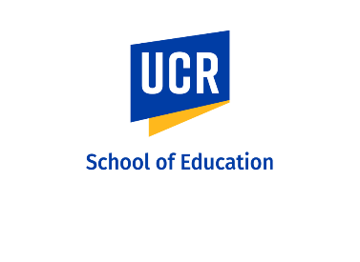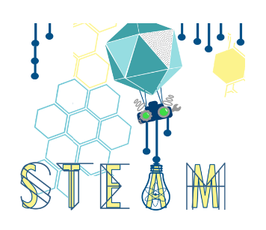
The STEAM Academy is an exciting two-week, summer, academic experience providing quality STEM programming for middle and high school students with a specific focus on those who are under-performing, but have high potential and interest. Mathematics, engineering, and problem solving alongside near-peer mentorship serve as tools for strengthening student academic identity and increasing learning opportunities and outcomes.

When: June 24-July 3
Where: UC Riverside
CAMP Times: 9am- 3:30pm Daily (Working hours will be slightly longer than camp hours)
Training hours – Mid June in person training and online training

University of California Riverside (UCR) School of Education invites you to apply to join our STEAM Academy team to mentor middle and high school students and ignite their interest in science, technology, engineering, and mathematics (STEM). As a Pod Leader you will participate in training and will provide inspiration, mentorship, support, supervision, academic guidance and STEM instruction for participants during a summer experience at UCR. The STEAM Academy pod leaders will work closely with program faculty throughout the program.
We are specifically looking for applicants who are committed to educational equity. Applicants with majors in science, mathematics, engineering, education, special education, and ethnic studies are encouraged to apply!
Please apply by completing this google form (https://forms.gle/Z19rpSMrJ8YqVHHSA)
and submitting your resume. Please send resume to Tracysc@ucr.edu

