


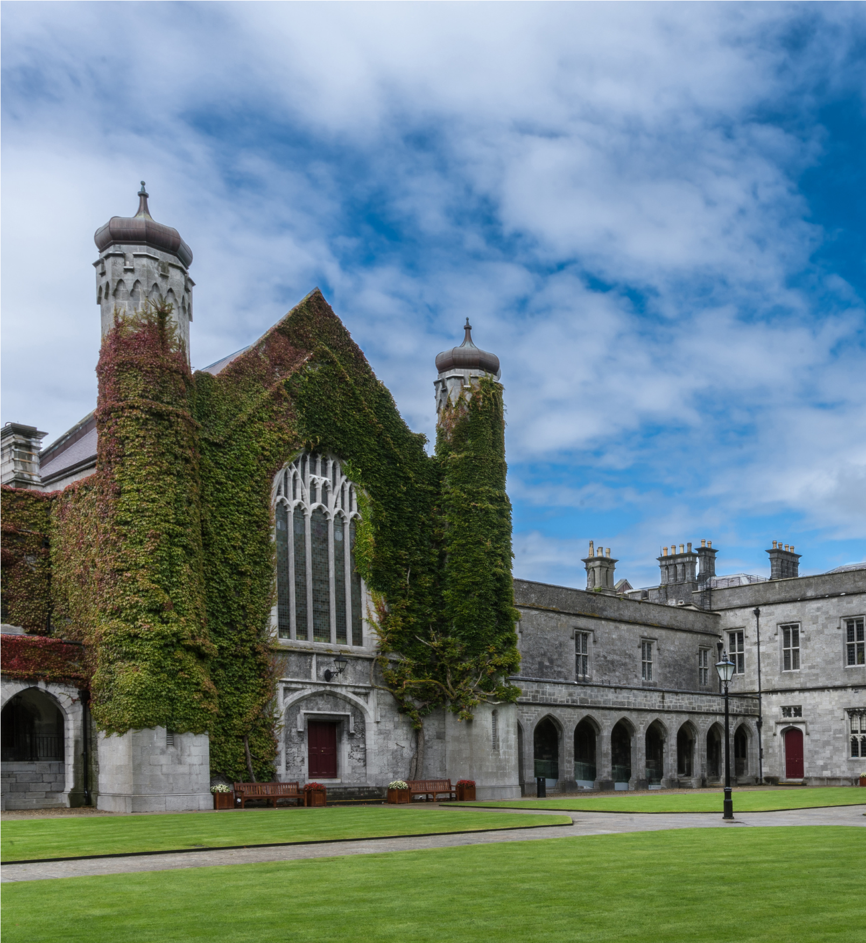

Lecturer in Environmental Science
Permanent, 1FTE
Contract Type B
Ref #: 009972

TABLE OF CONTENTS
Page Number

Job Advertisement 4

Job Description 5

Eligibility Requirements 6

Competency Framework for Lecturer roles at University of Galway 7

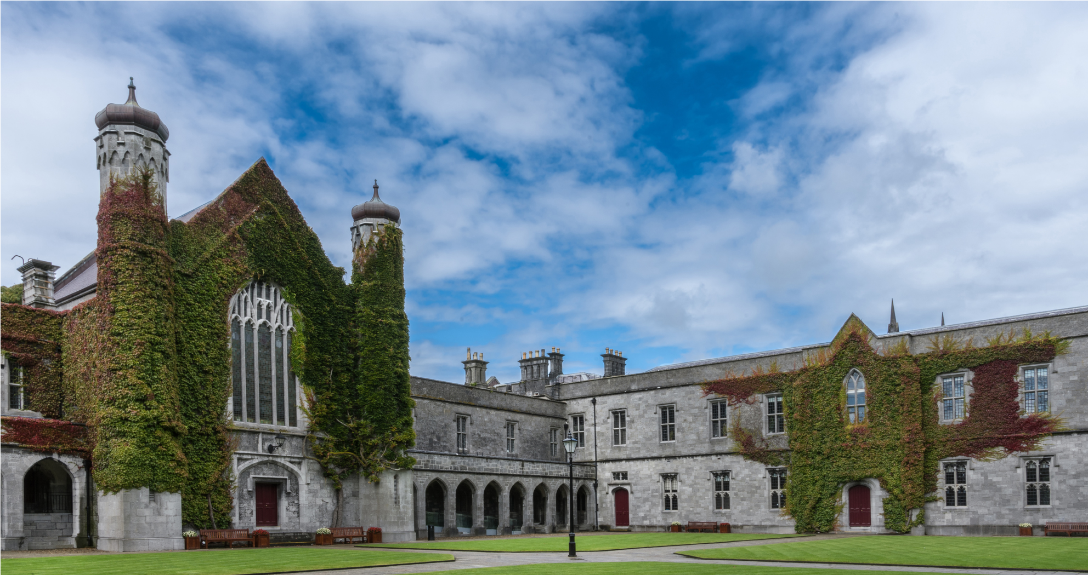

Lecturer Contract Type B
Lecturer Environmental Science, Contract Type B, permanent contract

College | Science and Engineering
School | Natural Sciences
Post Title & Subject Area | Lecturer in Environmental Science
Post Duration | Permanent
Level | Lecturer
Reports to | Head of Earth and Life Science

JOB ADVERTISEMENT

Applications are invited for an appointment as full-time (1FTE) appointment as a Lecturer (Contract B) in Environmental Science at University of Galway.

Applications from candidates with teaching experience and a research record in Environmental Science are welcome. Candidates should have a strong foundation in ecosystem management and environmental conservation with an emphasis on field-based teaching and research. Their research should have a focus on ecological protection or restoration in the face of global environmental change.

The successful candidate will be a key member of the School and will have an active research agenda in the broad area of environmental science. They will complement existing expertise in the School and will have experience teaching a broad range of environmental science modules to both undergraduate and postgraduate students.

About University of Galway
178 years in the making, University of Galway is a world-class Irish university set in an iconic location at the edge of Europe.
With 19,000 students, over 3,000 staff and 126,000 alumni spanning 100 countries across the world, we are a community of creative thinkers and thought leaders connected by shared values of respect, openness, excellence and sustainability.
Our commitment to the public good is evident in our teaching and research achievements. University of Galway is counted among the Top 270 universities in the world according to the QS World University Rankings, positioned in the top 2% globally. In 2023, the University became the only university in Ireland to be awarded SDG Champion status and was ranked 34th among the world’s top universities for UN-SDGs (THE Impact Rankings 2022–23).
About the School of Natural Sciences
The School of Natural Sciences runs a number of general and denominated BSc programmes (including Environmental Science, Earth & Ocean Sciences, Marine Science, Botany/Plant Science and Zoology) and taught MSc programmes (including Biodiversity & Land-Use Planning; Sustainable Environments; Environmental Leadership; and Sustainable Resource Management: Policy & Practice (with the University of Limerick). Members of the School also contribute to the University’s Research Institutes, including the Ryan Institute for Sustainability, Environmental, Marine, and Energy Research.

The appointed lecturer will be expected to contribute to the delivery of learning and teaching; supervision and programme coordination as well as to build a research team and follow a personal and collaborative research agenda and contribute to other aspects of School, College and University life as a good colleague.

The successful candidate will have good interpersonal skills and be prepared to collaborate with colleagues within Earth and Life Science and the wider School, College, University, nationally and internationally.

For informal enquiries, please contact Dr Tiernan Henry, Head of Earth and Life Sciences, Email tiernan.henry@universityofgalway.ie; and Dr. Gesche Kindermann, Deputy Head of Earth & Life Sciences, Email gesche.kindermann@universityofgalway.ie.

Additional information on the School/College is available at:
School of Natural Sciences - University of Galway
Environmental Science/Applied Ecology Unit https://www.universityofgalway.ie/applied_ecology_unit/

Salary:
€58,917 to €92,148 p.a. (applicable to new entrants effective from January, 2011)
(This appointment will be made on the Lecturer scale in line with current Government pay policy)

Closing date for receipt of applications is 17:00 (Irish Time) on Friday 15th September 2023. It will not be possible to consider applications received after the closing date.

Garda vetting may apply.

Appointments will be conditional on work authorisation validation.
Further details are available at www.dbei.ie

For more information and Application Form please see website:
http://www.nuigalway.ie/about-us/jobs/ Applications should be submitted online.

University of Galway is an equal opportunities employer. The University and the School have a deep commitment to equal opportunities, and in 2018 University of Galway was conferred with the Athena Swan Bronze Award.

JOB DESCRIPTION

Principal Duties and Responsibilities

The post-holder duties will include, but not be limited to, the following:

Teaching
To give instruction and supervision, as directed by the Head of Earth and Life Sciences/Head of School, to students of the University in courses and programmes organised by the School of Natural Sciences or to another School or College to which the School of Natural Sciences contributes. Such duties to include preparation and delivery of lectures, tutorials, project supervision (BSc and taught MSc programmes), contribution to curriculum and course design, and general examination and other assessment responsibilities. The post-holder will also be available to students for academic counselling and advice. Where appropriate, in some subjects, academic activities may also include laboratory, workshop or clinical instruction, supervision of fieldwork, site visits and other off-campus activities. The postholder will support existing undergraduate and MSc programmes and specifically develop new materials and modules in the area of environmental science.

Research
To engage in research and other creative and innovative activity as appropriate to the discipline. The post-holder is required to disseminate their research in academic publications, other outlets as appropriate and to participate in postgraduate supervision. The post-holder is encouraged to engage in initiatives to seek research funding, as appropriate. The post-holder is also encouraged to promote and engage in the development of collaborative research.

Contribution and Scholarly Activity
To participate in academic administration at School, College and University levels as part of their contribution to the University. To engage with the wider community regionally, nationally and internationally from a civic, economic, social and cultural perspective as a contribution to the life of the University. In representing the University externally, the post-holder is expected to maintain the highest professional standards, thereby enhancing the reputation of the University. The post-holder is expected to engage in scholarly activity such as, but not limited to, refereeing of journals, membership of discipline related advisory bodies and peer review panels and work associated with external examinership.

The post-holder shall carry out these duties under the direction of the Head of the School or of an authorised senior member of the staff of the School (i.e. Head of Earth and Life Sciences).

The post-holder shall be a member of College/Colleges in accordance with University Statutes.

The hours of work are those prescribed under the Public Service Agreement in respect of Academic Staff.

ELIGIBILITY REQUIREMENTS

Essential Requirements:

- BSc or equivalent in Environmental Science, Ecology or cognate discipline
- PhD in Environmental Science, Ecology or cognate discipline
- Experience of teaching Environmental Science, Ecology or cognate discipline at undergraduate and/or postgraduate levels.
- Recent peer-reviewed research publications in fields relevant to the post and commensurate with experience.
- Demonstrated experience in applying for and securing competitive research funding (including fellowships).
- Ability to work with others as a team player.
- Evidence of good communication and interpersonal skills.
- Research/teaching specialism are a good fit with the Earth and Life Sciences unit and which would aid in the development of new modules and programmes.

Desirable Requirements:

- Field research experience in freshwater ecology and/or entomology or ornithology.*
- Recognised higher education teaching qualification.
- Experience in design and development of modules.
- Experience in teaching-associated administration.
- Experience in postgraduate supervision or co-supervision.
- Experience of modern teaching technologies.
- Development and integration of modern teaching technologies in field and on-campus teaching
- Full, clean driver’s license.

*Note: While applications from candidates who have field research experience in freshwater ecology and/or entomology or ornithology are especially welcomed, applications from candidates who have field research experience in other areas of field ecology will also be considered.

The appointment will be made to the School of Natural Sciences and will be largely associated with Environmental Science, but will contribute to other areas within Earth and Life Sciences.

Competency Framework for Lecturer (Contract Type B) Roles at University of Galway

 | Academic  Excellence |  | Leadership Excellence |  | Organisational Excellence
CORE | Excellence in Research  The Lecturer (Contract Type B) furthers their discipline and contributes to the body of knowledge in their area through planning, carrying out and publishing/ disseminating their own high quality research, building and leading research groups and providing supervision and support for postgraduate students to enable them to produce quality research. They keep up to date with relevant developments in their field and network and collaborate with others, both internally and externally, to optimise the value and relevance of the research being produced and to maximise the School’s/Discipline’s ability to attract research funding. | CORE | Personal Effectiveness  The Lecturer (Contract Type B)is enthusiastic about their discipline and is committed to making their best personal contribution through employing excellent planning and organising, communication and decision making skills to achieve their goals and through working hard and being flexible in order to meet the multiple and changing demands of the Lecturer (Contract Type B) role. | CAPACITY TO DEVELOP | Strategy & Vision  The Lecturer (Contract Type B)should contribute to the strategic development of the discipline by developing a strong awareness of the wider environment, how the discipline is developing and how the School/Discipline can develop in the long term to optimise its contribution. They must have the ability to make a strong case for the development of new programmes or engaging in joint programmes or collaborations that they feel will add long term value to the School/Discipline.
CORE | Excellence in Teaching  The Lecturer (Contract Type B) develops and delivers quality teaching programmes which engage and inspire students at all levels and maximises their learning. They are confident in using a range of teaching techniques, are open to innovations in teaching and are focused on continually developing their own teaching skills. | CAPACITY TO DEVELOP | Leading Others  The Lecturer (Contract Type B) must work well with others, providing leadership and direction to students, colleagues and support staff in relation to projects or areas of work that they are leading on. They effectively encourage, support and manage the contributions of others to deliver results for the discipline and to ensure that high standards are met. | DEVELOPING | Collegiate & Community Contribution  The Lecturer (Contract Type B) values and engages in a collegiate approach to working with others, within their own discipline, school and university and also within the wider external community. S/he actively seeks to build effective networks and is willing to contribute their time and expertise to a range of broader university wide or community projects.

Competencies for Lecturer (Contract Type B) in University of Galway

ACADEMIC EXCELLENCE
Competency 1: Excellence in Research
The Lecturer (Contract Type B) furthers their discipline and contributes to the body of knowledge in their area through planning, carrying out and publishing/ disseminating their own high quality research, building and leading research groups and providing supervision and support for postgraduate students to enable them to produce quality research. They keep up to date with relevant developments in their field and network and collaborate with others, both internally and externally, to optimise the value and relevance of the research being produced and to maximise the School’s/Discipline’s ability to attract research funding.
- Conducts high quality research that furthers the School / Discipline
- Publishes research frequently in high quality, peer-reviewed journals and presents research at high profile conferences
- Builds up collaborative links and networks with other organisations and keeps up to date with research in own area and what is happening in the international research community
- Goes to relevant conferences, and works with industry and other relevant external bodies to keep research relevant
- Writes strong research and grant proposals which sells the value and potential benefits of a piece of research
- Effectively plans research and can estimate the time and resources required to complete it, and delivers on schedule
- Provides quality supervision and guidance in relation to the research of undergraduate and postgraduate students, motivating and encouraging them to help them overcome problems

Competency 2: Excellence in Teaching
The Lecturer (Contract Type B) develops and delivers quality teaching programmes which engage and inspire students at all levels and maximises their learning. They are confident in using a range of teaching techniques, are open to innovations in teaching and are focused on continually developing their own teaching skills.
- Provides a high standard of teaching to students across a range of programmes in their discipline
- Provides mentoring and supervision to PhD students / projects / programmes as required
- Leads on/contributes to the development and review of the curriculum and programmes delivered and encourages other staff to contribute
- Confident teaching student groups of various sizes and at different levels
- Competent and consistent in setting and organising/co-ordinating the marking of examinations
- Demonstrates, through their teaching, strong enthusiasm for their subject area and a high level of up to date knowledge and expertise in their area
- Competent in a range of teaching methods and strategies and is willing to continually evaluate and develop their teaching methods and skills, looking for better ways of teaching
- Open to using technological innovation as part of their teaching and keeps up-to-date with developments in this area
- Organises and structures their teaching logically to help maximise learning and ensure a good student experience
- Keep students engaged by incorporating research and current topics into teaching and informing their teaching by what is going on in the wider environment and including external input
- Demonstrates a commitment to students and gives the time and effort to engage with, and be accessible to students
- Has the ability to give constructive and timely feedback and advice to students
- Balances a concern for students with a focus on being consistent and equitable in their treatment
- Benchmarks teaching programmes against those in other universities and aims to ensure they are of a high standard
- Works with students to prevent plagiarism, and puts systems in place to detect and manage plagiarism

LEADERSHIP EXCELLENCE
Competency 3: Personal Effectiveness
The Lecturer (Contract Type B) is enthusiastic about their discipline and is committed to making their best personal contribution through employing excellent planning and organising, communication and decision making skills to achieve their goals and through working hard and being flexible in order to meet the multiple and changing demands of the Lecturer (Contract Type B) role.
- Demonstrates excellent planning, organisation and prioritisation skills, to effectively meet deadlines and to deliver to high standards across the areas of teaching, research and administration
- Has good time management skills to manage a heavy workload
- Demonstrates clear commitment and is willing to work hard for the success of their area
- Has a reflective approach to their own work and can consistently review it in order to ensure it is of the highest possible standard
- Active in reviewing systems and processes to maximise the time available for research and teaching
- Flexible and adaptable in managing competing demands while protecting core values
- Shows a strong commitment to keeping up to date and maintaining professional competence
- Is resilient and maintains a positive outlook in a challenging and pressurised environment
- Takes a balanced approach to the demands of the role and is flexible with what the role encompasses
- Understands the importance of budget management and raising programme funds, and can assimilate financial information and report back on financial matters

Competency 4: Leading Others
The Lecturer (Contract Type B) must demonstrate a capacity to develop skills and competence to work well with others, providing leadership and direction to students, colleagues and support staff in relation to projects or areas of work that they are leading on. They effectively encourage, support and manage the contributions of others to deliver results for the discipline and to ensure that high standards are met.
- Works constructively within a collective collegiate structure
- Consistently works with others to ensure high standards in all aspects of the role
- Is able to get the most of out of people and to secure their support and cooperation in relation to work they are leading/managing
- Gives clear instructions in relation to the contribution expected from others
- Has the ability to manage and encourage others to deliver what is required
- Actively supports the career development of postgraduate students and newer colleagues
- Organises and delegates work in a way which is consistent and fair and makes best use of resources
- Understands the importance of, and can use a range of strategies to, motivate students and support staff and colleagues
- Takes the initiative to put good ideas into practice

ORGANISATIONAL EXCELLENCE

Competency 5: Collegiate and Community Contribution
The Lecturer (Contract Type B) values and engages in a collegiate approach to working with others, within their own discipline, school and university and also within the wider external community. S/he actively seeks to build effective networks and is willing to contribute their time and expertise to a range of broader university wide or community projects.
- Actively builds strong internal and external networks and collaborative links
- Participates in cross discipline working groups in addition to taking on roles in external institutions/agencies (with the necessary University approval in place)
- Takes time to build up positive working relationships with others and treats everyone fairly and with respect
- Assumes administrative/organisational roles and tasks to help ensure the smooth running of the School/Discipline
- Acts as chair on committees or acting or as representative at school/college/university level and works to develop the skills needed to perform these roles effectively
- Makes an effort to understand and take account of different people’s views and perspectives
- Contributes outside the university to different committees, the local community, and voluntary organisations
- Encourages students to get involved in relevant external groups also, where appropriate
- Supports colleagues internally and with other universities in initiating collaborative enterprises/programmes
- Possess the negotiation skills required to achieve a balance between the university’s academic requirements with potentially competing requirements of external bodies

Competency 6: Strategy and Vision
The Lecturer (Contract Type B) should demonstrate a capacity to develop skills and competence to contribute to the strategic development of the discipline by developing a strong awareness of the wider environment, how the discipline is developing and how the School/Discipline can develop in the long term to optimise its contribution. He /She must have the ability to make a strong case for the development of new programmes or engaging in joint programmes or collaborations that they feel will add long term value to the School/Discipline.
- Has a clear overall vision for what the School/Discipline is trying to achieve and how their work fits in with the overall direction
- Understands how the discipline is developing and brings this to bear on their work
- Uses initiative to benchmark against other organisations and takes other opportunities to increase understanding of best practice across the system
- Knows what research is being done within their area and what type of research will attract funding from which sources
- Identifies opportunities for new modules and programmes by assessing what will be viable and of interest in the long term
- Uses judgement to build and sell a persuasive case for resources/new programmes on behalf of their area/college
- Creates, and takes advantage of, opportunities to market programmes to attract high quality postgraduate students
- Able to negotiate for an area while recognising the realities and the resource restrictions and is willing to change and adapt to meet future needs

