Overview

This guide outlines the steps necessary to create or associate an approved Pre-Trip Travel Request with Expense Report in Concur.



Steps to Take

Create a new expense report from an approved request (best practice)

1. Sign into Concur
2. From the Concur homepage, click **Request.**

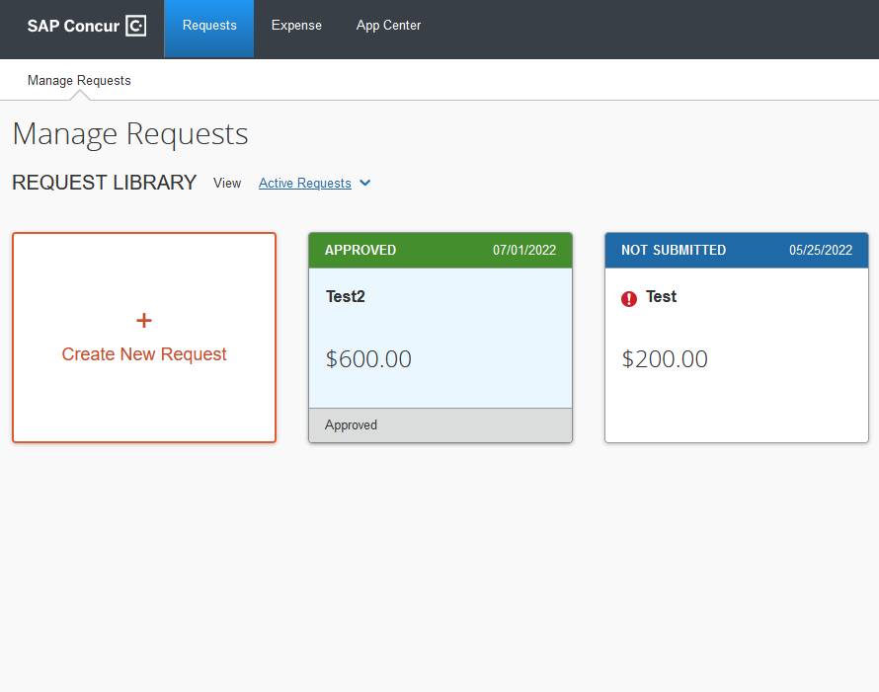

**Approved Pre-Trip Travel Requests have green headers that say Approved.**

1. Click the **Approved** Pre-Trip Travel Request to create a new expense report from an approved request (best practice), or on the **Manage Requests** page, click **Approved** in the **View** menu to view the list of approved requests.
2. Open the approved request from which you want to create an expense report.
3. Click **Create Expense Report**.

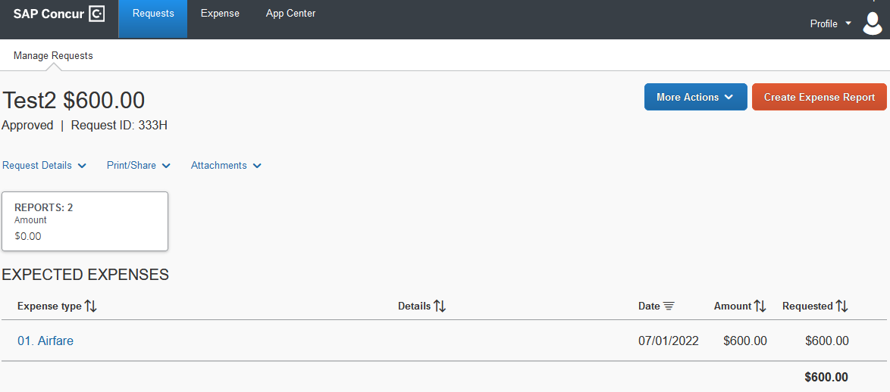  
  
**Result:** The new expense report opens in Concur Expense with the request already associated with the expense report. You are now ready to capture expenses on the expense report!