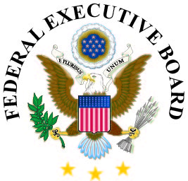

**Federal Executive Board Campus Series**

Students and Recent Graduates are the future of the Federal workforce and understanding the Federal employment process is critical to making a career in public service a reality. The U.S. Office of Personnel Management and the Federal Executive Boards (FEB) present the **Federal Executive Board Campus Series 2022** that is open to all students, recent graduates, and FEB Federal academic partners. This three sessions series will help explain the Federal application and hiring process to help you find internships and full-time jobs working in your career field.

**Registration is open now so sign-up today!**

**Navigating USAJOBS, March 30, 2022, at 1:30 PM to 3:00 PM (Eastern)**

This overview covers key aspects of a job search using USAJOBS including, searching for jobs, creating an account and profile, managing an account, reviewing job announcements, and applying for jobs.

**Registration is open!** <https://usajobs3302022.eventbrite.com>

**Resume Writing, April 6, 2022, at 1:30 PM to 3:00 PM (Eastern)**

This session dives into unique aspects of the Federal Job Opportunity Announcement (i.e., the job posting); how to tailor a Federal résumé; required information for a Federal résumé; and the Federal hiring process.

**Registration is open!**  <https://resume4062022.eventbrite.com>

**Interviewing Techniques, April 13, 2022, at 1:30 PM to 3:00 PM (Eastern)**

During this information session, participants will be provided with specific information that will prepare them for Federal interviews. We will cover preparing for and participating in a structured interview.

**Registration is open!** <https://interview4132022.eventbrite.com>

**Enhance Your Webinar Experience**

**Connectivity:** Please test the MS Teams link that you receive in the confirmation email prior to the session and work with your local IT Help desk if you experience access issues. The series can be accessed from workstations and from home! In addition, you may access the webinars from various mobile devices.

**Sound -** The sound will come from your device speakers or headphones. Please ensure your device sound is enabled.

**Accessibility**

Closed Captioning is provided for all presentations. Other requests for accommodation will need to be submitted to the Event Organizer at [Outreach@opm.gov](mailto:Outreach@opm.gov) no later than one week prior to the information session.