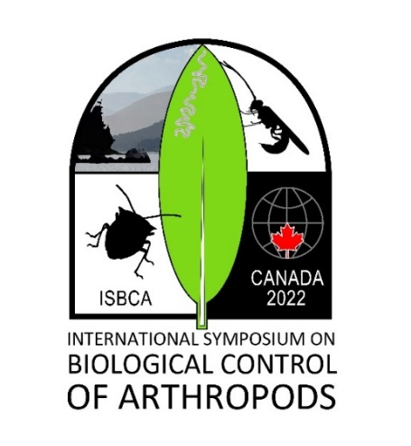**6th International Symposium on the Biological Control of Arthropods (ISBCA)**

British Columbia, Canada (Virtually), March 15-17 and 22-24, 2022

[www.isbca2022.com](http://www.isbca2022.com)

**Free registration is now open!** The 6th meeting of the ISBCA will be held virtually over two weeks in March 2022 (March 15-17 and 22-24). Registration is **FREE** but you must register ([www.isbca2022.com/registration](http://www.isbca2022.com/registration)) in order to receive a link to attend. A free and virtual meeting format with sessions staggered among time zones and a mix of live and on-demand content will allow the participation of the biological control community from around the globe from the comfort of their homes or workplaces, without concerns about travel restrictions. The meeting will be held over six days spread out over two weeks to allow attendees to attend to personal and professional responsibilities on non-meeting days. We encourage researchers and others interested in arthropod biocontrol of all career stages, including students, from around the globe who are interested in biological control of arthropod pests – including classical, augmentative, and conservation approaches – to attend the meeting.

**Scientific Sessions.** Scientific sessions will showcase arthropod biological control work from around the globe. Topics include: *Stakeholder knowledge and perceptions of biological control*, *Biological control against forest pests: challenges and opportunities*, *Challenges and progress in using native and exotic natural enemies for augmentative biological control at field scale*, *Climate change and the disruption of biological control: mitigation strategies for climate smart agriculture*, *Sustainable pest regulation in agricultural landscapes in Latin America*, *Importance of biological control for the management of invasive species*, *Underpinning science for the successful use of pathogens in biological control*, *Underpinning science for the successful use of pathogens in biological control* and a workshop: *Biological control of ticks*.

A special symposium will take place to highlight the research of students/early career researchers, each of whom will receive a cash award sponsored by IOBC Global. Dr. Martin Hill, President of IOBC-Global, will give an opening keynote address summarizing the current state of biological control. As with past ISBCA meetings, a published proceedings with extended Abstracts is planned. Further details can be found at the meeting’s website, [www.isbca2022.com](http://www.isbca2022.com), which is being updated on a continual basis.

We look forward to seeing you in March,

|  |  |
| --- | --- |
| **ISBCA 2022 Scientific Committee**  Paul Abram and Peter Mason (co-chairs)  Barbara Barrett, Jana Collatz,  Michael Furlong, Mark Hoddle,  Ulrich Kuhlmann, Nick Mills,  Tania Zaviezo | **Local Organizing Committee**  Paul Abram, Dave Gillespie,  Chandra Moffat, Brian Spencer  **Proceedings Editors**  Don Weber, Rob Morrison, Tara Gariepy |