**Directions for Student Seminar Day 2021 Picnic**

**Sept. 15, 2021 4:00pm**

**Important Note**: Please watch speed on all dirt roads, but especially near active plots, driving above 10 mph creates dust clouds that can damage plants.

1. Enter Agricultural Operations from Martin Luther King Blvd.
2. Drive past the office and quickly take the first left turn over a concrete bridge, then turn right on the dirt road.
3. Follow the road briefly along the canal and then take the first left in front of the open plots.
4. Drive down this dirt road until you pass a large building on the left and reach a paved road, turn left.
5. Follow the paved road towards the Canyon Crest Dr. gate until you see eucalyptus trees on the right.
6. You can park off the road here or turn right at the first tree and follow the dirt path between greenhouses and down a hill.
7. Follow signs for the parking areas around the picnic area (see map). Find parking out of the way of the road.
8. To Exit, return to the paved road, and turn right towards Canyon Crest Dr. and drive to the gate. There will be an RFID keycard attached to the scanner. Tap the card to the scanner to open the gate and leave card.

Please see the map for more information as well as a map of some potentially good places to park and avoid the plot to the east of the shaded picnic area. Overall be considerate of Ag Ops for allowing us to hold our event here and let’s try to not give them any reason to regret their decision.

*If you arrive later than 5:00, the MLK gate may be locked. Please contact Kathy Redd or Benjamin Nyman for entry instruction.

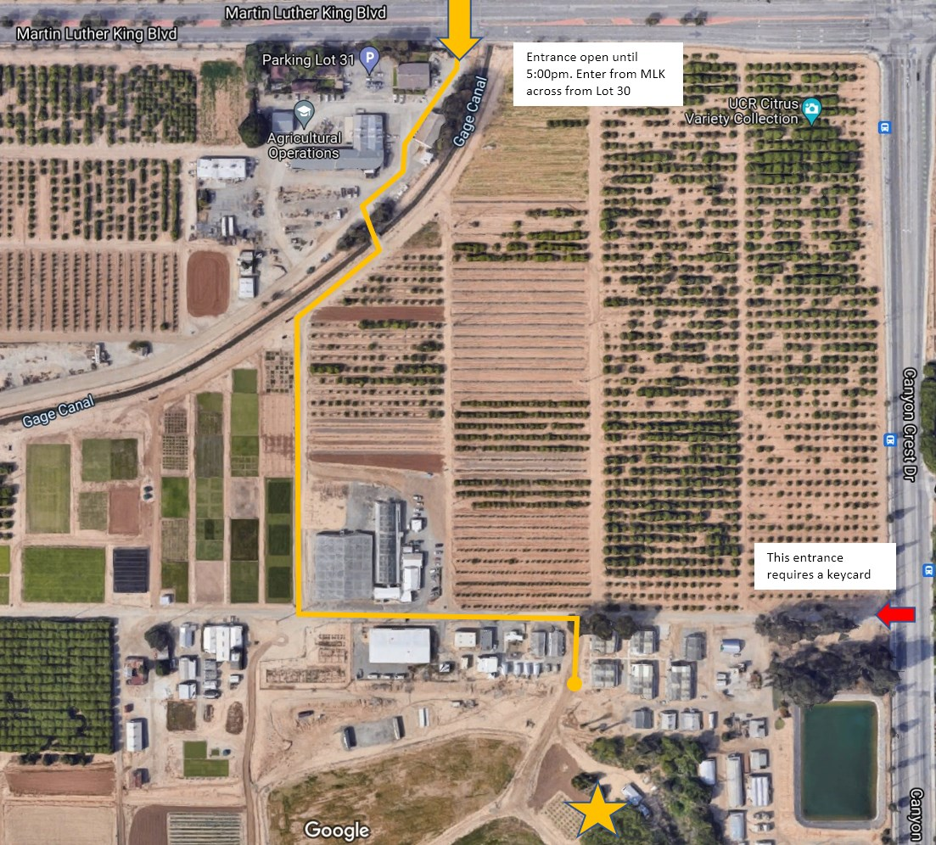

**Exit**

