Field Site Location: | Lancaster/29 Palms
Activity Description: | Vegetation monitoring/surveying, watering, outplanting
Plan Created for: | RestoreNet members | Date of revision: | April 1, 2020
Date(s) of Travel: | March – May 2020, multiple trips

A field safety plan serves as a tool to document your hazard assessment, communication plan, emergency procedures, and training. This plan should identify hazards, as well as precautions and actions taken to address and mitigate those hazards. Instructions:
- Complete this field safety plan: insert specifics for your site and operations, delete irrelevant sections.
- Complete appropriate training for your site and operations (e.g. first aid, heat illness, task-specific training).
- Obtain immunizations and prophylaxis for your destination, if applicable (schedule 8 weeks in advance).
- Hold a pre-trip meeting with your group and/or supervisor to review your field safety plan, travel logistics, pack list (including first aid kit), personal safety and security concerns, and any remaining training needs.
- Register trips more than 100 miles from campus via UC Away for travel insurance documentation, location-specific travel alerts via email, and emergency/travel assistance contacts. For international work, the Worldcue Trip Planner is available to assist with planning logistics, identify local services, and provide precautions regarding local hazards. Click on “location intel” and create a “trip brief.” A mobile Worldcue app is also available after you register a specific trip/destination via UC Away.
Site Information
Location:  29 Palms | Latitude: 34.224741° |  |  | Longitude: -116.107247°
Location:  Lancaster | Latitude: 34.701539° |  |  | Longitude: -118.309734°
Site Information | 29 Palms: Creosote scrubland near an old jojoba field. Elevation: 591m  Lancaster: Active nursery, site near refuse piles. Elevation: 753m
Travel to Site | Drive along highways, paved roads, and eventually some dirt roads.
Site Access | No locked gates. 29 Palms site is off of a dirt road (park up the berm near the plot fence). Lancaster site is behind an unlocked gate, which is open during business hours (park next to site).
Environmental  Hazards | Rattlesnakes, cacti, fire ants. Phacelia crenulata (contact dermatitis)  Mitigation: Wear snake gaiters and boots. Avoid Phacelia, don’t go around touching plants you don’t know.
Security | 29 Palms: Medium risk. Dirt road is frequented by local residents  Lancaster: Low risk, on Antelope Valley Resource Conservation District land.
No Go Criteria | Temperatures >100 degrees (see below for high heat procedures). Heavy rainfall rates, electrical storms, extreme winds
Expected Weather | High heat, strong winds, occasional storms
Drinking Water Availability | ☒ Bring extra tank of drinking water.  Please note: online heat Illness prevention training is available via the UC Learning Center (search using the keyword "heat", course length is 15-20 minutes).
Access to Shade/Shelter | If forecast exceeds 80°, shade must be provided by natural or artificial means for rest breaks.  29 Palms: ☐ Building structures ☐ Trees ☒ Vehicle with A/C  Lancaster: ☒ Building structures ☒ Trees ☒ Vehicle with A/C
High Heat Procedures | Required when temperatures are expected to exceed 95° F: If possible, limit strenuous tasks to morning or late afternoon hours. Rest breaks in shade must be provided at least 10 minutes every 2 hours (or more if needed). Effective means of communication, observation and monitoring for signs of heat illness are required at all times. Pre-work safety discussion required.  In a group: ☒ Direct supervision ☒ Buddy system ☒ Reliable cell or radio contact ☒ Other: Check in with lab members  Working alone: ☒ Reliable cell or radio contact ☒ Other: Check in with lab members
Emergency Services and Contact Information
Local Contact | 29 Palms:  Paul F. Smith, Land Owner; email; mobile  Christropher Johansing, Property Manager; email; mobile | Lancaster:  Debra Gillis, Exec Dir of AVRCD; email; mobile  Derek Winkel, email; mobile  Lodging location: TBD |  |  |  | University Contact  PI: Loralee Larios  Cell:  loralee@ucr.edu  Frequency of check ins: Mark visit prior to departure on lab calendar, report to lab when leaving to site and at the end of the workday on Larios Lab Slack fieldwork channel.
Emergency Medical Services (EMS) | Call 911.
Nearest Emergency Department (ED) | 29 Palms:  Urgent Care: Desert Oasis Healthcare Immediate Care-Yucca Valley; 57-840 Twentynine Palms Highway, Yucca Valley, CA 92284  Directions (30 minutes): Head south sunrise road and turn right onto pole line road and continue for 2.5mi until reaching Lear Ave. Turn left and continue for 6mi. Turn right on CA-62 W and continue for about 14.7 miles. Turn right and your destination will be on the left.  Contact: (760) 325-3642  ER/Hospital: Hi-Desert Medical Center: Emergency Room; 6601 White Feather Rd, Joshua Tree, CA 92252  Directions (20 minutes): Head south sunrise road and turn right onto pole line road and continue for 2.5mi until reaching Lear Ave. Turn left and continue for 6mi. Turn right on CA-62 W and continue for about 7.2mi. Turn left onto White Feather Rd and your destination will be on your left.  Contact: (760) 366-3711  Lancaster:  Urgent Care: Quartz Hill Walk-In Med Group, Inc: 42357 50th St W #107, Lancaster, CA 93536  Directions (15 minutes): Head east on Ave I for 5.2mi, then turn right onto 50th St W and continue for 5.2mi until you’ve reached your destination.  Contact: (661) 943-6455  ER/Hospital: Antelope Valley Hospital, 1600 W Ave J, Lancaster, CA 93534  Directions (20 minutes): Head east on Ave I for 7.5mi, then turn right onto 27th St W, continue for ~2mi until at the AV Hospital.  Contact: (661) 949-5000  Maps attached below
Cell Phone Coverage | Primary Number: Multiple, see roster below  Coverage: Good  Nearest location with coverage: NA |  | Satellite phone/device:  NA |  | Device carried? ☐yes ☒no
Nearby Facilities | 29 Palms: No facilities on site. Nearest restrooms, gas, and food services on Adobe Rd (east on Pole Line Rd, turn right to go south on Morongo Rd, left onto Indian Trail, and right onto Adobe Rd.  Lancaster: Bathroom on site near office. Drinking water may be available. Nearest services back along Avenue I, past the highway.
Side Trips | NA
Participant Information
Field Team/ Participants | Is anyone working alone? ☒ Yes ☐ No If yes, develop a communications plan with strict check-in procedures; if cell coverage is unreliable, carry a satellite communication device or personal locator beacon: Check in prior and post-field work over Lab Slack  Primary Team Leader: x, xxx-xxx-xxxx  Primary Field Team Leader: x, xxx-xxx-xxxx  ☒ Field Team/Participant list is attached as training documentation
Physical Demands | Carrying heavy equipment (water tanks), sun exposure
Mental Demands | Long travel days, long work days, repetitive tasks
First Aid Training  & Supplies | Cal/OSHA requires at least one trained person (with current certification) for work at remote sites. CPR also recommended.  SS: Wilderness First Aid training, CPR, CA-Epipen Administration  LS: Wilderness First Aid training, CPR, CA-Epipen Administration  Location and description of group medical/first aid kit: First Aid Kit stored in vehicle or stored with a team member.
Immunizations or Medical Evaluation | Recommended: tetanus vaccine

Equipment and Activities – Consult with EH&S for specific training and requirements.
Research Activities | Outplant seedlings and seed in the field. Water and monitor seedling through the season
Field  Transportation | Vehicle Rental through Fleet Services
Research Tools | Planting: Power auger (USGS), measuring cups, plants, herbicide, trowels, buckets, water tanks, rulers  Watering: Water tanks, buckets, measuring cups/beakers  Monitoring: Rulers, datasheets, clipboards, pvc plot frames
Other Research Hazards | Initial herbicide application, dangerous wildlife
Personal Protective Equipment | Required: Boots/sturdy shoes, hats, sunscreen, sunglasses  Recommended: Gloves, long pants, insect repellant, kneeling pads, snake gaiters
Additional Considerations
Insurance | Review the University Auto Insurance Policy (Please note, coverage differs for paid staff versus students)
International Activities | Check with the Global Engagement Office (GEO) regarding required approvals. Visas, permits, finances, import/export controls, transportation of specialized equipment, and data security must be considered. See UC Global Operations (ucgo.org) or contact the Office of Legal Affairs or Research Administration & Compliance for further guidance
Personal Safety & Security | Personal safety risks during free time should be considered and discussed in advance, e.g., alcohol or drug use, leaving the group, situational awareness, sexual harassment, or local crime/security concerns. Review expectations and set the tone for a safe, successful trip.  High Risk Travel: UC Support Services  Check the U.S. State Department travel site for current travel alerts and you may use the Worldcue Trip Planner ‘Location Intel’ tab to generate a security brief for your destination.  UC also offers pre-travel security risk planning, in-country security risk assessments, and contingency planning for those traveling to high risk destinations. As soon as you know you will be travelling to a high risk area, contact Risk Services to arrange assistance.
Campus Contacts
UCPD | 951.827.5552
University Health Services | www.ehs.ucr.edu  Faculty/Staff: 951.222.2206 (Occupational Health)  Students: 951.827.3031 (Campus Health Centre), 951.788.3000 (Riverside Community Hospital)
EH&S | 951.827.5528
UC Travel Emergency  Assistance | 951.827.5528 Campus Risk Services  800.527.0218 United Healthcare/UC Travel Insurance  410.453.6330 Outside the U.S. or via email assistance@uhcglobal.com.
Report Injuries | Call EH&S at 951.827.5528 and use the Employer’s Report of Injury.

First Aid Reference – Signs & Symptoms of Heat Illness
Signs & Symptoms | Treatment | Response Action:
HEAT EXHAUSTION  - Dizziness, headache  - Rapid heart rate  - Pale, cool, clammy or flushed skin  - Nausea and/or vomiting  - Fatigue, thirst, muscle cramps | - Stop all exertion.  - Move to a cool shaded place.  - Hydrate with cool water. | Heat exhaustion is the most common type of heat illness. Initiate treatment. If no improvement, call 911 and seek medical help. Do not return to work in the sun. Heat exhaustion can progress to heat stroke.
HEAT STROKE  - Disoriented, irritable, combative, unconscious  - Hallucinations, seizures, poor balance  - Rapid heart rate  - Hot, dry and red skin  - Fever, body temperature above 104 °F | - Move (gently) to a cooler spot in shade.  - Loosen clothing and spray clothes and exposed skin with water and fan.  - Cool by placing ice or cold packs along neck, chest, armpits and groin (Do not place ice directly on skin) | Call 911 or seek medical help immediately.  Heat stroke is a life threatening medical emergency. A victim can die within minutes if not properly treated. Efforts to reduce body temperature must begin immediately!

Include any additional resources: route/location maps, photos of general terrain and areas requiring extra caution, etc.

Maps to Emergency Services:

29 Palms
Urgent Care
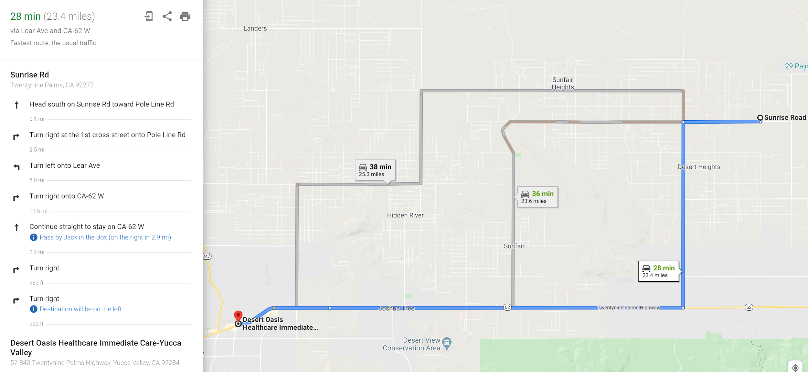

ER/Hospital
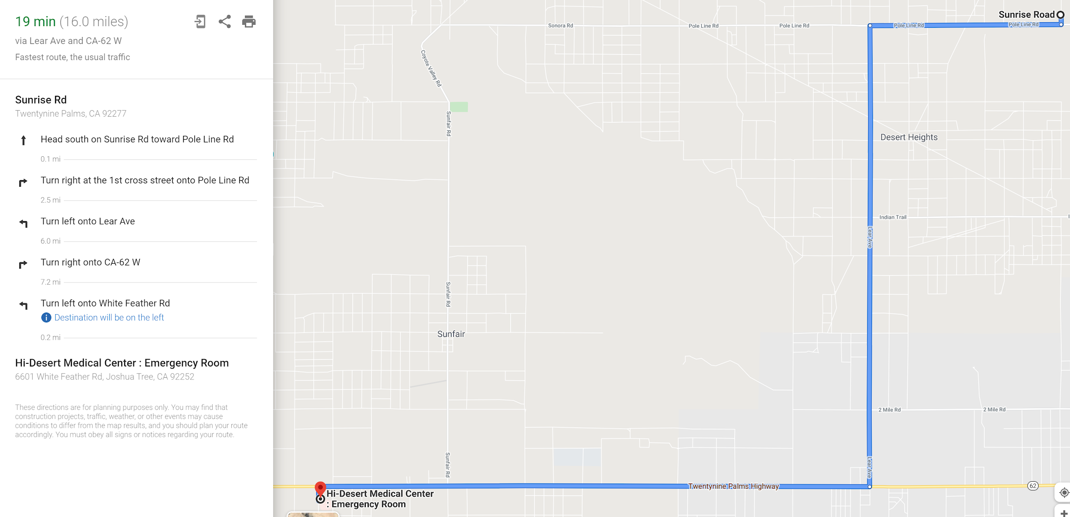

Lancaster:
Urgent Care
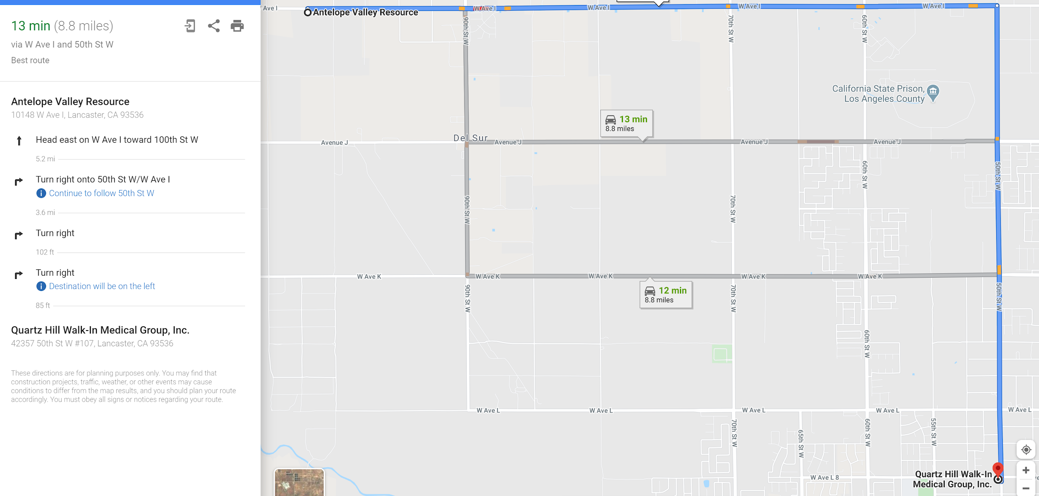
ER/Hospital
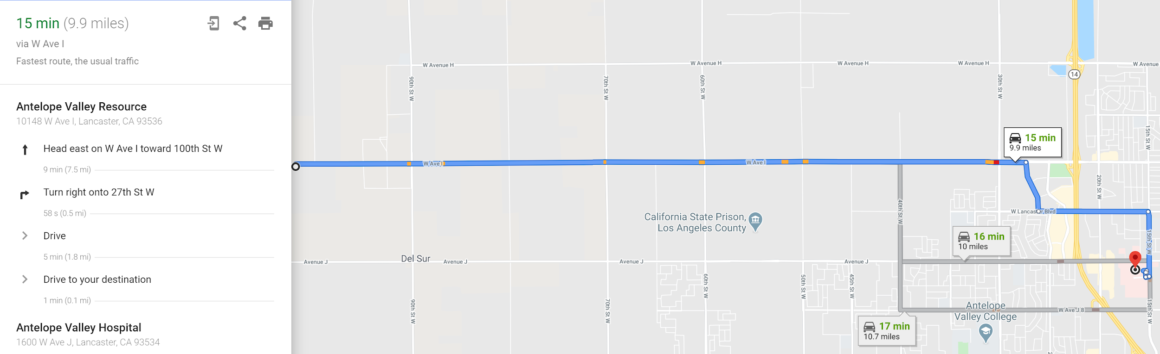

Signature of PI/Supervisor:
I acknowledge this safety plan has been prepared for field work under my supervision.

Name | Signature | Date | Phone Number
Loralee Larios

Field Team/Participant Roster - Training Documentation
I verify that I have read this Field Safety Plan, understand its contents, and agree to comply with its requirements.
Name/Phone Number | Signature/Initials | Date | Emergency Contact/Phone Number

