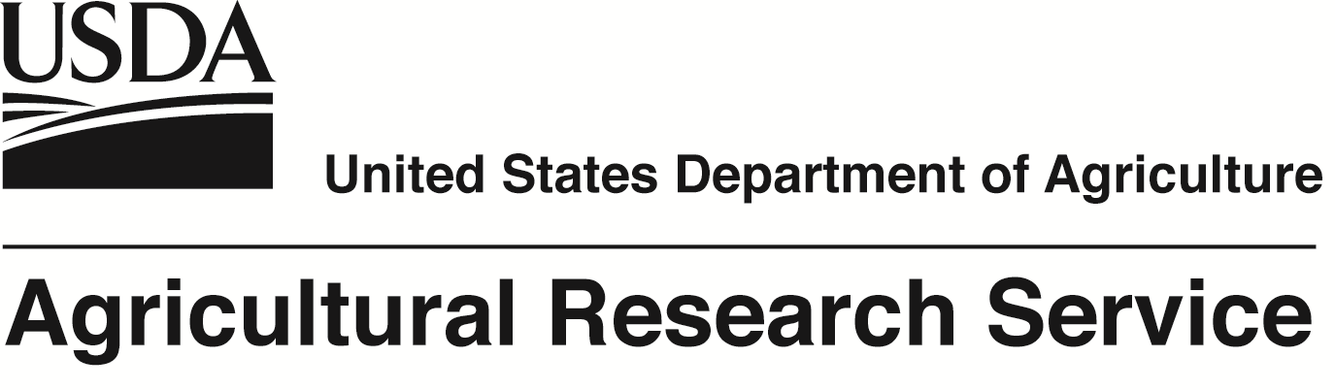
“The premier food and agricultural research agency of USDA”

Position: Research Entomologist
Salary Range: $81,723 to 126,336 per year
The U.S. Department of Agriculture, Agricultural Research Service, Subtropical Horticulture Research Station, Miami, Florida, invites applications for a Research Entomologist position.
The incumbent will be expected to: 1) develop, evaluate, and apply next generation technologies to improve detection and monitoring of adult fruit fly populations in the field by using automated systems not requiring regular human intervention to count and identify trap captures; 2) improve post-harvest detection of fruit fly larval infestation within host fruit by using non-destructive imaging and/or chemical sampling techniques; 3) use knowledge and expertise toward development of novel detection approaches for other agricultural pests that threaten to invade or have established in South Florida; 4) evaluate applications of robotics, unmanned aerial drones, and nanotechnology as warranted for improving pest detection networks; 5) Maintain laboratory colonies of test insects.
This position requires a degree in entomology or a related discipline of the biological or physical sciences that included at least 16 semester hours in entomology. Experience is required conducting research on trapping and detection systems for invasive insect pests; use of electronics, remote monitoring, mathematical modeling, imaging techniques or other appropriate 'next generation' technologies for pest detection; experience in designing, developing, or evaluating new insect traps and/or automated monitoring systems, such as 'smart traps'; maintaining laboratory colonies of test insects; experience in evaluating applications of robotics, unmanned aerial drones, and nanotechnology as warranted for improving pest detection networks. The candidate must demonstrate proficiency of oral and written English.
The applicant must be an U.S. citizen or a lawfully admitted permanent resident who will apply for citizenship when eligible. Applicants must clearly indicate their country of citizenship or legal status in their resume/CV.
The position is full time, permanent. A comprehensive benefits package is available.
Applications not including a resume with a thorough description of the work performed and lists publications/presentations/references, and complete transcripts that show completion of a degree in entomology or related field as described above will not be considered.
Vacancy announcements (ARS-D20Y-10893579-ABS) and where to apply can be found at website www.usajobs.com. Closing date for applications is October 13, 2020.
The USDA is an Equal Opportunity Provider and Employer.

