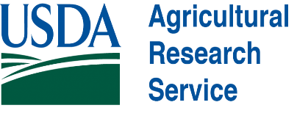
GRADUATE RESEARCH ASSISTANTSHIPS AVAILABLE
Description: The Boetel lab (North Dakota State University, Fargo) and Russavage lab (USDA ARS) are recruiting 2-3 students that will pursue M.S. degrees and focus on: 1) chemical ecology of beet leafhopper and beet curly top virus, 2) plant resistance traits against sugar beet root maggot, or 3) remote sensing of sugar beet pests. Individual projects may involve insect rearing, plant volatile collections, analytical chemistry techniques (GC-MS, HS-SPME), RNAi, behavior tests, insecticide/ plant resistance trait assays, and field trials of management strategies.
The ideal candidate will have a bachelor’s degree in biology, entomology, plant science, agronomy, ecology, environmental science, or a related field. The candidate will be highly motivated, work well in a team or independently, have good organizational skills, and some research experience. The successful candidate will be expected to conduct experiments (with guidance from advisors), present research findings at conferences, prepare/write manuscripts, and complete the necessary coursework.
Start Date and Compensation: The successful applicant will start around June-July 2027 (as mutually agreed upon). The assistantship includes a stipend ($25,000/year), tuition, and health insurance.
Application Procedure: Interested applicants should submit the following to Dr. Emily Russavage (emily.russavage@usda.gov) and Dr. Mark Boetel (mark.boetel@ndsu.edu) with the subject line “M.S. Entomology Application”:
- Cover letter describing your research experience, interests, and career goals
- CV/Resume
- Unofficial transcripts
- Name and contact information for two references

