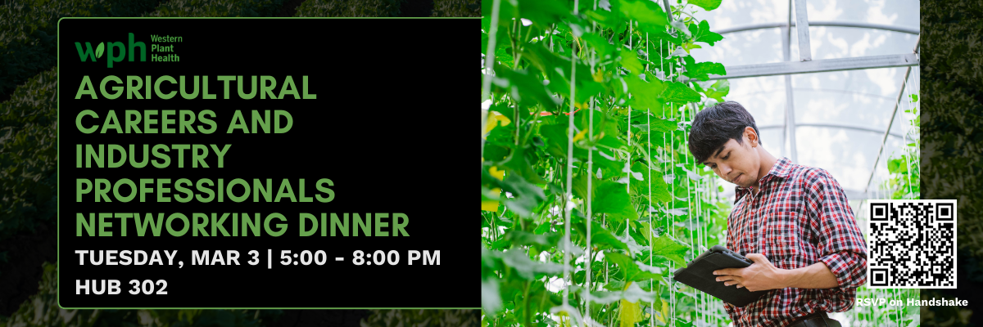
🌱 Agricultural Careers & Industry Professionals Networking Dinner
Interested in exploring careers, internships, and real-world pathways in agriculture, plant science, and sustainability? Join the Western Plant Health Association (WPHA) for an in-person Networking Dinner designed to connect CNAS students with industry professionals working across California’s agriculture sector.
WPHA represents companies at the forefront of crop protection, plant health, biotech, and sustainable agriculture—and they are eager to meet students interested in shaping the future of food and farming.
What to Expect
- Network with professionals from agribusiness, research, and public-sector organizations
- Learn about internships, entry-level roles, and emerging innovations in plant health and agriculture
- Gain insight into career paths spanning biotech, pest management, sustainability, and regulatory work
- Enjoy a free dinner while building meaningful professional connections in a relaxed setting
Featured Employers Attending:
- Buttonwillow Warehouse Co.
- Helena Agri-Enterprises
- Riverside County Agricultural Commissioner's Office
- Western Plant Health
Event Details
📍 Location: HUB 302
📅 Date: Tuesday, March 3, 2026
⏰ Time: 5:15 PM – 8:00 PM
🔗 Deadline to RSVP: February 24
WPHA is committed to fostering the next generation of agricultural leaders. Space is limited—register early to secure your spot.

