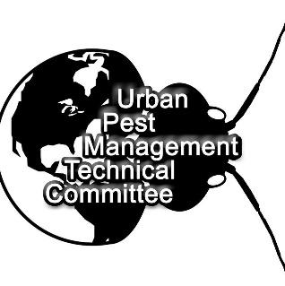

Urban Pest Management Technical Committee Internship

[upmtcinfo@gmail.com](mailto:upmtcinfo@gmail.com)

[UPMTC.org](https://l.facebook.com/l.php?u=http%3A%2F%2Fwww.UPMTC.org%2F%3Ffbclid%3DIwAR0kogPUVygyc-9_NylFIjtg7x30WhQbTRJz77qY_tD7iR72s4Ap-pyvT5g&h=AT1tsltOhWrK20GeVaRySKIBZtJe-GEk52KzeFT-2-GtG6P8qmgcTQGVGlUOPLhHFEx1oN6bnn6fP8JUbZwh3-FbufViRZq23mfbo_dBXszLPFd_wxzqmCUd4rhXyRqY)

#### UPMTC promotes science and professionalism in urban pest management by developing the industries’ current and future technical directors and trainers. Members get an opportunity to discuss the latest challenges, trends, and interesting observations about urban pest management during our monthly virtual meetings.

#### In addition, we meet semi-annually for immersive field discovery and world-class training from experts who are leading pest management innovation.

We are thrilled to announce an exciting opportunity for you to join one of the UPMTC represented teams as an intern!

As Urban Pest Management providers we specialize in the effective management of common household and industrial pests, including various species of spiders, ants, cockroaches, mosquitoes, bed bugs, and occasional invaders. As an intern with us, you will have the opportunity to work closely with seasoned professionals and gain hands-on experience in a dynamic and fast-paced environment.

Here's what you can expect working in the urban pest management career:

* **Practical Training**: You will receive comprehensive training in the identification, behavior, and management of common household and industrial pests. This will include learning about the biology of different species, their habitats, and effective control methods.
* **Field Experience**: Get ready to roll up your sleeves and dive into the field! As an intern, you will accompany our experienced technicians on service calls, assisting with pest inspections, treatment applications, and monitoring activities. This hands-on experience will give you invaluable insights into the day-to-day operations of urban pest management.
* **Problem-Solving Skills**: Urban pest management often involves tackling complex pest infestations in diverse settings. You will learn how to assess pest problems, develop customized treatment plans, and implement integrated pest management strategies to effectively control infestations while minimizing environmental impact.
* **Customer Interaction**: You will have the opportunity to interact with our clients, providing them with expert advice and recommendations for pest prevention and management. Developing strong communication and customer service skills is an essential part of the job.
* **Industry Insights**: Gain a deeper understanding of the urban pest management industry, including emerging trends, regulatory requirements, and best practices. This knowledge will prepare you for a successful career in this rewarding field.

This internship is a paid position, offering you the opportunity to earn while you learn. In addition to valuable practical experience, you will also have the chance to network with industry professionals and potentially explore future career opportunities within the urban pest management industry.

If you are enthusiastic about entomology and eager to kick-start your career in urban pest management, we want to hear from you! Please submit the application and a brief cover letter outlining your interest in the internship to [upmtcinfo@gmail.com](mailto:upmtcinfo@gmail.com)

We look forward to welcoming you to our team and supporting you as you embark on this exciting journey in Urban Pest Management!