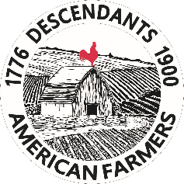 | April 2025

As California State Ambassadors representing the National Society Descendants of American Farmers, it is our pleasure share with you an opportunity for your students to apply for a $2000 scholarship!

Students need not be a member of this society to be eligible.

The National Society Descendants of American Farmers was established with the following goals:

- To identify and honor the memory of our ancestors who were "farmers" and living within the present boundaries comprising the forty-eight (48) contiguous states of the United States of America between July 4, 1776 - December 31, 1900.
- To collect and preserve records, documents, and relics pertaining to the history and genealogy early American farmers.
- To produce and distribute publications relating to the history and genealogy of these farmers.
- To encourage study and inspire an appreciation of the rural and country life led by our ancestors.
- To engage in related educational, historical, genealogical, patriotic, literary, and social activities.

As a college professor myself, I am keenly aware that many students face financial hardship while pursuing their educational goals– we can help! We are descendants of early farmers in multiple states, and we are deeply committed to supporting and bringing attention to California farmers, and agricultural students in California colleges.

Please share this link (www.nsdoaf.com/scholarships) to our scholarship application with your students, peruse our National website (www.nsdoaf.com), and reach out to either one of us with any questions that you may have. Our next scholarship deadline is just around the corner on August 1, 2025.

In support of today’s and tomorrow’s California farmers,

Chris and Sue

Christina Hurst-Loeffler and Sue Fitzpatrick
California State Ambassadors, National Society Descendants of American Farmers
churstloeffer@gmail.com suefitz1@gmail.com

