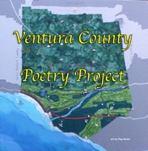
The Ventura County Poetry Festival is sponsoring a poetry contest. The festival takes place on March 6th – 9th, 2025 at Studio Channel Islands in Camarillo. Nationally-known poets, the finest poets from the Central Coast, and even an international poet will be present.
Winners of the contest will receive recognition, awards, and the chance to read their poem in the Ventura County Poetry Festival.
The theme is “Passages.” Please write a poem about a memory or an experience rooted in a passage. A passage is the act or process of moving through, from one place to another, the stages of an individual’s life, an inflection point or change, a threshold, a liminal state of being
The poem should be no longer than 35 lines. Your name, contact info, and the title of the poem should appear in the email. The poem including title should be attached without identifying information. Poems must be emailed to vcpoetryproject@gmail.com at the end of Friday, Feb. 21, 2025.

