Troubleshooting – Service Invocation Failed

September 24, 2020

# Banner Issue: “Service Invocation Failed; Couldn’t access remote service”

### Overview and Usage

Connection to Banner is severed, requiring a reconnect, generally involving signing back in through the Single-sign-on (CAS). Historically, troubleshooting this issue required closing all windows and tabs on the browser, restarting the browser, and then signing back in through CAS SSO. Often the solution would also require clearing the cache of the browser. Banner allows for a more direct resolution that bypasses the need to close windows, by selecting the ‘Sign Out’ button on the Dashboard Menu at the left of the main Banner screen.

### Navigational steps for resolving a “Service Invocation Failed” error

1. Select the **Sign Out** button on the Dashboard Menu at the left of the main Banner screen. You may also use the keyboard shortcut **Ctrl+Shift+F** in lieu of the **Sign Out** button, which will take you to the banner logout window.

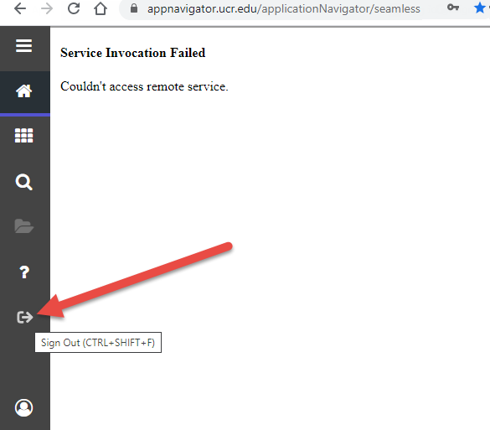

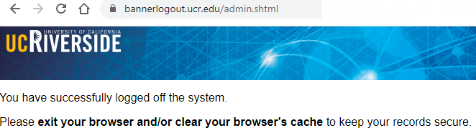

1. In the address bar of your browser, replace the <https://bannerlogout.ucr.edu/admin.shtml> URL with the Banner Production link (<https://appnavigator.ucr.edu/> or <https://appnavigator.ucr.edu/applicationNavigator/seamless>) **OR** you may use a personal bookmark/shortcut for this page, if you have one setup.

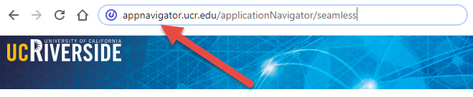

1. Enter your UCR NetID and password to log into CAS

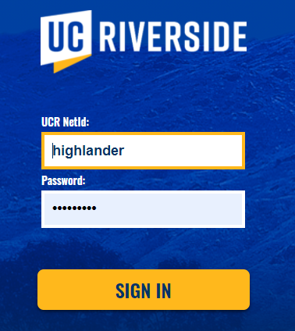

1. At this point, should be where you want to be on the Banner Home screen; however, if the follow screen appears after logging in to CAS, select the **OK** button at the bottom of the screen.

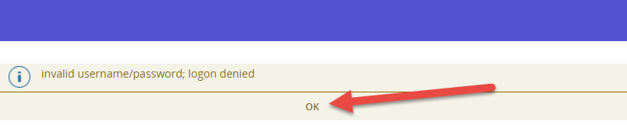

1. Then select the **RETURN HOME** button on the next screen, which will take you to the Banner Home page.

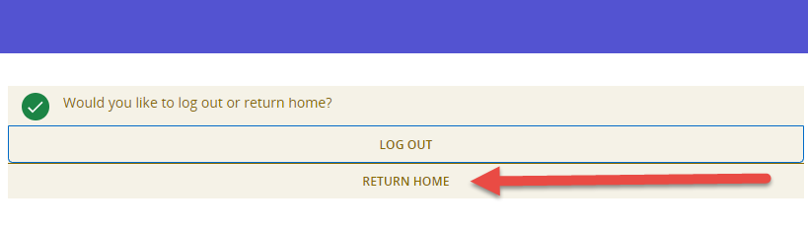

# Document Tracking

The following table is used to log all changes made to this document.

|  |  |  |  |
| --- | --- | --- | --- |
| Version | Date | User | Description |
| 1.0 | 9/24/2020 | James Fox | Initial Release |
|  |  |  |  |
|  |  |  |  |
|  |  |  |  |
|  |  |  |  |