Discourse and Free Expression Hold ( will be assigned October 23rd/24th)
Log in to R’Web
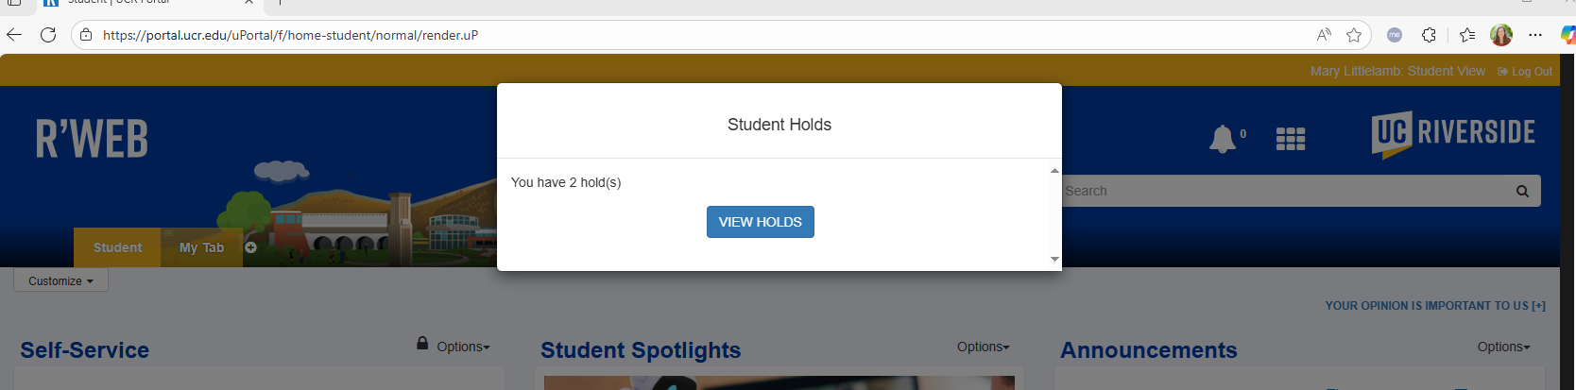
Click on Registrar
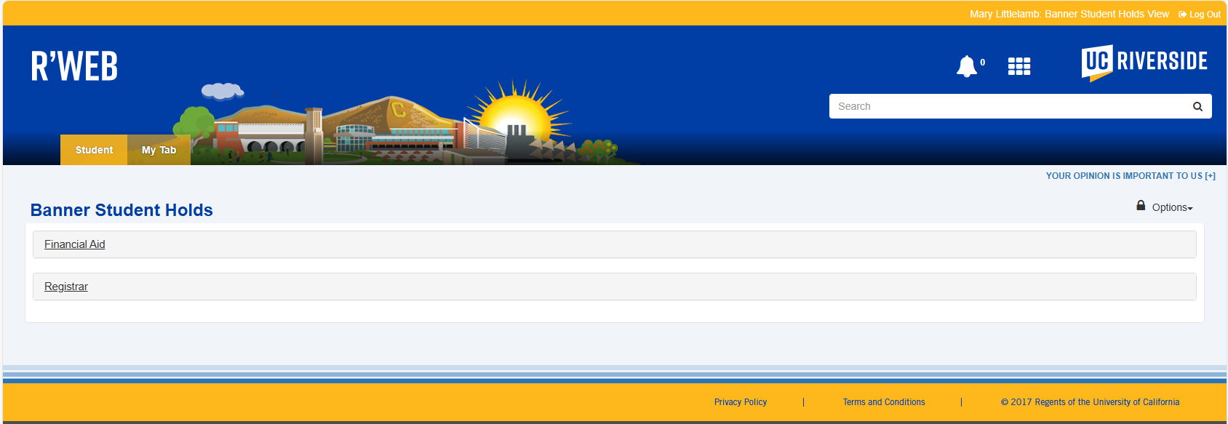
Click on the hold “Discourse and Free Expression”
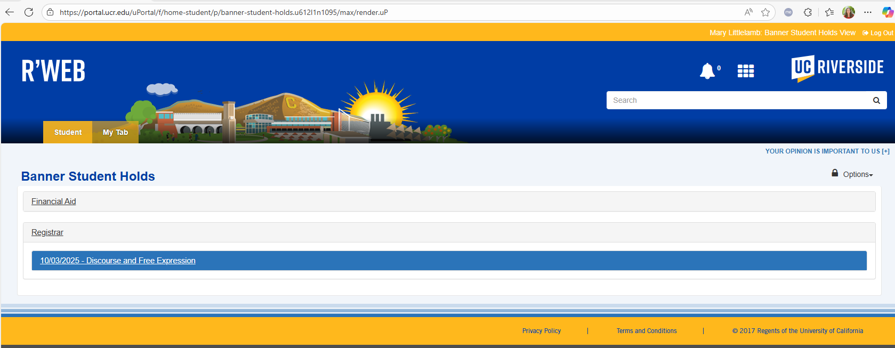
Review the content, watch the video and then the student needs to check the box at the bottom left of the box to acknowledge the content. This will clear the registration hold.
