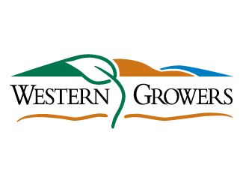
SAVE THE DATE

Please join Western Growers on February 11 for the Global Harvest Automation Initiative Launch!

Western Growers is launching a Global Harvest Automation Initiative on February 11. Every year crops go unharvested because of the increasing unavailability of harvest labor. Harvest robots are needed to increase food security and sustainability so that every crop gets harvested and food grown is not wasted. Western Growers’ members have made it clear that this is one of their largest challenges.

To date, hundreds of startups have raised millions of investment dollars over 10+ years to develop solutions that have done little in practical terms to solve the problem. With this launch, Western Growers is making a commitment to enable more harvest robot startups to launch and get into farmer’s fields faster. We will make it easier for startups to work with tractors and robot arms so they can focus on building the end effectors that harvest the food and the artificial intelligence code that controls them. We will help farmers identify the startups that are delivering harvest automation solutions by crop type and help them measure the impact of these startups in helping to solve the food security challenges.

On February 11, we are going to provide the details for the Global Harvest Automation Initiative – the partners that are involved, what we plan to develop, and how we plan to roll the solutions out to our grower members and harvest automation startups. Please join us at 9:00 am for a day full of information on how Western Growers will be leading the global charge to solve harvest automation.

If you would like to attend, please forward this email to the members of the WGA Innovation team organizing the launch and let us know who would like to attend from your organization.

Walt Duflock – wduflock@wga.com
Dennis Donohue – ddonohue@wga.com
Emily Lyons – elyons@wga.com

We will forward you an email with event registration details once everything is live. Consider this a “save the date” email placeholder with more details to follow.

