Quick Steps to start using MS Teams

- Download MS Teams for your desktop at https://www.microsoft.com/en-us/microsoft-teams/download-app
- Go to your Downloads folder. Double-click Teams_windows_x64.exe
- Logon to Microsoft Teams using your UCR email netid@ucr.edu

- New to MS TEAMS? Then click on the link below to download a Quick Start Guide for an introduction and how to navigate thru all options available in MS Teams. https://download.microsoft.com/download/D/9/F/D9FE8B9E-22F5-47BF-A1AB-09539C41FCD0/Teams%20QS.pdf

- Roles:
  - Roles include “Owner” and “Member”
  - “Owner” has all rights to create, delete, and manage members (there should always be more than one owner per MS Team)
  - ITS recommends that more specific permissions on specific files be managed by sending link to document or creating a private “Channel”
  - “Members” have the same rights as the “Owner” except the ability to manage members.
- Working with files
- Click on “Teams” from the left menu, then select a Team which you’re either a member or the owner from the list or grid.

- Click on one of the Channels in the selected Team, then “Files” on the top of the right panel. This “Files” panel works similar to the “File Explorer” on your computer.
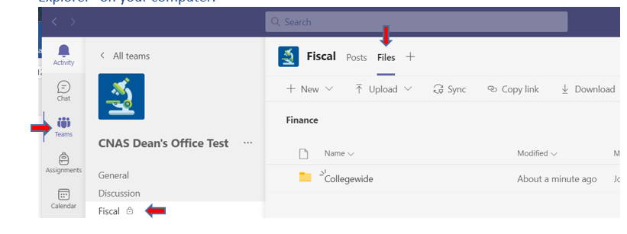
- Click on the link below for a quick training on how to work with files and sharing files.
https://www.linkedin.com/learning/microsoft-teams-working-with-files/share-files-in-teams?u=26135898

- Hints:
- There are many ways to open/edit a file:
- Double click on a file to open it in MS Teams.
- Open in Desktop app.
- Open in Browser.
- Download the file.
When editing a file in MS Teams or the Browser, you may not have the same options/features that are available in the desktop version of Excel or Word, but the file is automatically saved while you’re editing it.
If you choose to open in Desktop app, when the “Save” option is selected, the content of the file will automatically sync to MS Teams.
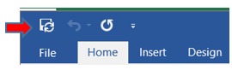
If you choose to download the file to your local computer for editing, don’t forget to upload the file back to MS Teams with the “Upload” option.
Regardless of which option you choose to open/edit a file, if you want to block other members from editing the same file while you’re editing it, use “Check Out” option. After editing is done, don’t forget to return the file back to MS Teams by using the “Check In” option by clicking on “...” next to the file name.
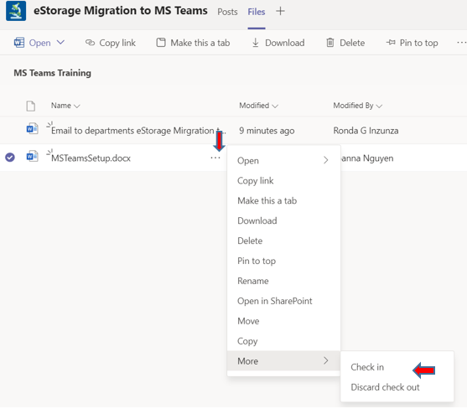
- When more than one person are editing the same file, either names or pictures of the other members are displayed on the top right corner of the file.
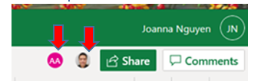
- MS Teams keeps history of all changes that were made to the file. With the versioning feature, you can revert the changes by clicking on “Restore” option. “Version History” option can be found at “File – Info – Version History”.

- To view all changes while you’re editing a file, click “Review” then “Show Changes” options, the “Changes” panel will display with all changes details.
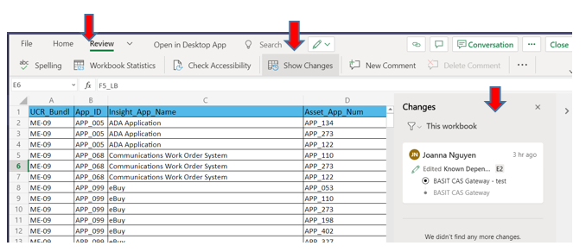

- Setup “Alert” is recommended so that Teams will send an email notifying you of when any file or folder was deleted from the channel. You will then be able to recover the file or folder immediately if it was deleted by other team members unintentionally. Teams will keep all deleted files or. folders in a deleted items bucket for 93 days. After 93 days, all deleted files or folders are not recoverable. To setup “Alert”, open the folder or file in SharePoint. In SharePoint, click on the three dots for popup menu, then select “Alert Me” option.

- As a rule of thumb anytime you see the … symbol that indicates there are more options available. Just click on the “…” symbol, a popup will be displayed with more options for you to select.
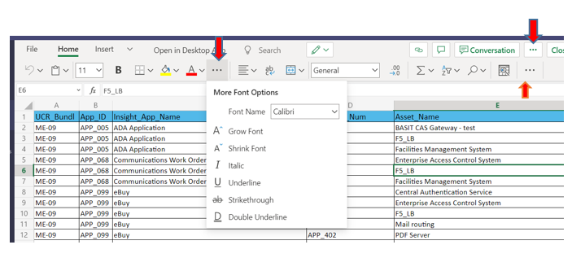
- To learn about all essential MS Teams features, click on this link https://support.microsoft.com/en-us/office/microsoft-teams-video-training-4f108e54-240b-4351-8084-b1089f0d21d7

