**Colonel F. John Burpo, Sc.D.**

Professor, USMA

Head, Department of Chemistry & Life Science

United States Military Academy, West Point, NY 10996

**“Biomedical Sciences in the Army”**

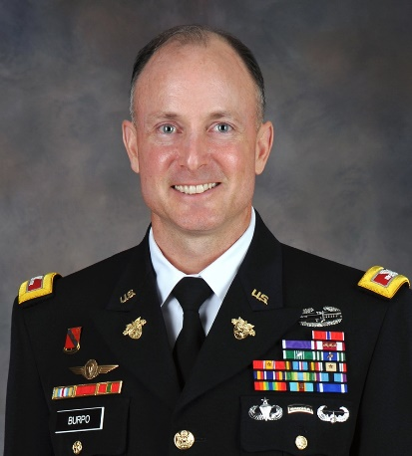Colonel Burpo is a Professor, United States Military Academy and currently serves as the Department Head for West Point’s Department of Chemistry and Life Science. COL Burpo earned a B.S. in aerospace engineering from the United States Military Academy, a M.S. in chemical engineering from Stanford University, and a Sc.D. in biological engineering from the Massachusetts Institute of Technology. Following his doctoral work, he conducted a dual post-doctoral fellowship in the Biomolecular Materials Laboratory and an Army War College fellowship in the Security Studies Program, both at MIT.