**Heidi Hoard-Fruchey, Ph.D.**

Medical Toxicology Research Division Chief

US Army Medical Research Institute of Chemical Defense

(USAMRICD)

**“Becoming an Army Civilian Scientist and Leader”**

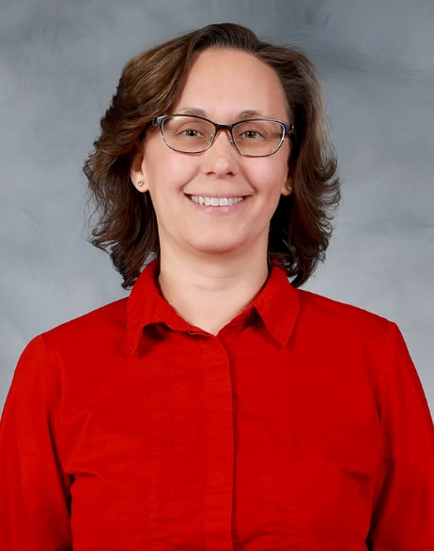Dr. Heidi Hoard-Fruchey is the Medical Toxicology Research Division Chief at the US Army Medical Research Institute of Chemical Defense (USAMRICD). She grew up in southern Michigan and attended Michigan State University (MSU), obtaining a B.S. in Biochemistry. After a year internship in a MSU pathology laboratory, she attended graduate school at the Mayo Clinic where she completed a Ph.D. in Molecular Biology, studying mitochondrial enzymes involved in inborn errors of metabolism. For her first post-doctoral fellowship, she joined a yeast genetics and cell biology laboratory at Johns Hopkins University and studied mitochondrial morphology. She joined the USAMRICD for her second post-doctoral fellowship to study botulinum neurotoxin, and through networking at the institute, became a contractor, working on mitochondrial proteomic changes induced by chemical warfare nerve agent (CWNA) exposure. Dr. Hoard-Fruchey went on to become a principal investigator running a transcriptomics laboratory at USAMRICD. Working with several colleagues, she identified potential medical countermeasures to be tested for CWNA or toxic industrial chemical exposures. Serving as the USAMRICD Oak Ridge Institute for Science and Education (ORISE) program coordinator, she discovered her passion for helping others achieve their career goals. After a brief experience at the Army Public Health Center, Dr. Hoard-Fruchey returned to USAMRICD to become a supervisor for scientific staff. During her professional journey, she met her husband Isaac and had two children – Jacob and Sophia.