Melissa Strong, Ph.D.
Scientist
Vertex Pharmaceuticals

“Multiple pivots: from Postdoc to Government to Industry”
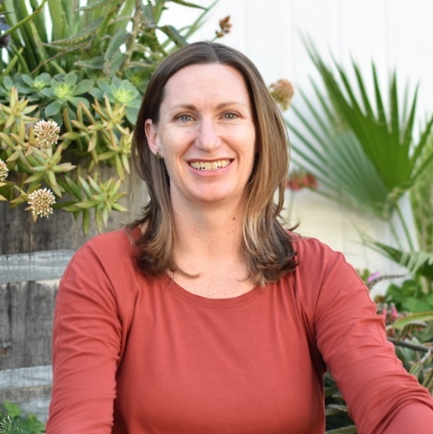
Melissa received both her B.S. in Biology and Ph.D. in Biomedical Sciences from the University of California, Irvine (with one summer as a technician at UCR!). In graduate school, she studied neuroscience in the lab of Oswald Steward, gaining experience in rodent models of spinal cord injury and mouse models of Huntington's disease. She applied molecular techniques to investigate factors that determine neuronal survival and death in disease. As a postdoc at the University of Washington in Edwin Rubel's lab, she continued this same line of inquiry, but in a new model - hearing loss. From her postdoc, she made her first major career switch - Forensic Biology at the San Diego Police department. She spent 7 years there as a criminalist validating new techniques that made a large impact in the quality of forensic DNA testing for the city of San Diego. After those major validation projects ended, she made another major career switch just this last year into the biotech industry. With her new title, Melissa is now a Scientist in the In Vivo Pharmacology group at Vertex Pharmaceuticals in San Diego working to help create solutions for people suffering from pain.

