Amanda Smith, MS, LCSW
Director of Medical Student Support & Wellness, School of Medicine
University of California, Riverside

“Wellness, Gratitude, and Connection”

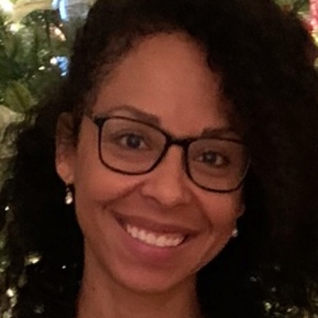
Amanda Smith is a UCR alumni. She has a Masters in Social Work from CSUSB and is a Licensed Clinical Social Worker as well as Mindfulness Facilitator. She is an expert in mental health services and crisis intervention for over 14 years. She previously worked for Veterans Affairs in various departments including Veterans Treatment Courts, In Home Nonskilled services, and finally Supervisor for clinical staff in the ED and Inpatient Psychiatric Units. She was also actively involved in creating an employee wellness program. She is always looking for ways to build connection and community with clients and student populations to assist individuals with improving their overall wellbeing.

