Scott Pegan, PhD.
Professor
School of Medicine – Division of Biomedical Sciences
University of Riverside, California

“Keeping the DoD up at Night: Countering Nerve Agents and Viral Threats”
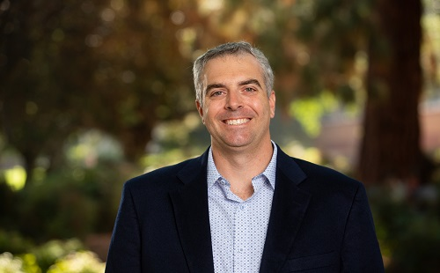
A native of Livermore, California, Dr. Pegan joined the School of Medicine in 2021. He earned his Ph.D. in Chemistry from the University of California in San Diego. His current research focuses on the regulation of the human innate immune system and the discovery of new therapeutics for nerve and pesticide agent poisoning. He has published over 54 peer-reviewed articles and holds over seven U.S. and international patented discoveries. He is a U.S. Army Operation Iraqi Freedom combat veteran, a U.S. Army Reserve Major, and a Biochemist for the United States Medical Research Institute of Chemical Defense. Dr. Pegan has partnered for a number of years with industry and federal agencies on research for drug discoveries and is a requested panelist and speaker at numerous forums on drug discovery, viruses and structural biology.
Dr. Pegan previously served as the Director of Drug Discovery, Interim Associate Chair, and Professor at the University of Georgia’s College of Pharmacy, an Assistant Professor of Chemistry and Biochemistry at the University of Denver, Research Assistant Professor of Medicinal Chemistry at the University of Illinois College of Pharmacy. Through his numerous faculty and administrative roles, Dr. Pegan has redesigned all levels of student experiences to provide students with hands-on scientific experiences in research, presentation, and writing, as well as opportunities for practical application of computational and cheminformatic techniques. Beyond teaching, Dr. Pegan enjoyed making several contributions to improving the research environments of institutions where he has served and those of several US research agencies.

