**Natalie Zlebnik, PhD.**

Assistant Professor

School of Medicine - Division of Biomedical Sciences

University of Riverside, California

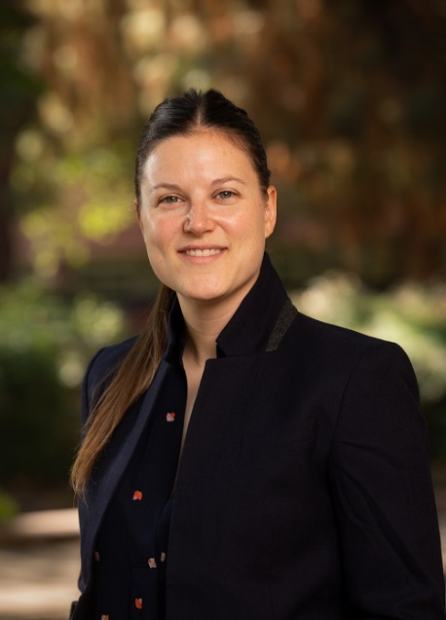

Natalie E. Zlebnik, PhD, is a new Assistant Professor in the Division of Biomedical Sciences. She completed her graduate training at the University of Minnesota, followed by a postdoctoral fellowship at the University of Maryland, School of Medicine. The overall aim of her research program is to understand how drugs of abuse exploit neural mechanisms of motivated behavior with the goal of developing novel therapeutics to reduce drug craving and the propensity to relapse. In her spare time, her other research interests include searching for the hottest hot sauces and tastiest tacos in the Inland Empire.