Pablo M. Paez
Associate Professor
Institute for Myelin and Glia Expleration
Department of Pharmacology and Toxicology
School of Medicine and Biomedical Sciences
University at Buffalo
The State University of New York

“Modulation of oligodendrocyte development and myelination by voltage-gated Ca⁺⁺ channels”

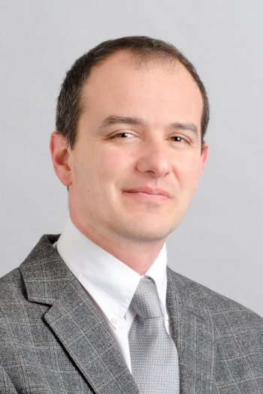
Dr. Pablo Paez earned his Ph.D. in Pharmacology and Biochemistry at the University of Buenos Aires in 2005. Dr. JM Pasquini directed his doctoral research, which focused on the in vitro developmental cell biology of oligodendroglia. Dr. Paez joined Tony Campagnoni’s laboratory at UCLA in 2006 for continued postdoctoral training in the cell and molecular biology of oligodendroglia, focused on the determination of the role of the ubiquitous golli proteins encoded by the myelin basic protein gene. He was subsequently appointed to the position of Research Neuroscientist in the Department of Psychiatry at UCLA. In 2013, he joined the School of Medicine and Biomedical Sciences at the State University of New York at Buffalo, where he is presently an Associate Professor in the Department of Pharmacology and Toxicology. Paez’s current research focuses on understanding the function of ion channels in oligodendrocytes and astrocytes. His research has been instrumental in identifying ion channels that connect the electrical activity of neurons with the maturation of oligodendrocyte progenitor cells and the myelination process.

