Clean-Air Artistic Expressions
The Clean-Air Artistic Expressions contest aims to engage the community through creative expression via the arts. The contest is sponsored by the College of Engineering, Center for Environmental Research and Technology (CE-CERT), and the Center for Healthy Communities (CHC).
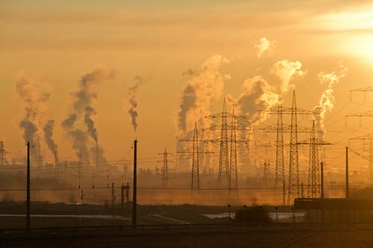

Why a Clean-Air Artistic Expression Contest?
Did you know… that J.W. North High School and the surrounding neighborhoods are squarely situated in a region with the highest air quality disadvantaged status according to CalEnvironScreen.

Did you know… the majority of the resident’s experience health impacts either caused or exacerbated by poor air quality on a regular or semi-regular basis, including asthma, reduced heart function, and cancer. This is why we need people like you; key players, and influencers that can lend their expertise on how we can effectively address the poor air quality issue that are plaguing our community. We will not achieve this goal without your input, and we need you to make a positive impact.

This contest encourages community members to get engaged through the arts to drive change and make a positive change within the community:
- How am I making an impact?
- Does this engage the community?
- What is the impact I hope to express?
- What am I trying to say about our duty as a community?

Through our community engagement, we must stop and reflect on our work to align intentions, ideals, and actions to ensure that we are ethically impacting the lives of others in the community.

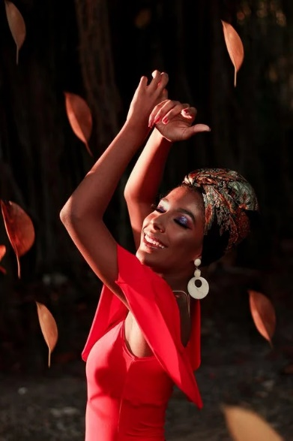
Guidelines
To be considered for this award, each entry must follow the following guidelines:
- Submit original artistic expression to CHC@medsch.ucr.edu
- Participants must be residents of Riverside and/or San Bernardino County.
- Only one entry per individual or group.
- Artistic expression can be submitted by individuals or by a group e.g. student organizations.

Categories
- Written Expression
  - Essay or Poem
    - All entries must:
      - Be a maximum of 500 words.
      - Have a name and title.
      - Be typed in 12-point font.
      - Reflect factual knowledge or research and use appropriate language, grammar, and spelling.
      - Be original, your own words and/or include citations.
- Artistic Expression
  - Submit a photograph, digital art, video or an original painting, collage, or drawing.

- Oral Expression
  - Video of yourself reciting (not reading) a poem or speech or singing a song.
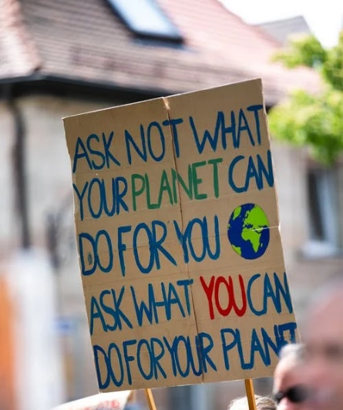
    - Be a maximum of 5 minutes long.
    - Include the words from the performance.

Awards and Prizes
- 1st place prize will be awarded in each of the three categories.
- Prize winners will receive $400 each
The winner will also be showcased on CHC’s webpage

Judging Criteria
Entries will be judged by a panel based on their relevance and impact related to the topic, along with the criteria listed below:
- Does the artistic expression show the adverse effects of air quality within the IE?
- Does the artistic expression reflect the reality of the situation?
- Does the artistic expression show people with dignity, equality, support, and integrity?
- Does the artistic expression present a unique perspective of the issue?
- Does the artistic expression present a practical/pragmatic solution?

Entries that are plagiarized, incomplete, or late will not be accepted.

Deadline
All submissions are due no later than May 1st

For more information please email The Center for Healthy Communities at chc@ucr.edu

