U.S. Hegemony
In Evolutionary Perspective
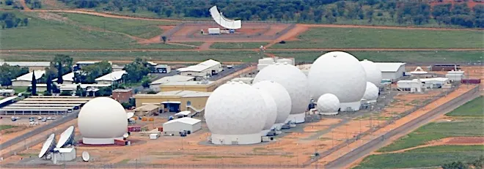
Pine Gap, U.S. surveillance base, Northern Territory, Australia
Christopher Chase-Dunn and Emlyn Zhai
Institute for Research on World-Systems
University of California-Riverside
<chriscd@ucr.edu>
Riverside, CA 92521
Draft v 4/7/2025 12898 words

Paper accepted for publication in a special issue of Critical Sociology
Abstract: This article examines the trajectory of the hegemony of the United States in a comparative world-historical context with a focus on recent decades. Most complex and hierarchical world-systems experienced sequences in which a single polity rose to power over other polities and attained a peak level of power for a while and then declined. The modern global system is not an exception. The rise and decline of the United States in the 19th, 20th and 21st centuries has been studied extensively by sociologists, political scientists, historians and policy analysts, but usually not in the context of the evolution of polities, interpolity systems and modes of accumulation since the Stone Age. Much can be gained by carefully examining changes in quantitative absolute sizes and relative shares of economic and military power and with attention to “soft” political and ideological power. In this essay we summarize recent quantitative and computational modeling studies of the relative power of states, and we discuss some of the V-Dem findings about political regime change patterns (democracy and autocracy) since the 1900 CE. We also venture into the murky realm of speculation about the short, middle and long-run futures of the structure of global power.
Keywords: Sociocultural Evolution, Global Governance, Hegemony, Empires, United States, Peoples Republic of China, Global Power, Power Transitions, World-Systems, Capitalism, Geopolitics, Transformations of Logics of Accumulation, International Power Configurations

The long-run history of the rise and fall of hierarchies in systemic human interaction networks shows the emergence of centralized hierarchies both within polities and in networks of interpolity and transpolity connectedness. Paramount chiefdoms, early states, early tributary empires, commercialized maritime colonial empires, and modern hegemons rose and fell (see Figure 1).
The Long-Run Evolution of Interpolity Governance and Modes of Accumulation
Long-term evolutionary prehistory and history is germane for prehending changes in the rise and demise of interpolity hierarchies and how the U.S. growth/decline curve is like and different from earlier interpolity and transpolity hierarchies. This anthropological framework of comparison also sheds light on the ways social production and accumulation have evolved since humans were living in small nomadic foraging polities and how these changes have altered the nature of interpolity power.
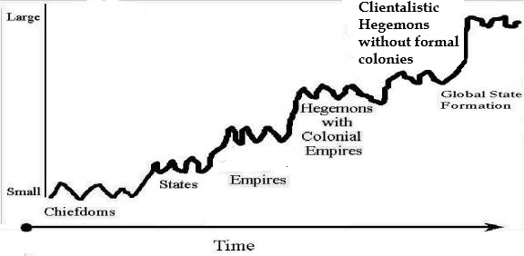
Figure 1: Evolution of Interpolity Hierarchies
Figure 1 is a stylized characterization of what happened in regional systems that became larger and more complex because of population growth, technological, organizational and institutional developments and transformation in the logics of accumulation that eventuated in the global system in which we all now live. The complexity of human polities and of interpolity systems increased and hierarchical structures emerged to regulate these systems, but the processes of hierarchy formation were uneven and cyclical. They did not happen in the same way in all regions and some managed to reproduce networked complex hierarchies that lasted for centuries (Kristiansen 2007). Before the rise of the tributary modes of accumulation human polities mobilized social production and distribution primarily by means of consensual moral orders constructed as kinship relations (Wolf 1997) – the kinship modes of accumulation. As polities and interpolity systems got larger and more complex, kinship became hierarchical and institutionalized coercion emerged as the predominant logic of accumulation – the so-called tributary modes (Chase-Dunn and Khutkyy 2017). In most regional systems there were periods in which hierarchies collapsed, interregnums, but these periods varied in length until an old regime revived or a new one emerged to take its place. These were the sequences of rise and fall (Inoue et al 2012). Most have heard about the rise and fall of empires, but the earlier rise and fall of chiefdoms is less well known. There is vast and fascinating anthropological and archaeological literature on “chiefly cycling”, the rise and fall of paramount chiefdoms, that is reviewed by David G. Anderson (1994).
The original world-system perspective (Wallerstein 2011a[1974]; Arrighi 2010 [1994]) focused primarily on the modern system since predominant capitalism emerged in Europe and its colonies to eventually become the global system of today. The comparative evolutionary world-systems theoretical research program (Chase-Dunn and Hall 1997) modified some of the concepts of the original perspective to allow for comparisons of older and smaller systems with more recent and larger ones. The focus was extended to an anthropological framework of comparison to examine systemic interactions within and between polities including transpolity interactions, class formations and the emergence and evolution of core/periphery hierarchies. This includes systemic networks of nomadic hunter-gatherers, the emergence of Mesolithic sedentism based on diversified foraging (Chase-Dunn and Mann 1998), the emergence of horticulture and agriculture, the rise of chiefdoms, Bronze Age states, empires and the sequence of hegemonies in the modern system.
These evolutionary sequences occurred somewhat similarly in regions of Afro-Eurasia that were only weakly connected with one another and in the Americas and Oceania. This degree of parallel evolution implies that there are endogenous processes at work that produce complexity and hierarchy. Causal explanations of these mechanisms should distinguish between the forces that are continuous across all systems large and small (population pressure, environmental degradation, circumscription, technological change, cycles of conflict within and between polities, oscillations of trade expansion and contraction, etc. and forces that emerge with the qualitative evolution of modes of accumulation and core/periphery hierarchies (e.g. interpolity exploitation and semiperipheral development). Models of the causes of complexity and hierarchy should also distinguish between forces that operate within polities and those that operate in networks of interacting polities and posit models of the interactions between within-polity and between-polity causes. Interested scholars should consult Turchin (2009); Turchin and Nefadov (2009); Inoue and Chase-Dunn (2020) and Chase-Dunn and Zhai 2025).
Human sociocultural evolution is the long-term trend in growing size, complexity and hierarchy of institutions, polities and interpolity systemic networks since the emergence of homo sapiens. As settlements and polities got larger, the networks of systemic interaction also spatially expanded. New transportation and communications technologies facilitated consequential connections among more distant peoples, and so local world-systems merged and engulfed one another to become the single global systemic network of today (see Figure 2.
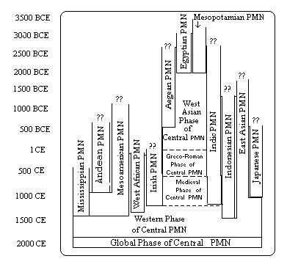
Figure 2: The incorporation of twelve interpolity systems into the Central Political/Military Network (PMN) (Source: Derived from Wilkinson 1987).
Evolution of Empires and the Long Rise of Capitalism
Empires are states that conquer or otherwise control other states and non-state peoples (bands, tribes, chiefdoms). The first was the Bronze Age Akkadian Empire that was formed when a cup-bearing servant of the King of Kish, Sargon of Akkad, led a rebellion of semitic-speaking workers against the Sumerian kings of the Mesopotamian city-states in the 24th century BCE (Taagepera 1978a; Wikipedia “Akkadian Empire”). Empires evolved as the systems in which they operated developed institutions and technologies that facilitated larger trade and larger military interaction networks and longer-distance power projection. Michael Mann (1986) called the latter (power projection) “technologies of power” that enabled some polities to dominate and extract resources from other polities.
Human individuals, families, institutions, social movements, organizations, dynasties, regimes and polities are born, they live, and they die. Rein Taagepera (Taagepera 1978a, 1978b, 1979 and Taagepera and Nemcok 2024) coded the changing territorial sizes of largest empires in world regions since the Bronze Age using maps from historical atlases. Their main measure of polity size is square megameters of territory over which a polity exerts an important degree of control. Taagepera and Nemcok’s (2024) quantitative analysis of growth/decline curves allows them to make several useful comparisons regarding differences between these curves.
Empires got bigger and fewer over time. They varied in terms of size and longevity. Those that came up quickly did not usually stay up long (Taagepera 1978a). Thomas Barfield’s (2023) comparative study of thirty AfroEurasian empires since the Iron Age compares patterns of rise and demise, strategies and organizational structures with strong attention to interactions in world regions. Barfield developed a useful distinction between Endogenous and Shadow empires and a typology of seven kinds of Shadow empires. Endogenous empires mainly extracted resources (labor, crops, manufactured goods and taxes) from their own populations, whereas large polities that extracted resources from these Endogenous Empires are called Shadow Empires. Barfield also noted that those Shadow Empires that emerged from the non-core and were able to transition into Endogenous empires had advantages over those that emerged from core states because they knew more about how things worked from two very different angles, and this allowed them to become larger and to last longer.
Empires slowly commercialized and capitalist city-states emerged in semiperipheral interstices in the Bronze Age in which elites increasingly gained their wealth as profits instead of taxes and tribute. The city-states that focused on trade were the first states in which the ruling groups were mainly capitalists. In the Iron Age large maritime empires emerged (Athens and Carthage) that combined conquest and trade as strategies for accumulation. This evolutionary trend in which large empires increasingly adopted commodified forms of production and exchange, and capitalist city-states were agents of market expansion eventuated in the emergence in Europe of a world-system in which capitalism and capitalist states became the main actors and the predominant logic of accumulation became capitalist geopolitics (Wallerstein 2011b [1974]; Chase-Dunn and Lerro 2016: Chapter 10). This was the rise of the West, the first capitalist world-system. The evolution of interpolity hierarchies (imperialism) is depicted in Figure 3.
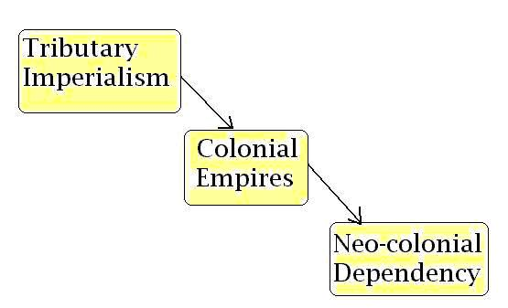
Figure 3: The evolution of imperialism
Figure 3 depicts evolutionary changes in the forms of imperialism. The early empires militarily conquered adjacent polities that had desirable resources. They raided and plundered but soon developed political institutions that allowed them to extract yearly tributes. Colonial empires combined force with diplomacy and trade to establish distant settlements that facilitated transportation, extraction and commerce. Some of these were trading city-states in the interstices between tributary empires (Dilmun, Old Assur, Phoenician cities, Cozumel (Sabloff and Rathje 1975) etc.). Others were larger maritime empires (e.g. Athenian, Carthaginian, Srivijaya ).
Perry Anderson’s (2017) historical philology of the hegemony concept traces its evolution and applications both within polities and in interpolity systems. Following Antonio Gramsci, Anderson focusses on the balance that must be maintained in any institutionalized hierarchy between coercion and consent. Most other international relations scholars who use Gramsci’s concept of hegemony imply that he (Gramsci) had developed the concept in his analysis of within-polity class struggles in Fascist Italy (e.g.. Robert Cox (1983). But Lorenzo Fusaro (2010; 2020) based on his reading of the new critical edition of the Prison Notebooks (Gramsci 2001) contends that Gramsci already had an idea of international hegemony and Fusaro compares and reformulates the usages of Gramscian hegemony developed by Giovanni Arrighi (2010[1994] and Robert Cox (1983).
The term hegemony is not equivalent to that of empire because a powerful state can exercise influence and forms of control even if it has not conquered and colonized other states. And a state that has a formal colonial empire can be the hegemon of a whole world-system and project influence and power beyond the boundaries of its colonies. Interpolity hegemony is a power relationship between a single hegemon and other core states as well as non-core states and peoples that are in the same whole world-system.
Waves of Modern Colonialism and Decolonization
Formal colonialism was abolished in two large decolonization waves (see Figure 3 below). But neocolonial institutions were developed that continued to allow core states to control and extract resources from less powerful non-core states. Dependence on foreign investment and control by means of indebtedness and foreign aid have been combined with covert operations and intermittent military invasions to maintain interpolity power differences and to facilitate extraction and unequal exchange.
Decolonization converted the colonies into theoretically sovereign states but did not end core/periphery inequalities. Neocolonial forms of control and exploitation enabled powerful core states to keep getting raw materials and cheap labor from the non-core. But it was a step toward greater reliance on consent than on coercion and in the direction of a possible future world welfare state that would coordinate efforts to solve global problems on an Earth-wide scale.
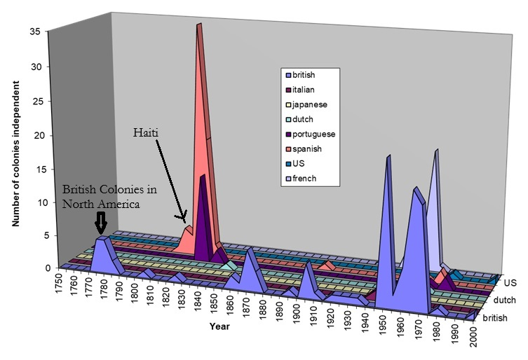
Figure 4: Waves of Decolonization 1750 -2000 CE Number of colonies decolonized {Source: Henige (1970) updated to 2000}
Figure 4 uses David Henige’s lists of colonial governors to show the two waves of decolonization since 1750 CE that eventually produced a global system of theoretically sovereign nation-states (see also Bergesen and Schoenberg 1980).
The Functions of Hierarchies
The evolution of hierarchies both within polities and in world-systems happened because of a mix of the functional causes of hierarchy-formation and conflict processes of exploitation and domination. The functionalist approach to the rise of states was formulated by Elman Service (1975) who contended that states grew out of chiefdoms because the stabilization of order required a peaceful, institutionalized way for power to pass from one ruler to another. Primo-geniture created an aristocracy, and thus the transition to class society was due to the need of society to preserve authority and order. The benefits to commoners included protection from outsiders, peaceful conflict resolution at home, the operation of a redistributive system which could overcome temporary and local shortages, and the mobilizing of resources needed for large-scale projects. And the accumulation of surplus product allowed rulers to devote time and resources to the invention of the arts of civilization. Hierarchies often rise following collapses when elites and masses get tired of squabbling with one another and acquiesce to the emergence of a new regime that promises peace and prosperity or when a powerful external polity conquers and establishes a new regime. The application of functional explanations to interpolity hierarchies was made explicit in the power cycle theoretical research program regarding “modern industrial polities” (Modelski and Thompson 1996) and in the international relations literature on “hegemonic stability theory” (Kindleberger 1973; Nye 2017). The argument is that the empire or the hegemon is a system leader that produces and distributes public goods that reduces conflict by providing an ideological and institutional “world order.”
Inequality Overshoot
One problem with these theories is that they suggest reasons why hierarchies might emerge but have little to say about why they decline. It is possible to combine the functional and conflict theories in ways that can explain both rise and demise. The functional theory implies that there is an optimal level of inequality that provides benefits to the non-elites as well as to the elites, but that most hierarchies go beyond this optimal level as they get older – inequality overshoot (Chase-Dunn, and Inoue 2024). Conflict theories focus on the interests of elites in maintaining their privileges, power and wealth. State collapses occurred when population growth exceeded productive capacity, elites expanded, and inequalities got too large. Masses rebelled and contending elites fought with one another for control. And after a period of conflict a new regime emerged either because an elite faction could get enough support because the masses were tired of strife or the weakened old polity was conquered by a semiperipheral marcher state.
The within-polity process has been theorized by the Goldstone (1991) and in Turchin and Nefadov (2009) structural demographic secular cycle model. Overshoot is also part of the reason that social movements demanding greater equality keep reemerging throughout human history. But hierarchies continue to reemerge after collapses because of the functional needs of complex polities for regulation. And political institutions emerged that involved less violence and that allowed some popular say over the processes of regime change. Despite continuing chaos, genocides and injustices, this has been a process of political evolution. And after a period of conflict a new regime emerged either because an elite faction could get enough support because the masses were tired of strife or the weakened old polity was conquered by a semiperipheral marcher state.
The interpolity aspect of rise and fall was first theorized by Ibn-Khaldun’s (2015 [1337) theory of nomad/sedentary interactions. An expanding empire eventually hit a wall beyond which further expansion was too costly. The returns to conquest and economic exploitation declined and the costs of providing public goods grew to become greater than the returns. The empire or the hegemon went down. But a new rise eventually happened for reasons like those that operated within polities. Political instability grew when an old paramount empire was no longer able to provide enough public goods. Contenders for system-wide power employed warfare and this eventually became tiresome. Eventually a winner emerged and formed a new paramount empire or hegemon. But the cycle is also a sequence in which whole systems got larger, more complex and more hierarchical and the institutional nature of power evolved. This evolution is illustrated in Figures 1 and 3 above.
In the transition from colonial empires to clientelist hegemony formal colonial controls were replaced by neocolonial mechanisms that continued to allow the core to exploit and dominate the non-core. The modern capitalist hegemons (Dutch/British/U.S.) got larger with respect to the size of the system and capitalism itself evolved in what Giovanni Arrighi (2006a: Figure 10.1,p.206) called “systemic cycles of accumulation” led by rising capitalist hegemons that successively expand and deepen by internalizing protection, production and transaction costs. The U.S. hegemony is called a hegemony because was not mainly a colonial empire. And it is not one because of its own history, a “new nation” that decolonized.
The Rise of U.S. Hegemony
The modern capitalist hegemons include:
- an alliance between Genoa and Portugal in the 15th century (Arrighi 2010),
- the Dutch hegemony in the 17th century,
- the British hegemony in the 19th century, and
- the U.S. hegemony in the 20th and 21st centuries (Wallerstein 1984).
The history of the rise of the United States of America is both similar in some ways to the rises of earlier empires and hegemonies and different. To sort this out we need to notice that all nation-states claim some version of what has been called exceptionalism. This is part of all ideologies about national identities and the relevant audiences are both internal and external. The U.S. is no exception to ideological exceptionalism. But to separate myth from fact comparisons with earlier interpolity power structures are necessary. While all the modern hegemons and many of the earlier paramount empires had, before their ascensions, been in non-core positions within their world-systems, the U.S. is unique because it rose in a place that was outside the Europe-centered modern system, became a set of colonies in the periphery, and then rose to the semiperiphery, and then to the core and then to the position of hegemon. This degree of upward mobility is much greater than most of the earlier empires and all the prior modern hegemonies. World Revolutions are constellations of revolts and rebellions that break out periodically in distant parts of world-systems and that challenge local and intercontinental power structures (Arrighi, Hopkins and Wallerstein 1989; Chase-Dunn and Almeida 2020). That first blue bump in Figure 4 (above) was the kickoff to the World Revolution of 1789 in which a radical idea from the French Revolution (popular sovereignty) spread to the British and French colonies and then to the Spanish colonies in the Americas. The fact that the U.S. was itself a rebel against colonial imperialism, the “first new nation,” was important for the way in which it eventually constructed its hegemony in the 20th century.
The 1804 Haitian Revolution is hidden behind the rise of Spanish decolonizations, that big rose-colored spurt in Figure 4. Haiti was a slave revolt that produced the second new nation. Toussaint Louverture, an early leader of the Haitian rebellion against France, was a freed former slave who had served in the French Army in Savannah helping the United Statesians gain independence. The big rose spurt was the Bolivarian decolonization wave in Latin America and Simon Bolivar himself was given sanctuary in Haiti during that struggle. Napoleon sold Louisiana to the U.S. after he failed to retake Haiti, and the fledgling United States managed to prevent the British from retaking their colonies in 1812 after the defeat of Napoleon.
After the Napoleonic Wars in which Britain finally defeated its main competitor, France, supra-national political institutions began to emerge over the top of the international system of national states. The first proto-world-government was the Concert of Europe, a fragile flower that wilted when its main proponents, Britain and the Austro-Hungarian Empire, fell out about how to handle the World Revolution of 1848, especially the issue of Italian nationalism. The Concert was followed by the League of Nations and then by the United Nations and the Bretton Woods international financial institutions (The World Bank, the International Monetary Fund and eventually the World Trade Organization).
Political independence was the first step up the food chain that is the core/periphery hierarchy, but most of the other decolonized countries in the Americas remained in the periphery of the modern system. The alliance between the Southern colonies and the Northern ones in the U.S. was always complicated by the rather different ways in which they related to the European core. The South was a producer of raw materials using slave labor on large plantations. The North, especially New England, was trying to insert itself into the division of labor at a higher level, shipbuilding and carrying trades. These differences grew after the textile industry and other manufactures (core capitalist production) expanded in the North during the period in which imports were interrupted by the Napoleonic wars. After the wars the North wanted to follow the plan laid out in Alexander Hamilton’s (2017 [1827]) Report on the Subject of Manufactures which proposed a roadmap for the U.S. to become a core capitalist power that would compete with the Europeans. This would require a national bank, a strong currency, a road and canal system linking the ports with the inland agricultural districts inland, and tariffs to protect “infant industries” – manufacturing start-ups.
Tariff Politics and the Core/Periphery Hierarchy
Tariff policies and politics are useful windows into positions in the core/periphery hierarchy because successful core states who have comparative advantages in high wage, high technology production generally want free trade and peripheral producers of raw materials that use cheap labor also want free trade, but semiperipheral countries that desire to move up the food chain need to protect their domestic markets with tariffs so that their start-up industries do not get smothered by imports (Chase-Dunn 1980). The U.S. was a rising semiperiphery that combined peripheral exports of raw materials with an expanding core capitalist sector of manufactured goods from 1816 to 1880 when its status as a core power became cemented. The Southerners did not want tariffs because they were exporting their products to Europe. The Nullification Crisis of 1832 occurred when South Carolina declared that the Federal tariffs of 1828 and 1832 had no force in South Carolina. A compromise was reached but the issue of states rights was again to play a role in the coming of the Civil War. The U.S. Civil War was a fight between the North and South over two very different developmental paths. The South wanted to continue with slavery and the export of agricultural raw materials. The north wanted to use the powers of the federal government to support the development of industry and transportation, and tariffs continued to be an important issue. The South was willing to stay with the Union as long as it could maintain powerful influence in the federal government, but when Lincoln won the presidency and Kansas became a free state those days were over.
The outcome of the Civil War was not preordained. If France or England had supported the South or if things had gone differently at Gettysburg the South might have gained independence and there would have been two states instead of one (Ransom 2005). In almost every Latin American country that gained independence from Spain there was a civil war after independence between the same kinds of factions that emerged in the U.S., except that in Latin America the internal “South”, the latifundistas, won those wars.
But the North won in the U.S. and by the 1880s it had risen to the core, and, after the Spanish American war of 1898, it had joined the other core states (“great powers”) of the now-global world-system. U.S. tariff politics continued with protectionism, especially during the McKinley presidency (McCoy 2025), and again in the 1930s. Free trade was not fully embraced until after World War II. The rapprochement with the British in the 1880s was led by New York bankers who were facilitating British investments into the U.S from London and so the U.S. entered World War I in time to save England from the Axis powers. President Wilson was a mainstay of support for the League of Nations, but the isolationists in the Senate were still hearing George Washington’s America First advice against “entangling alliances” and so the U.S. never joined the League.
The World Revolution of 1917 included the Bolshevik revolution, but also the Chinese and Mexican revolutions, the 1916 Arab and Irish revolts and the further rise of socialist and communist challenges to the capitalist regimes of private ownership of the major means of production. In the U.S. the anarcho-syndicalist Industrial Workers of the World led a general strike in Seattle in 1919 to support locked-out shipyard workers and to protest the U.S. Navy sending supplies to the White Russians. In the early 1930s the U.S. Communist Party had three million members and in 1934 the West Coast International Longshoreman’s Association, led by Harry Bridges, organized the San Francisco General Strike. This rising challenge to the rule of capital was a major factor behind the rise of the New Deal in the U.S. as well as labor parties and welfare states in Europe and the Global South as capitalists and politicians came to realize that a class compromise had become necessary (Hobsbawm 1994).
In World War II the United States-led coalition (which included the Soviet Union) defeated both Germany and Japan and the U.S. sealed the deal by obliterating two large Japanese cities, Hiroshima and Nagasaki, with atomic bombs. The U.S. now stepped forth to take up the political role of hegemon by strongly supporting the establishment of multilateral institutions that were designed to stabilize the world economy (the World Bank, the International Monetary Fund) and the international system of states (the United Nations). The U.S. also strongly supported free trade, the Marshal Plan helped rebuild the war-shattered economies of Europe and substantial aid (grants and credits) were made to China, Japan, India, Indonesia, South Korea, Pakistan, Israel and the Philippines. U.S transcontinental military power was built by supporting the “independence” of the colonies of European powers in exchange for trade and investment openness and treaties establishing U.S military bases (Go 2011). Thus U.S. hegemony emerged by replacing formal colonialism with alliances in which client states retained formal sovereignty and the U.S. only invaded militarily when soft power or covert interventions failed to provide cooperative regimes. Military interventions occurred, but they were temporary. And the multilateral institutions that the U.S. sponsored included protections for sovereign nation-states in their constitutions. This model had been perfected in the continental expansion of the U.S. in which conquered territories would become states with powerful representation in the federal government once certain requirements were met (Go 2011).
This clientelist form of “non-empire” is still an empire, but compared with earlier empires it is less exploitative and relatively more dependent on consent than on coercion. Giovanni Arrighi (2006b,2010) noted this in his comparisons between the British Empire and the U.S. hegemony.
When profits and taxes from their colonies declined or when they needed resources to deal with other problems the British could still raise taxes and conscript colonial soldiers. A clientelist empire does not have these fallbacks.
U.S. Peak and Decline
Military Keynesianism rose during the Korean War after a short period in which the U.S. federal military budget had returned to a peacetime level after World War II. The military/industrial complex became an important mainstay of private capital accumulation in the U.S. and an important force in U.S. foreign policy, which helps explain the heavy involvement of the U.S. in proxy wars abroad. These are great opportunities for weapons testing and for demonstrating equipment that is then sold to allied states across the globe. But these episodes of imperial overreach are both signs of decline embarrassing causes of it, especially when the wars are lost. The employment of brutal torture in Afghanistan was an abandonment of the civilizational moral high ground and, like Israeli genocide in Gaza, generated blowback (Johnson 2004) on a massive scale.
The peak of U.S. shares of both military and economic power was at the end of World War II when the other “great powers” had been destroyed by the war (Chase-Dunn and Zhai 2025: Figures 4 and 10; Figure 5 below). But by the 1970’s U.S. predominance in manufacturing was matched by the recovery of Germany and Japan (Brenner 2002) and the profit rate went down. The response to this and to the student-led World Revolution of 1968, was the rise of Reaganism/Thatcherism – the neoliberal globalization project that involved the export of manufacturing jobs, attacks on labor unions and welfare reforms, privatization and deregulation, culture wars and financialization.
Measuring Global Power
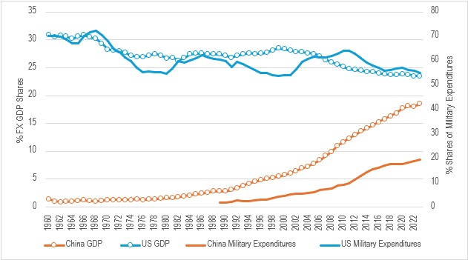
Figure 5: Best Military and Economic Shares Indicators for the U.S. and China: Military Expenditure Shares (1960 constant cases) 1960-2023 and GDP FX shares 1960- 2023 (Sources: World Development Indicators Updated: 11/13/2024 :GDP (constant 2015 US$)(NY.GDP.MKTP.KD); SIPRI
https://www.sipri.org/databases/milex

Figure 5 shows that the U.S. is going down in both military and economic power shares and China is coming up. Not surprisingly China is closer to closing the gap in relative economic size than it is in closing the gap in military power. The implication of this is that if these trajectories continue the gaps will continue to decrease and there will be crossing points sometime in the future. Most of the power transition theories proposed by international relations theorists see the years near crossing points as high-risk periods regarding the likelihood of violent conflict.
The Nixon/Kissinger visit to the Peoples Republic of China (P.R.C.) in 1972 and the later reforms of the Deng Xiaoping regime enabled an acceleration of a geographical Eastward shift of the material aspects of capitalist accumulation that had started with the post-War recovery of Japan and the industrialization of South Korea and Taiwan. This eventually led to the rise in the P.R.C.’s shares of global economic and military power (Figure 5 above and Chase-Dunn and Zhai 2025: Figures 7-11).
The holdings of U.S. Treasury Bonds by the Peoples’ Republic of China expanded hugely from 2000 CE to 2012, plateaued and then has been declining since 2017 (U.S. Department of the Treasury 2025) as the U.S. has shifted from treating China as an allied client to a rival for global power. The U.S. dollar is still the main medium of global trade and the most important reserve currency, but challenges to that status have been voiced by powerful players in world politics and the rise of crypto-currencies, with apparent support from the Trump 2.0 regime, is injecting an expanded fog of unknown unknowns into the efforts of investors and states to maintain the value of their fluid wealth. The BRICS countries voiced dedollarization ideas but have backed off, probably because their leaders are themselves dependent on U.S. dollar reserves (Bond 2020, Chase-Dunn and Erin 2025). The efforts of the Trump 2.0 regime to further privatize institutions, terrorize immigrants, and to rebalance U.S. trade and balance of payments deficits by threatening protectionist tariffs are accelerating the demise of U.S. intercontinental power based on clientelism.
International relations political scientists and foreign policy analysts have developed quantitative measures of the distributions of different dimensions of global power and computational models of future trajectories of shares of global power among contending states. This literature is reviewed and updated in Chase-Dunn and Zhai 2025. The main conclusions have been described above.
The Pardee Center for International Futures at the University of Denver (Moyer and Markle 2018; Moyer et al 2024) has developed a Global Power Index (GPI) that estimates relative shares of military, demographic, economic and energy variables, Research and Development spending, “Information Communication on Technology” (ICT), capital stocks, foreign aid, embassies, memberships in International Governmental Organizations (IGOs), treaties signed and ratified, and estimations of diplomatic power shares. The weighting schemes used for the components of the GPI vary across six time periods (1816-1944. 1945-1959, 1960-1972, 1973-1989- 1990-2004 and 2005-2019 (see Table 1 in Moyer et al 2024) to take changes in technology into account. The political power components of the indices developed by the Pardee Center (diplomatic power, shares of foreign aid, etc.) are potentially very valuable but results that could show how their different components separately have changed over time have not yet been published.
Figure 6 is used with permission from the Pardee Center. It shows the historical and predicted estimates of the Pardee Center’s Global Power Index (GPI) from 1816 to 2050.

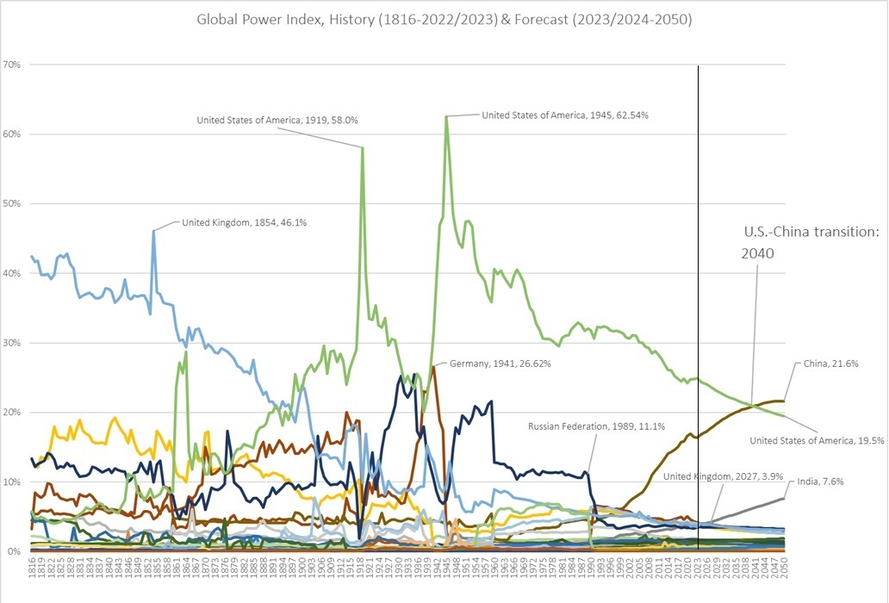
Figure 6: Pardee Global Power Index (1816-2023CE) and forecast to 2050 CE (Source: Moyer et al 2024)
The graph of the Pardee GPI composite index shows results that are similar to the general story told by our studies of different dimensions of international power shares in Chase-Dunn and Zhai (2025). But what is added are the results of a computational model that projects from 2024 to 2050. The vertical line in Figure 5, which we have added, shows where the historical estimates stopped, and the computed estimates began. The model predicts a continued U.S. decline at about the same rate as it has been since 1990 and a continuing rise of China, but at somewhat decreasing rate, with these two countries crossing in 2040. The P.R.C. GDP growth rate has fallen since a peak in 2007 and has gotten quite bumpy in recent years because of problems in overcapacity, a real estate investment collapse and the covid shutdown. All the other countries are predicted to hold steady or to decline a little except for India which is projected to grow to about 8% over the next 25 years.
Democracy and Autocracy Since 1900
The Varieties of Democracy Institute (V-Dem) was founded in 2014 at the Department of Political Science at the University of Gothenburg (Sweden) to study the changing characteristics of national governments. V-Dem produces an annual Democracy Report that codes regimes to study changes over time in the strength of national democratic institutions. The V-Dem coding sorts types of political behavior and regulation into two main categories: democracy (mutual consultation and majority rule) and autocracy (a small elite makes social decisions regardless of the majority). A large panel of experts scores regimes into two levels of democracy, two levels of autocracy, and two “grey zones” of uncertainty and they study how regimes have changed since 1900 using this scheme.
The 2025 Democracy Report (Nord et al 2025) is a fascinating study of the trends of countries and averages of regions and of the world. The codings are done by five experts per country-year observation, using a pool of over 4,200 country experts who provide judgments on concepts and cases (Nord et al 2025:49).
Upward Trend of Democracy Interrupted by Autocracy Recoveries
Figure 7 shows average V-Dem scores for their Electoral Democracy Index for all the countries studied (“World”), which are weighted by their population sizes from 1900 to 2024. It also shows the scores for the U.S., China and India because we are studying the U.S. hegemonic decline and India and China because the quantitative studies of economic and military power reviewed above show that these are they only countries that are converging on the declining U.S. power shares. 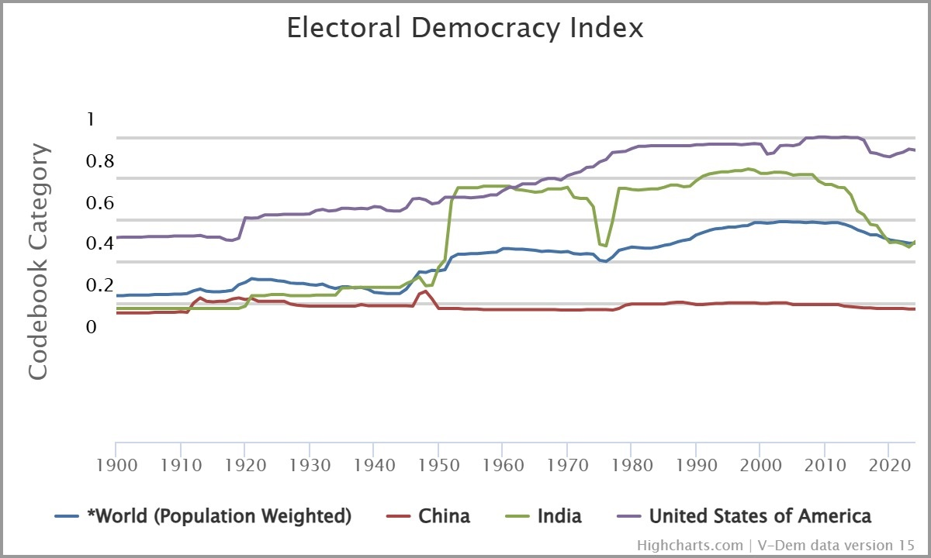
Figure 7: V-Dem Electoral Democracy Index for World, China, India and the United States Source: Coppedge et al 2025).
The weighted World scores in Figure 6 are on the blue line. This shows a general upward trend with three waves of democratization and three periods in which democratization declined and autocratization increased (from 1921 to 1944; a drop from 1960 to 1975 and another drop from 2012 to 2024. The V-Dem 2025 Report focuses on this most recent “Democratic Backslide” but the two earlier backslides were followed by returns of the upward trend toward electoral democracy and the overall trend upward was interrupted twice by downturns in which autocratic regimes gained ground but that were turned back toward democratization after 23 years and 15 years.
The 1921-1944 democratic backslide was part of the World Revolution of 1917 [Hobsbawm’s (1994) Age of Extremes], in which right-wing populist movements attacked the Left with the backing of powerful landowners and capitalists and established fascist and autocratic regimes in Germany, Italy and other European and Latin American countries and in Japan.
The V-Dem Electoral Democracy Index (Figure 7) shows that the world democratic backslide since 2012 has returned to levels like those of 1985. Figure 7 also shows the Electoral Democratic Index for China, India and the United States. China (the red line) has always been lower than the world average and has not changed much since 1900. India (the green line) was down near China before decolonization but then experienced a huge jump up in 1949 to become slightly more democratic than the United States for a few years, then a dip from 1970 to 1978, a recovery and then another dip starting in 2008 and a small recovery in 2023 (Tudor 2023). The United States (the purple line) was always higher than the world average and both India and China, except for a short period in the 1950s when India was more democratic according to the V-Dem Index. The U.S. had a sharp increase from 1918 to 1920 and then a gentle rise until a high point in 1981, a little dip from 2000 to 2007, and then a highest level until 2016 and then a drop to 2020 and a slight recovery until 2024 (see Nord et al 2025: 46-47 Box 9: “U.S.A: A Democratic Breakdown in the Making?”)
Whether or not the Trump 2.0 regime succeeds in significantly moving the U.S. down the road to autocracy, it is definitely accelerating U.S. hegemonic decline by threatening the web of clientelist alliances that has constituted the main basis of U.S. hegemony (McCoy 2018:232; 2025) The embrace of trade tariff protectionism ironically has handed an important universalistic ideology to the P.R.C., now a staunch defender of global free trade. And the insulting treatment of European and North American allies is also providing the P.R.C with opportunities for strengthening alliances in these regions (Abril 2025).
Short-Run, Middle-Run and Long-run Futures
Evolutionary theory is based on tracking changes in sociocultural evolution over long periods. But when we study history, we see that short-run and middle-run predictions are very difficult because erratic conjunctures of events and processes often happen that disrupt trajectories of change. It is easier to predict structural trends in the long-run future if we do not need to be very precise about exactly when they will happen. The most obvious long-run prediction that is implied by our evolutionary study of hierarchies is that eventually an Earth-wide state will emerge. But we do not know when. Now we are entering an interregnum in the long-term trajectory of increasing size and decreasing number of states because the old hegemon is going down and new challengers are rising, and we are well into a set of climate change calamities produced by industrialization. But how long will the interregnum last before the long-term upward trend resumes? Obviously that depends on things like whether or not there is another hot war among powerful states and when that happens if it does happen, and which states are the main combatants and how destructive and lethal the wars are, and whether one side is victorious or both sides are decimated, and how the timing of the war is related the occurrence of the onrushing disasters that are likely to be brought about by climate change. The evolutionary perspective allows us to be somewhat optimistic if enough of humanity survives these calamities to begin again.
Short-Run Futures
By short run futures we mean configurations that are likely to emerge in the next twenty-five years – from 2025 to 2050. Although there are important similarities between the late 19th century and early 20th century decline of the British hegemony with what is happening with U.S. decline, there are also important differences. The similarities are the approach of a multipolar configuration of power among the most powerful states, a configuration that, in the past, has led to interimperial rivalries and hot wars among the great powers. An important difference is between an interstate system that is configured as a set of sovereign nation-states rather than as a set of colonial empires, a more developed set of multilateral governmental institutions, a more globalized structure of production and class relations, hugely increased long-distance transportation and communications infrastructure, the evolution of military technology to include much more lethal and destructive weapons and the expansion of the arenas of power projection that have added airpower, space power and cyberwarfare to the older land and sea power theatres. The answer to the question about the future of great power war is likely to be influenced by all these differences.
Inflexion Points and Great Power War
Heim and Miller (2020) used a modified version of the Pardee Global Power Index (GPI) to model future changes in the relative distribution of power using a base-line model that does not include international conflict to examine what differences population explosion, a lost decade of Chinese economic growth, or different degrees and speed of onset of global warming would make for the relative power shares of national-states. The also employed Charles Doran’s (2012) version of power transition theory to try to predict when the risk of war between the U.S. and the P.R.C. would be highest. All the models of power transition imply that when a rising power gets close to, or passes, the relative power of the old hegemon the risk of war is high. But Doran’s version sees other inflection points when the rates of change increase or decrease. This produces confusion and uncertainty and makes it difficult for decision-makers to be clear about what is happening. And Doran contends that when several of the great powers (core states) go through inflection points in the same short period the risk of warfare is higher. The most obvious inflexion point in Figure 6 above is around 2040 when China’s GPI score is likely to pass the U.S. But when we track economic and military power shares separately, as in Figure 5 above, we can see that it will probably take China longer to catch up with the U.S. military share level than the U.S. economic power share level. The risk of war is probably more influenced by military inflection points, and this implies that the dangerous period might not arrive until the 2050s. The uneven onset of global warming and climate change disasters will probably alter the probabilities regarding which configurations of global power emerge in the next several decades. The Heim and Miller model of the Global Power Index tried different levels of temperature increase and models of which regions are likely to be affected the most. The global warming scenarios show that China will see a significant increase in global power relative to the baseline model, Russia will see a slight gain and the U.S. and India will experience moderate declines (Heim and Miller 2020: Figure 19, p. 20; Figure 21, p. 21).
William R. Thompson’s 2022 book on the decline of U.S. systemic leadership uses the power cycle theoretical research program that he developed with George Modelski to update their estimates of shares of long-distance military power projection (see also Lee and Modelski 2018) and to ponder the short-run future of the global power system. Thompson thinks that the avoidance of the use of weapons of mass destruction that has worked to prevent wars among the great powers since World War II will hold in the next few decades because a war that uses these would likely be disastrous for all sides of the conflict and for large numbers of others not directly involved (but see Goddard and Larkin 2025). So far, the Russia/Ukraine war seems to encourage this position. But Thompson also notes that the situation of mutually assured mass destruction has been, and still is, vulnerable to accidents and miscommunications of the kind that nearly led to nuclear war several times during the Cold War between the U.S. and the Soviet Union. We agree with Thompson that even with growing interimperial rivalry between China and the U.S. and concurrent hot wars in Eastern Europe and the Middle East the likelihood is that there will not be a war among great powers in which weapons of mass destruction are used because decision-makers believe that such a war is unwinnable and would be devastating for both sides. But we also note what Thompson said about accidents and miscommunication during periods of stress. Another world war is not likely but could happen. If it does it would probably not kill all the humans and so sociocultural evolution would start back up again.
Power Configurations: G2 Bipolarity. Tripolarity or Multipolarity?
Thompson thinks that the most likely next power configuration will be bipolarity between a regional system in East Asia with China as the regional hegemon and in the Americas with the U.S. world hegemony reduced to a regional hegemony. He calls this “G2”. Thompson contends that the U.S. decline in global power shares will likely cease at about 25%, down from its post-World War II peak, but will probably stabilize at around that point. And that the U.S. will establish a secure regional hegemony that it can afford to defend and provide for. We agree that this bipolar G-2 configuration of global power is probably the most likely power configuration for the next several decades. This would be bipolar but the difference between the U.S. and the Chinese shares of global power would probably be smaller than the difference between the U.S. and Soviet shares were during the Cold War (see Figure 6 above). And there could be other regional hegemonies centered on Europe, Russia, Brazil, India or South Africa during the period of multicentricity. Depending on the relative power sizes of these, the coming power configuration could be bipolar, tripolar or multipolar.
A Chinese World Hegemony?
Another possibility for the next few decades is the rise of China to Earth-wide hegemony.
This could occur if the P.R.C or a succeeding Chinese regime is able manage the problems of overaccumulation and environmental destruction that its form of autocratic capitalism has produced and if China succeeds in its efforts to move up the production chain and to further grow domestic demand and to surge ahead in military and information technology. As mentioned above China has new opportunities for strengthening alliances in Europe and elsewhere because of Trump’s America Firstism, but these could be reduced if a succeeding U.S. regime to Trumpism tries to restore the Atlantic alliance and repair the other rifts that Trump’s Firstism has created.
China is already moving toward projecting a more universalistic ideology that has appeal beyond its own borders. Hegemony requires consent as well as payoffs and coercion. A universalistic hegemonic ideology must be able to legitimate authority in both domestic and international audiences. The shift from Maoism to Confucianism (Wang and Nahm 2019) was ok for the Chinese middle class but did not find much appeal abroad. But the P.R.C. has adopted and promoted the philosophy of “ecological civilization” (Harrel 2023, Wikipedia (n.d.-b) ), which is a big improvement over Confucianism regarding its global appeal. In order convincingly embrace the goals of ecological civilization however, China would need to more consistently and thoroughly lead the way toward a carbon zero world economy by using its capabilities to support and carry-out a global energy transition and by abandoning projects that protect natural resources within China by extracting them from other countries in the Global South (Schwartzman 2005).
Another Round of U.S. World Hegemony?
Another round of U.S. hegemony is not impossible. The Modelski/Thompson power cycle model has two rounds of British leadership -- one in the eighteenth century and one in the 19th century. But for this to happen the U.S. would need to mobilize a return to its former centrality in the production of profitable material exports and this seems unlikely because Wall Street is quite happy with the profits to be had from investing globally and the expansion of profitable opportunities produced by privatization and accumulation by dispossession grabs that rely on control of federal and state governments at home and abroad. The U.S. federal government had been developing a technical capacity for planning and industrial policy before the rise of the neoliberal globalization project in the 1980s but that capacity was decimated by decades of privatization, deregulation, financialization and letting the big corporations do the planning. The Trump 2.0 regime is blaming the deindustrialization that resulted from the rise of the Washington Consensus on the Democrats, but Republicans and Wall Street also supported the neoliberal globalization project as a solution to the declining rate of profit in manufacturing that came along when German and Japanese manufacturing caught up with the U.S. in the 1970s (Brenner 2002).
The Trump effort to Make America Great Again by engaging in tariff wars with trade partners is unlikely to succeed because it does not appear to be directed with any awareness of the actual comparative advantages that the U.S. still has or could soon develop. Mobilizing political support from workers who lost their high wage jobs with the promise that they will soon get new highly paid jobs in industries that have been robotized is cruel cover for another tax break for the oligarchs. The United States could become an exporter of high technology products involving nanotechnology, biotechnology and robots, but to do this would involve investing in higher education and workforce training. The Trump regime’s attack on the federal government, institutions of higher learning and scientific research is not going to make America Great. The U.S. decline trajectory will likely be gradual, as was Britain’s, but longer because it started from a higher point in terms of systemic shares. Trumpism is dismantling the Atlantic alliance and raising tariffs on almost all the U.S.’s trade partners in the hope that these countries will invest in production within the U.S. to avoid the tariffs. This is not likely to work. America Firstism also does not bode well for Thompson’s idea that the U.S. will become a regional hegemon because the immediate neighbors are also under attack and are responding with their own projects of national autarky. Firstism is contagious just like it was in the 1930s.
Middle and Long Run Futures
The U.S. hegemony has been an important instance in the evolution of interpolity hierarchies in several respects. The territorial size of the U.S. federal state is much larger than that of earlier capitalist hegemons. The geographical reach of U.S. economic and military power has been much greater, especially with the rise of communications and military global satellite networks. Internally the U.S. federal structure, with considerable control residing within states, counties, municipalities and local school boards, produced a less primate city size distribution and an institutional separation of economic and political power (New York and Washington, DC) and a less primate size and power distribution of cities within and between states. St. Lous could not prevent the rise of Chicago and Chicago could not prevent the rise of Minneapolis. The U.S. was not the first federal state but it elaborated and instituted federalism to a greater degree than earlier federal states had.
But the main institutional feature of the U.S. hegemony that demonstrates its evolutionary character was the substitution of clientelist empire for colonial empire. This allowed a greater degree of flexibility for non-core states and their people. It is possible to ignore the will of the hegemon, though it may be costly. This also raises the costs of this form of empire. The size of the U.S. relative to the size of the whole system slows down the rate of decline, but the cliental institutional structure speeds it up because the costs of the provision of public goods are greater than in colonial empires. The transition from colonial to cliental empires was a step in the direction of a global welfare state that would be committed to, and capable of, implementing solutions to those problems that need addressing on the Earth-wide level.
The Trump 2.0 administration in the U.S. advertises the costs of global hegemony in a situation in which the U.S. is no longer the epicenter of material production and the U.S. trade and payments have become very unbalanced. But the Trump regime does not seem to have a coherent policy of incentivizing investments in the kinds of production in which the U.S still has a comparative advantage. Bringing back some steel and automobile production is just a political ploy to gain more MAGA worker enthusiasm. Trump’s notion that tariff walls will motivate investments to flow into to the U.S. probably underestimates the power of the economic nationalism that his policies engender in its former allies abroad.
The resistance in the U.S. against Trumpism needs to understand the contradictions of the U.S. hegemony that produced Trump and to implement a project that takes better care of its workers and citizens while it also has a less manipulative and coercive relationship with its allies and trade partners. The U.S. still has comparative advantages that can allow it to produce things that are useful and profitable both at home and abroad. It does not have to be the hegemon of the world to do these things. The decline of U.S. hegemony is an opportunity for the people of the U.S. and the peoples of Earth if it is used to build a more sustainable and zero carbon economy in North America and to help this happen in the rest of the world. Social movements of young people and progressive forces in both the Global North and the Global South in the current world revolution can be the agents of this alternative to a system that is now driven by the forces of war, capitalist accumulation and destruction of the natural world. Social movements of young people and progressive forces in both the Global North and the Global South in the current world revolution can be the agents of this alternative to the current system that is driven by the forces of war, capitalist accumulation and destruction of the natural world. And the existing multilateral supranational governance institutions could be reformed to be more democratic and less under the thumb of the U.S. Abolishing the veto in the Security Council in the United Nations and establishing a global people’s parliament to represent populations as well as member states would make the U.N. more democratic. The U.S. has been effectively blocking efforts to abolish the veto, but further decline of U.S. global power might be an opportunity to get that abolition done.
A more desirable structural alternative would be an Earth-wide and democratic welfare state that had powers of taxation that moved resources to where they are needed. Such an institution will probably emerge in the long-run future or maybe in the middle run, but not in the short run. It is important for people to understand that this is a real possibility in the future and to build the kinds of communities and local economies that will be the building blocks of a peaceful and sustainable world society. A democratic world state could also provide global security with far lower costs than the current system of arms races and interimperial rivalry. A denuclearized and demilitarized world could get along quite well with a small military that only has to be strong enough to deal with any organized force that might try it. A global democratic commonwealth with real state powers would help move humanity toward a global culture that is a synthesis of the converging civilizations and national cultures that exist now. This would not be utopia, but it would be a big improvement over the war system of the past and the present.
References
Abril, Guillermo 2025 “Amid Trump’s Turmoil, China Anticipates U.S. Withdrawal and Chance to
Strengthen Ties with Europe” El Pais International. Madrid , March 20.https://english.elpais.com/international/2025-03-30/amid-trumps-turmoil-china-anticipates-us-withdrawal-and-chance-to-strengthen-ties-with-europe.html
AidData/China, n.d.College of William & Mary's Global Research Institute, Williamsburg,
VA.https://www.aiddata.org/ and https://www.aiddata.org/china
Anderson, David G. 1994 The Savannah River Chiefdoms: Political Change in the Late Prehistoric Southeast.
Tuscaloosa, AL: University of Alabama Press.
Arrighi, Giovanni 2006a “Spatial and other ‘fixes’ of historical capitalism” Pp 201-232 in C. Chase-
Dunn and S. Babones (eds.) Global Social Change. Baltimore: Johns Hopkins University Press
______________ 2006b Adam Smith in Beijing. London: Verso
_______________2010 [1994] The Long Twentieth Century. London: Verso.
Arrighi, Giovanni, Terence K. Hopkins, and Immanuel Wallerstein 1989. Antisystemic Movements
London: Verso.
Arrighi, Giovanni and Beverly Silver 1999 Chaos and Governance in the Modern World-System: Comparing
Hegemonic Transitions. Minneapolis: University of Minnesota Press.
Barfield, Thomas J. 2023 Shadow Empires: An Alternative Imperial History Princeton, NJ,
Princeton University Press
Bergesen, Albert and Ronald Schoenberg 1980 "Long waves of colonial expansion and contraction,
1415-1969." In Albert J. Bergesen (ed.), Studies of the Modern World-System, New York:
Academic Press
Bond, Patrick. 2020“Subimperial BRICS Enter the Bolsonaro-Putin-Modi-Xi-Ramaphosa Era,” Pp. 106-139 in (ed.) Vishwas Satgar BRICS And The New American Imperialism: Global Rivalry And Resistance. Johannesburg: Wits University Press.
Brenner, Robert 2002 The Boom and the Bubble: The U.S. in the World Economy. London: Verso.
Chase-Dunn, C. 1980. “The development of core capitalism in the antebellum United States: tariff
politics and class struggle in an upwardly mobile semiperiphery" in Albert J. Bergesen
(ed.) Studies of the Modern World-System. New York: Academic Press. https://irows.ucr.edu/cd/papers/ustariffpol.htm
Chase-Dunn, C. 2024 Review of Tom Barfield’s Shadow Empires. in The Developing Economies
http://doi.org/10.1111/deve.12416
Chase-Dunn C. and Thomas D. Hall, 1998 "World-Systems in North America: Networks, Rise and
Fall and Pulsations of Trade in Stateless Systems," American Indian Culture and Research
Journal 22,1:23-72.
Chase-Dunn. C and Kelly M. Mann 1998 The Wintu and Their Neighbors: A Small World-System in
Northern California, University of Arizona Press
Chase-Dunn, C and Bruce Lerro 2016 Social Change: Globalization from the Stone Age to the
Present. London: Routledge
Chase-Dunn C. and Dmytro Khutkyy 2017 “The Evolution of Geopolitics and
Imperialism in Interpolity Systems” in Peter Bang, C. A. Bayly & Walter
Scheidel (eds. The Oxford Handbook World History of Empire
https://irows.ucr.edu/papers/irows93/irows93.htm
Chase‐Dunn, C., Grimes, P. and Anderson, E.N. 2019 “Cyclical Evolution of the Global Right”
Canadian Review of Sociology/Revue canadienne de sociologie, 56: 529-555. doi:10.1111/cars.12263
Chase-Dunn, C. and Paul Almeida 2020 Global Struggle and Social Change Movements: From Prehistory to
World Revolution in the 21st Century Baltimore: Johns Hopkins University Press.
Chase-Dunn, C and Hiroko Inoue 2024 “Inequalities Within-Polities and in Interpolity Relations
Since the Paleolithic Age” Presented at the American Sociological Association Section on
Political Economy of the World System Roundtables, Sunday August 11, This is IROWS
Working Paper #146 available at https://irows.ucr.edu/articles/irows146/irow146.pdf
Chase-Dunn, C and Sakin Erin 2025“The BRICS+ and the Middle-Run Futures of the Global
System” International Review of Modern Sociology Special Issue on “Crises, Conflicts, and the
Future of the World Capitalist System,”Edited by Berch Berberoglu, Vols 1-2.
Chase-Dunn, C and Hiroko Inoue (eds.) 2025 The Globalization of World-Systems: Time-Mapping
Systemic Boundaries Cham, Switzerland: Springer Nature
Chase-Dunn, C and Emlyn Zhai 2025 The Evolution of Global Governance, U.S. Hegemony and Future
Configurations. https://irows.ucr.edu/papers/irows147/irows147.pdf
Chomsky, Noam and Robert Pollin 2020 Climate Crisis and the Global Green New Deal London: Verso
Coppedge, Michael, John Gerring, Carl Henrik Knutsen, Staffan I. Lindberg, Jan Teorell, David
Altman, Fabio Angiolillo, Michael Bernhard, Agnes Cornell, M. Steven Fish, Linnea Fox,
Lisa Gastaldi, Haakon Gjerlöw, Adam Glynn, Ana Good God, Sandra Grahn, Allen Hicken,
Katrin Kinzelbach, Joshua Krusell, Kyle L. Marquardt, Kelly McMann, Valeriya Mechkova,
Juraj Medzihorsky, Natalia Natsika, Anja Neundorf, Pamela Paxton, Daniel Pemstein, Johannes von Römer, Brigitte Seim, Rachel Sigman, Svend-Erik Skaaning, Jeffrey Staton, Aksel Sundström, Marcus Tannenberg, Eitan Tzelgov, Yi-ting Wang, Felix Wiebrecht, Tore Wig, Steven Wilson, and Daniel Ziblatt. 2025. "V-Dem Country-Year Dataset v15" Varieties of Democracy (V-Dem) Project. https://doi.org/10.23696/vdemds25
Cox, Robert W. 1983 "Gramsci, hegemony and international relations: an essay in
method." Millennium 12.2 :162-175.
Doran, Charles F. 2012 “Power Cycle Theory and the Ascendance of China: Peaceful or Stormy?”
SAIS Review, Volume 32, Number 1, Winter-Spring pp. 73-87 Baltimore: Johns Hopkins
University Press DOI: 10.1353/sais.2012.0016
Diamond, Jared 1999 Guns, Germs and Steel. New York: Norton.
_____________ 2005 Collapse. New York:Viking
Fusaro, Lorenzo 2010 "Gramsci’s concept of hegemony at the national and international level"First Conference of the International Initiative for Promoting Political Economy. Vol. 12.
______________2020 Crises and Hegemonic Transitions Chicago: Haymarket
Geist. Edward, Nathan Beauchamp-Mustafaga, Dahlia Anne Goldfeld, Nina Miller, Shawn Cochran,
Jeff Hagen, David R. Frelinger, Cindy Zheng, William Kim, Elliot Ji and Alexis Dale-
Huang 2024 Denial Without Disaster --Keeping a U.S.-China Conflict over Taiwan Under the Nuclear
Threshold: Vol. 4, Imagining Escalation Pathways to Chinese Nuclear First Use Via Analytic Strategic
Theory, Historical Case Studies, and an Original Analytic Framework Santa Monica, CA: Rand
Corporation https://www.rand.org/pubs/research_reports/RRA2312-4.html
Go, Julian 2007 “Waves of Empire: U.S. Hegemony and Imperialistic Activity from the
Shores of Tripoli to Iraq, 1787-2003” International Sociology 22(1): 5-40.
_________ 2011 Patterns of Empire: The British and American Empires, 1688 to the present Cambridge: Cambridge University Press
__________ 2023 Policing Empires: Militarization, Race, and the Imperial Boomerang in Britain and the US. New York: Oxford University Press
Goddard, Stacie E.and Colleen Larkin 2025 “Nuclear Shibboleths: The Logics and Future of
Nuclear Nonuse” International Organization Vol. 79 ,(1): 117 – 145
DOI: https://doi.org/10.1017/S0020818324000341
Goldstone, Jack. 1991. Revolution and Rebellion in the Early Modern World. Berkeley: University of California Press.
Gramsci Antonio 2001 Quaderni dal Carcere: Edizione critica dell’ Istituto Gramsci. A cura di
Valentino Garratana. Torino: Einaudi.
Hamilton, Alexander 2017 [1827] Report on the Subject of Manufactures New York: Cosimo Classics
Harrell, Stevan 2023 An Ecological History of Modern China. Seattle: University of Washington Press.
Harvey, David 1989 The Condition of Postmodernity. London: Blackwell
______________2014 Seventeen Contradictions and the End of Capitalism New York: Oxford University
Press
Heim. Jacob and Benjamin Miller 2020 Measuring Power, Power Cycles, and the Risk of Great-Power War in
the 21st Century Santa Monica: Rand Corporation
Hobsbawm, Eric J. 1994 The Age of Extremes: A History of the World, 1914-1991. New
York: Pantheon Books
Inoue, Hiroko, Alexis Álvarez, Kirk Lawrence, Anthony Roberts, Eugene N Anderson and
Christopher Chase-Dunn 2012 “Polity scale shifts in world-systems since the Bronze Age: A
comparative inventory of upsweeps and collapses” International Journal of Comparative Sociology
June 53 (3): 210-229 http://cos.sagepub.com/content/53/3/210.full.pdf+html
Inoue, Hiroko and C. Chase-Dunn 2020 "A Multilevel Spiral model of Sociocultural Evolution:
Polities and Interpolity Systems" IROWS Working Paper 126 http://irows.ucr.edu/papers/irows126/irows126.htm
Johnson, Chalmers 2004 Blowback New York: Holt
Khaldun, Ibn.2015 [1337] The muqaddimah: an introduction to history-abridged edition. Princeton University Press,
Kindleberger, Charles P. 1973 The World in Depression: 1929–1939 Berkeley: University of California
Press
Kristiansen, Kristian 2007 “The Rules of the Game. Decentralised Complexity and Power
Structures” Pp. 60-75 in S. Kohring and S. Wynne-Jones (Eds.). Socialising Complexity :
Approaches to Power and Interaction in the Archaeological Record. Oxford, U.K.: Oxbow Books
Lee, Michael and William R Thompson 2018“Major Powers vs. Global Powers: A New Measure of
Global Reach and Power Projection Capacity,” in William R. Thompson, ed. Oxford
Encyclopedia of Empirical International Relations Theory. New York: Oxford University Press
Lerch, Julia C., David J. Frank and Evan Schofer 2024 “The Social Foundations of Academic
Freedom: Heterogeneous Institutions in World Society, 1960 to 2022.” American
Sociological Review 89(1):88–125. https://doi.org/10.1177/00031224231214000
Lott, Lars Pelke and Janika Spannagel 2025 “Quality Assessment of the Academic Freedom
Index: Strengths, Weaknesses, and How Best to Use It" Perspectives on
Politics. 23. doi:10.1017/S1537592724001968
Mann, Michael 1986 The Sources of Social Power, Volume 1. Cambridge: Cambridge University Press.
_____________. 2002 Incoherent Empire. New York, NY: Verso.
______________ 2013 The Sources of Social Power, Volume 4: Globalizations, 1945-2011. New York: Cambridge University Press.
_____________ 2016 “Have Human Societies Evolved?: Evidence from History and Pre-history”
Theory and Society 45, 203–237. https://doi.org/10.1007/s11186-016-9269-8
McCoy, Alfred 2016 “Covert Netherworld: An Invisible Interstice in the Modern World System,”
Comparative Studies in Society and History 58, no. 4 (October), pp. 847-79.
____________2017 “Circles of Steel, Castles of Vanity: The Geopolitics of Military Bases on the
South China Sea,” Journal of Asian Studies 75 no. 4, pp. 975–1017.
____________ 2017 In the Shadows of the American Century: The Rise and Decline of U.S. Global Power Chicago: Haymarket
____________ 2021 To Govern the Globe: World Orders and Catastrophic Change. Chicago: Haymarket

____________ 2025 “Slouching Towards Mount McKinley: How Donald Trump’s Foreign Policy is

Ending the American Century” Tomgram, March 4 https://tomdispatch.com/slouching-towards-mount-mckinley/?utm_source=TomDispatch&utm_campaign=0435fb0a1f-EMAIL_CAMPAIGN_2025_03_04_02_37&utm_medium=email&utm_term=0_-0435fb0a1f-309114061#more
Modelski, George and William R. Thompson 1996 Leading Sectors and World Powers: The Coevolution of
Global Politics and Economics. Columbia, SC: University of South Carolina Press.
Moyer, Jonathan D. and Alanna Markle 2018 “Relative National Power Codebook”
Version Number 7.2.2018 http://dx.doi.org/10.2139/ssrn.4712180
_______________ Collin J, Meisel, Austin S. Matthews, Dvid K. Bohl and Matthew J. Burrows 2021 China-U.S. Competition: Measuring Global Influence. Washington, D.C.: Atlantic Council, Scowcroft
Center for Strategy and Security
________________, Alanna Markle, Collin Meisel and Adam Burgos-Szymanski 2024
“Relative National Power Codebook” Version Number 2

http://dx.doi.org/10.2139/ssrn.4714977

Nord, Marina David Altman, Fabio Angiolillo, Tiago Fernandes, Ana Good God and Staffan I.

Lindberg “Democracy Report 2025: 25 Years of Autocratization – Democracy

Trumped?” V-Dem Institute 2025

https://v-dem.net/documents/60/V-dem-dr__2025_lowres.pdf
Nye, Joseph S. 2017 “The Kindleberger Trap” Project Syndicate (January 9)
https://www.project-syndicate.org/commentary/trump-china-kindleberger-trap-by-joseph-s--nye-2017-01
Parsons, Talcott 1961 “An Outline of the Social System” Pp. 30-80 in Talcott Parsons, Edward A.
Shils, Kaspar D. Naegle and Jesse R. Pitts (eds.) 1961 Theories of Society. Volume 1. New
York: Simon and Schuster
________1971 The System of Modern Societies. Englewood Cliffs, NJ: Prentice-Hall

Ransom, Roger L. 2005 The Confederate States of America: What Might Have Been New York: Norton
Robinson, Kim Stanley 2020 The Ministry for the Future New York: Orbit
Robinson, William I. 2004 A Theory of Global Capitalism. Baltimore: John Hopkins University Press,
________________2020 The Global Police State London: Pluto Press
Rosen, Daniel H, Logan Wright, Jeremy Smith, Matthew Mingey and Rogan Quinn 2024
“After the Fall: China’s Economy in 2025” Rodium Group-China https://rhg.com/research/after-the-fall-chinas-economy-in-2025/&amp;_rt_nonce=c2c83cb56c
Sabloff, Jeremy A. and William L. Rathje (eds.) 1975 A study of changing pre-Columbian commercial systems.
The 1972–1973 seasons at Cozumel, Mexico. Cambridge, Mass: Monograph No. 3 of the
Peabody Museum, Harvard University.
Service, Elman R. 1975 Origins of the State and Civilization: The Process of Cultural Evolution. New York:
W. W. Norton & Company, Inc.
SetPol Project. The Research Working Group on Settlements and Polities, Institute for Research on
World-Systems, University of California- Riverside http://irows.ucr.edu/research/citemp/citemp.html
Schwartzman, David 2025 "A Science-based Ecosocialist Strategy for Climate Security’ Journal of World-Systems Research 31(1): xxx-xxx doi xxxxxxxxx
Schwartzman, David and Peter Schwartzman 2024 “Scenarios for combating global warming:
China's critical role as a leader in the energy transition”AIMS Energy,12(4) DOI: 10.3934/energy.2024038
Stinchcombe, Arthur L. 1968 Constructing Social Theories. New York, NY: Harcourt, Brace, and World
Taagepera, Rein 1978a "Size and Duration of Empires: Systematics of Size" Social Science Research 7:1(March):108-127.
_____. 1978b "Size and Duration of Empires: Growth-decline Curves, 3000 to 600 B.C." Social Science Research 7:2(June):180-196.
_____. 1979 "Size and Duration of Empires: Growth-decline Curves, 600 B.C. to 600 A.D." Social Science History 3:3-4(Oct.):115-138.
______________ and Miroslav Nemcok 2024 More People, Fewer States: The Past and Future of World
Population and Empire Sizes Cambridge: Cambridge University Press
Tilly, Charles 1984. Big Structures, Large Processes, Huge Comparisons. New York: Russell Sage.
Tudor, Maya 2023 “Why India’s Democracy Is Dying” Journal of Democracy, 34 (3):121-132
https://doi.org/10.1353/jod.2023.a900438
Turchin, Peter .2009 “A theory for formation of large empires” Journal of Global History, 4(2), 191-217.
____________ and Sergey Nefedov. 2009. Secular Cycles. Princeton: Princeton University Press.
Thompson, William R. 2022 American Global Pre-eminence: the Development and Erosion of Systemic
Leadership. New York: Oxford University Press.

U.S. Department of the Treasury 2025 Chart:

US Treasurys Owned by China, in USD Billions, 2000-2024
Varoufakis, Janis 2024 Technofeudalism: What Killed Capitalism Brooklyn: Melville House
Wallerstein, Immanuel. 1984 “The three instances of hegemony in the history of the capitalist
world-economy” Pp. 100-108 in Gerhard Lenski (ed.) Current Issues and Research in
Macrosociology, International Studies in Sociology and Social Anthropology, Vol. 37. Leiden:
E.J. Brill.
________________2003 The Decline of American Power New York: New Press
________________2011a “Structural Crisis in the World-System” Monthly Review 62 (10)
https://monthlyreview.org/2011/03/01/structural-crisis-in-the-world-system/
__________________ 2011b [1974] The Modern World-System, Vol. 1: Capitalist Agriculture and
the Origins of the European World-Economy in the Sixteenth Century. Berkeley: University
of California Press.
Wikipedia n.d.“Akkadian Empire” https://en.wikipedia.org/wiki/Akkadian_Empire
Wikipedia n.d.“Ecological Civilization” https://en.wikipedia.org/wiki/Ecological_civilization
Wilkinson, David 1987 "Central Civilization." Comparative Civilizations Review 17:31-59.
______________1991 "Core, peripheries and civilizations." Pp. 113-166 in Christopher Chase-Dunn and Thomas D. Hall (eds.) Core/Periphery Relations in Precapitalist Worlds, Boulder, CO.: Westview.
______________ 1992 "Cities, civilizations and oikumenes:I."Comparative Civilizations Review 27:51-87 (Fall).
_______________ 1993 �Cities, civilizations and oikumenes:II” Comparative Civilizations Review 28: 41-72.
_______________2004 The Power Configuration Sequence of the Central World System, 1500-700 BC Journal of World-Systems Research Vol. 10, 3. https://doi.org/10.5195/jwsr.2004.279
Woetzal, Lola, Jeongmin Seong, Nick Leung, Joe Ngai, James Manyika, Anu Madgavkar, Susan
Lund, and Andrey Mironenko 2019 China and the World: Inside the Dynamics of a Changing
Relationship. McKinsey Global Institute, July, https://www.mckinsey.com/featured-insights/china/china-and-the-world-inside-the-dynamics-of-a-changing-relationship
Wolf , Eric 1997 Europe and the People Without History, Berkeley: University of California Press.

The authors have not used Artificial Intelligence (AI) tools in the writing of this article.
We use the term “polity” to generally denote a spatially bounded autonomous realm of sovereign authority such as a band, tribe, chiefdom, state, or empire. We use this term instead of “societies” because autonomous realms of authority are usually easier to bound spatially and are societies, as persuasively argued by Charles Tilly (1984) and Michael Mann (1986). Tilly (1984) pointed out that societies (defined as communities that share a common language and culture) are messy entities when we consider interaction networks.
In common usage prehistory means before the emergence of writing and documents.
The sequence illustrated in Figure 1 only occurred in what is called the Central PMN in Figure 2 below except for the predicted eventual emergence of an Earth-wide state. Most local systems only experience some of these stages before they were incorporated in to larger and more hierarchical systems
The Settlements and Polities (SetPol) research working group is a project of the Institute for Research on World-Systems at the University of California-Riverside. It studies the growth/decline sequences of settlements and polities to test propositions about the causes of the rise of complexity and hierarchy. It is affiliated with the Political Economy of the World-System Interuniversity Consortium (PEWS-IC) https://irows.ucr.edu/pewsic/pewsic.htm and participates in the International Big History Association.
Interpolity interactions are between polities as organizations. Transpolity interactions are between individuals, families, organizations and settlements in different polities.
Before the global world-system of today there were nested networks of systemic interaction: bulk goods networks, political/military networks, prestige goods communications networks. See Chase-Dunn and Lerro (2016: Figure 2.2 )
The term “settlement” includes camps, hamlets, villages, towns, and cities. Settlements are spatially bounded for comparative purposes as the contiguous built-up area.
Methods for spatially and temporally bounding whole systemic interaction networks that are not yet Earth-wide are the subject of a forthcoming collection of essays (Chase-Dunn and Inoue 2025)
The SetPol project (see Footnote 1) uses Common Era (CE) and Before Common Era (BCE) to indicate calendar years.
Though the Akkadian empire was the biggest polity on Earth in terms of territorial size at the time of its peak, by comparison with those that emerged later – the Mongol and British empires -- it was very small [(.8 vs. 24 and 35.5 square megameters (Taagepera and Nemcok 2024:320,328,332)].
Michel Foucault used this term in his analysis of discipline and prisons in European polities, but Mann was discussing how empires invented institutions of control over conquered peoples in the Bronze Age.
Inoue et al 2012 presented an inventory of cycles, upward sweeps and collapses of polity sizes in five separate world- systems: Mesopotamia, Egypt, South Asia, East Asia and the expanding Central System (Wilkinson 1991) that eventually became the contemporary global system. See also Friedman and Chase-Dunn’s (2005) Hegemonic Decline: Past and Present that contains several studies of instances of decline in earlier world-systems as well as comparative studies of declines.
See Chase-Dunn and Lerro 2016: Chapter 8 for a discussion of economic and political institutions that enabled accumulation in Bronze Age Sumerian states. Money, market and interest on loans were present but were probably only minor modes of production and distribution.
Lorenzo Fusaro (2010; 2020) contends that Antonio Gramsci already had a discussion of international hegemony that he finds in the critical edition of the Prison Notebooks (Gramsci 2001) and Fusaro compares and reformulates the usages of Gramscian hegemony developed by Giovanni Arrighi (2010[1994] and Robert Cox (1983).
Notice the little purple bumps in the U.S. row -- the Ryuku Islands and the Panama Canal Zone. The Philippines independence in 1947 is not visible behind the blue British row.
Stinchcombe (1968: 93-97) also outlined a version of Marxist functionalism as a corrective to the attacks on Parsonsian structural functionalism that emerged in the 1960s. Talcott Parsons developed his complex structural-functional model of sociocultural evolution using individual societies as the unit of analysis but in 1961 he discovered the modern world-system (Parsons 1961:71) and applied his evolutionary model to it in Parsons ( 1971).
The Modelski and Thompson (1996) power cycle theoretical research program produces a similar list of “system leaders” despite never mentioning capitalism and focusing mainly on the core powers. The overlap is mainly due to the power cycle focus on the importance of “new lead industries” in the rise of system leaders.
Nations are groups of people that identify with one another based on ethnicity, race or shared values. Nation-states are states that derive legitimacy based on claims to represent the interests of nations. Nationalism is one of the most important bases of collective solidarity in the modern global system.
North America (Turtle Island) was home to a set of regional world-systems that were becoming more linked with one another by the time the Europeans arrived in the late fifteenth century CE (Chase-Dunn and Hall 1998; Chase-Dunn and Inoue 2025: Chapter 16).
Alfred McCoy (2017:143-144, 298, Notes 40 and 41) reports that seventeen of the top twenty-five of ISIS (Islamic State) leaders had spent time in U.S. military prisons.
FX dollars are based on currency market exchange rates. PPP dollars, which are also tracked in Chase-Dunn and Zhai (2025) are based on the costs of comparable baskets of consumer goods. GDP in FX dollars are better indicators of international economic power because they reflect the abilities of countries to buy and sell with one another.
Another interesting project at the Rand Corporation is a study of strategies to lower the probability that the PRC would use nuclear weapons in a war with the United States that emerges in an effort by the PRC to conquer Taiwan (Geist et al 2024). This study uses scenario planning and vignettes to examine how a war using conventional weapons might escalate to a first use of Chinese nuclear weapons and how the risks of that could be reduced.
Access to the Pardee indices and their components are available from Professor Collin Miesel Collin.Meisel@du.edu at the Pardee Center
The “peak China” literature notes that the P.R.C.’s recovery from the covid lockdown was anemic and the planners quickly implemented several stimulus policies to get the economy growing again (Rosen et al 2024). How well this has worked will not be easy to figure out until the 2025 estimates become available.
“Electoral democracy exists when elections are free, fair, and reoccurring; elected officials wield political power de facto; suffrage is universal; political parties and candidates can form freely and compete; and the environment around elections make for a reasonably level playing field with speech, media, and civil society freedom.” (Nord et al 2025:P. 9. Box 1)
Chase-Dunn, Grimes and Anderson (2019) compared this wave of autocratization with the movements and regimes that have been emerging since 2012 to study the evolution of the Global Right.
By “middle-run” we mean from 2050 to 2150 and by “long-run” we mean two millennia after 2150.
AidData/China ( n.d.) has tracked the growth of Chinese soft power in the form of foreign aid projects and Confucius Institutes (see also Woetzal et al 2019)
Most of the states in the U.S. have capitals that are not the largest city because state constitutions, like the federal constitution, allocate power to space and so the capitals tend to be in the geographical center of each state.
This more differentiated and decentralized (federal) form was what Talcott Parsons (1971) pointed to as the reason why the U.S. was more advanced than the Soviet Union.
The United Provinces of the Netherlands was an earlier instance of a hegemon with a federal state but it did not extend its federalism to its colonies as the U.S. did.
Taagepera and Nemcok (2024:246) calculate that a single global state will emerge around 4616 CE based on long term trends in the effective numbers and largest sizes of polities.

