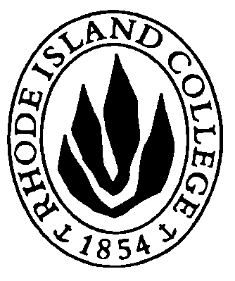RHODE ISLAND COLLEGE

Combined Job Description-

A: Coastal Ecologist/Marine Biologist
B: Anatomist/Physiologist

Title: Assistant Professor
Status: Tenure Track
Union Affiliation: RIC/AFT
Reports To: Biology Department Chair

Biology Department website: http://www.ric.edu/department-directory/department-biology

Submit applications to the RIC website: https://employment.ric.edu
Application Deadline: April 10, 2022

DESCRIPTION OF DUTIES AND RESPONSIBILITIES:

- A: Teach two classes from the following list-
  - Plant and Animal Form and Function (BIOL 213W)
  - Biostatistics (BIOL 240)
  - Ecology (BIOL 318)
  - Invertebrate Zoology (BIOL 321)
  - The Plant Kingdom (BIOL 353)
- B: Teach specialty classes populated by students majoring in the following areas: Biology, Nursing, and Health Sciences
  - Human Anatomy (BIOL 231)
  - Human Physiology (BIOL 335)
- Teach introductory biology courses
- Potential to develop an upper level (300+) course in the faculty’s area of expertise
- Develop and maintain an active research program that engages undergraduate and graduate (MA and Certificate) students
  - A: in the field of coastal ecology/marine biology
  - B: in the area of anatomy or physiology
- Potential to access state-wide funding opportunities: RI-EPSCOR and RI-INBRE
  - RI-INBRE: https://web.uri.edu/riinbre/
  - RI-EPSCOR: https://web.uri.edu/rinsfepscor/
- Advise students
  - A: in the biology major
  - B: in the health sciences major including medical imaging and clinical lab science
- Participate in College and Departmental activities
- B: Potential to serve as the Director of the Clinical Laboratory Science Program
- B: Participate in the Board of Rhode Island Schools of Allied Health (BRISAH)
- Perform other duties and responsibilities as assigned by the Department Chair

REQUIRED QUALIFICATION STANDARDS:

Education: Ph.D. in a biological science
- B: or relevant professional clinical degree (such as M.D. or D.O.)

Experience: Demonstrated commitment to undergraduate instruction and to mentoring student researchers

Skills, Knowledge and Abilities:
- Excellent communication skills (verbal and written)
- Effectively use available instructional technology and inquiry-based pedagogical methods
- Demonstrated research expertise and ability to work with undergraduates in a laboratory setting

Preferred:
- Evidence of effective undergraduate teaching
- Established record of support of undergraduate and/or graduate research
- Experience with nontraditional students and with an ethnically diverse student population
- Demonstrated grant writing skills
- A: Interest in coastal ecosystems, focusing on the health of Narragansett Bay communities
- B: Experience with data acquisition modules

ENVIRONMENTAL CONDITIONS:

Faculty members routinely deal with electronic and other scientific equipment and chemicals appropriate to the discipline. Rhode Island College does not have a site license for radioactivity.

The College requires that all applicants and employees be able to perform the duties and responsibilities of the job and will explore reasonable accommodations for individuals with disabilities.

Rhode Island College strives to maintain a safe environment for students, faculty, staff, and visitors. Currently all are required to be fully vaccinated against COVID-19 including boosters and a mask mandate is in effect. Updated information regarding the COVID-19 policy can be found on the RIC website: https://www.ric.edu/meet-rhode-island-college/health-wellness/covid-19

As an Affirmative Action/Equal Opportunity institution that values and is committed to inclusion and expanding the diversity of its faculty and staff, the College invites members of protected classes, including minorities and persons with disabilities, to identify themselves as such at the time of application.

