The Center for Ideas and Society, the Middle Eastern and Islamic Studies program and the department of History at UCR present:

Recent Protests and the Current Crisis in Iran: Is this the End?

An online panel discussion with:
Reza Aslan, UCR
Sholeh Wolpé, UCI
Afshin Matin-Asgari, Cal State University, LA
Fariba Zarinebaf, UCR ( moderator)

Monday, February 9, 4:30-6:00 pm
Zoom link:
https://ucr.zoom.us/j/2090797630?pwd=MlA5bk51d0V6TGJHMkl6MFdFcm9kdz09&omn=93726831957

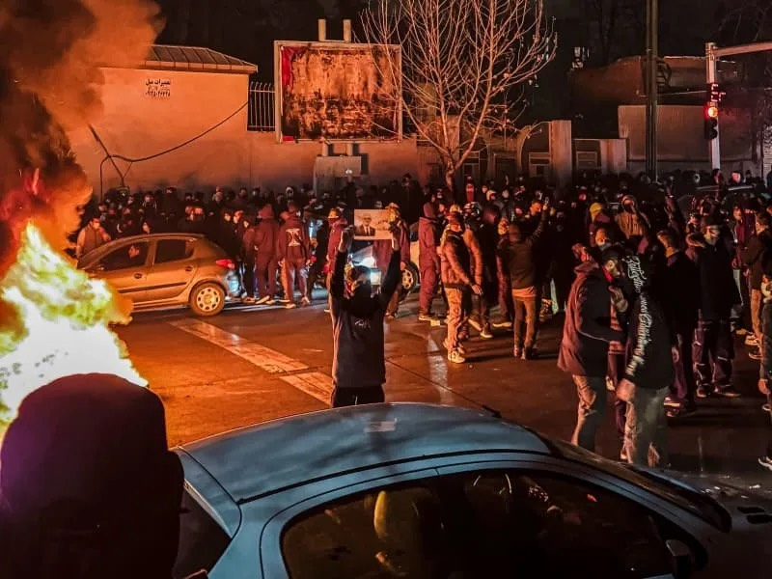
Dr. Reza Aslan (Creative Writing) is a renowned writer, commentator, professor, Emmy- and Peabody-nominated producer, and scholar of religions. A recipient of the prestigious James Joyce award, Aslan is the author of numerous internationally best-selling books, including the #1 New York Times Bestseller, Zealot: The Life and Times of Jesus of Nazareth. His biography of Howard Baskerville, An American Martyr in Persia, was nominated for the PEN/Jacqueline Beograd Weld Award.Sholeh Wolpé is a poet, writer, and librettist whose body of work spans seven collections of poetry, several plays, five books of translations and three anthologies, as well as texts and librettos for the choir and opera. Her most recent books are: The Invisible Sun – Attar (Harper Collins), and Abacus of Loss – A Memoir in Verse (Univ. of Arkansas Press). She is the Writer-In-Residence at the University of California, Irvine. Afshin Matin-Asgari is professor of Middle East History at California State University, Los Angeles and author of more than thirty articles/book chapters and three books on modern Iran's political and intellectual history. His latest book is Axis of Empire: A History Iran US relations (Verso, 2026). Fariba Zarinebaf is a professor of Middle East History at UCR. She works on the history of early modern Istanbul and has published several articles on comparative study of Constitutionalism in Iran and the late Ottoman empire. Among her publications are Crime and Punishment in Eighteenth Century Istanbul and Mediterranean Encounters, Trade and Pluralism in Early Modern Galata.

