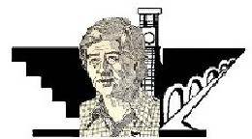
CÉSAR E. CHÁVEZ 5K RUN/WALK
University of California, Riverside
Saturday, April 3, 2010

TEAM REGISTRATION FORM (5 members)
(Please Print Clearly)

❐ Yes, we will participate in the César E. Chávez 5k Run/Walk
❐ Walk Team
❐ Run Team

Team Name_____________________________ Age Gender T-Shirt Size (Circle One)

Name__________________________________ ____ ______ S / M / L / XL

Name__________________________________ ____ ______ S / M / L / XL

Name__________________________________ ____ ______ S / M / L / XL

Name__________________________________ ____ ______ S / M / L / XL

Name__________________________________ ____ ______ S / M / L / XL

Please note if you register as a team you are not eligible for individual awards.

Registration Fee: $75/per team

OR, solicit $150 or more in sponsorship and have team registration fee waived. (Sponsor form and all checks/cash must be submitted by, March 24)

Make checks payable to:
Chicano Educational & Cultural Fund, Inc. (CECF, Inc.)

Mail completed form to:
César E. Chávez 5k Run/Walk
c/o Chicano Student Programs
145 Costo Hall
University of California, Riverside
Riverside, CA 92521

* On the day of the event all participants are required to sign a Waiver of Liability Assumption of Risk, and Indemnity Agreement.

