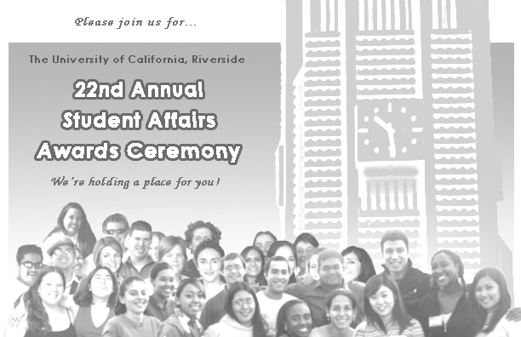

Your department staff and students
are cordially invited to attend the annual

Student Affairs Awards Ceremony

A celebration to recognize the contributions and achievements
of the outstanding students in the Division of Student Affairs

Friday, May 30, 2008
302 Commons North, 3-5 p.m.

Please RSVP to Ismael Diaz or Joni Lundgren at x26095
in the Dean of Students Office no later than May 22.

Refreshments immediately following program

