

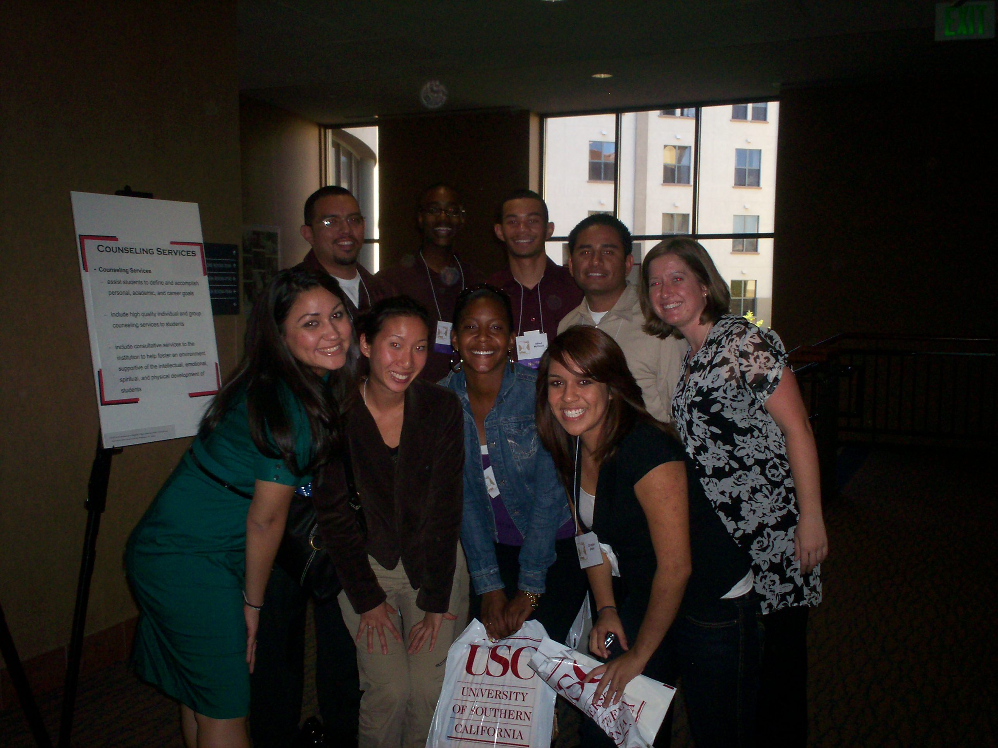

UC Riverside students at the Careers in Student Affairs Day at UCLA
Erica, a 2006 NUFP intern in DC for NASP
Everardo and Randy
2 NUFP interns at a community service project.
Interested in Higher Education as a career?

NUFP or the National Undergraduate Fellows Program (NUFP) is the college recruitment program for The National Association for Student Personnel Administrators (NASPA). It is a mentoring program for undergraduate students wishing to explore and better understand the field of student affairs and/or higher education.
The mission of the program is to increase the number of persons that are not normally represented in student affairs and higher education. This would include underrepresented minorities, persons with disabilities, women, and persons who identify themselves as LGBT.

NUFP provides a wonderful opportunity in that it is the student who structures the program. This national program gives the participants the opportunity to attend a national conference, participate in paid internships, and participate in the Summer Leadership Institute.

There are currently over 150 NUFP Interns at over 100 Universities throughout the country. At UC Riverside, we are looking to host up to 3 students to participate in this program at UC Riverside.

UC Riverside’s NUFP interns have participated in academic advising, assisted and implemented community service initiatives through the AVC/DOS office, helped with various retention programs out of the Learning Center, as well as worked with the various student program organizations on campus. They have represented their campus and gained ample experience in student affairs.

If interested, please contact Jennifer Miller in 381 Commons (951-827-5000) or at jennifer.miller@ucr.edu for an application. Applications are due Friday, April 11^{th,} 2008 to Jen Miller.

