You are invited…
Vice Chancellor Jim Sandoval
invites you to attend our
Annual Divisional Meeting on
February 21, 2008
at 8:00am
in the Commons Multipurpose Room.

Please join us for a hot breakfast and a discussion of our divisional goals for 2008.

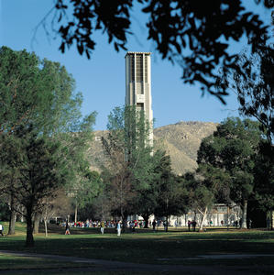 Is your invite to the existing property commercial development and future development sites seminar. This helpful information is for you. Please, don’t wait, call to book reservations now.
Annual VCSA Divisional Planning Meeting and Breakfast
RSVP by February 8, 2008 to Anna Tognazzini, anna.tognazzini@ucr.edu and
be entered to win a special VIP prize!

