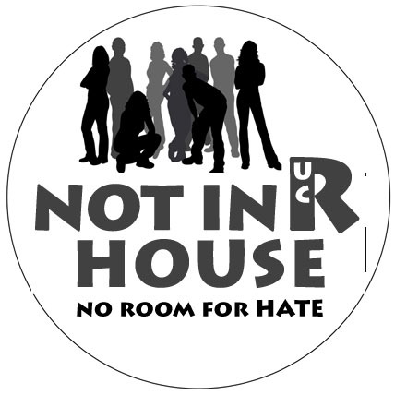

Who were those “preachers” at the Bell Tower?

Are “preachers” allowed on campus?

Why are they saying that some folks are sinners?

The UCR Hate Bias Response Team presents…

Not in R’ House – Part 1 and 2
You are welcome to join us for one or both of the following workshops
Attend both “Not in R’ House” workshops and receive a “Not in R’ House” t-shirt!

Part 1: Hateful words don’t belong in R’ House. As we learned from the recent uninvited “preachers,” words hurt. Come explore how you define yourself and your community and the role that language has in stopping hate. This interactive workshop will explore multiple identities and how we can build community at UCR.

Wednesday, Nov. 7 7pm Pentland Hills C101

Part 2: R’ House does not have room for hate crimes and hate incidents. How do you know if a certain event is a hate crime, hate incident, neither or both? This “Hate bias 101” workshop will cover definitions and scenarios related to hate crimes and hate incidents.

Wednesday, Nov. 28 7pm Pentland Hills C104

“Not in R’ House” workshops are part of the “First Year Success Series”
For information and to register for the programs: www.success.ucr.edu

