SOAS Colloquium
Department of Art & Archaeology
The Bayon of Angkor
Saturday, 2 February 2008 (2pm-6pm)
Khalili Lecture Theatre
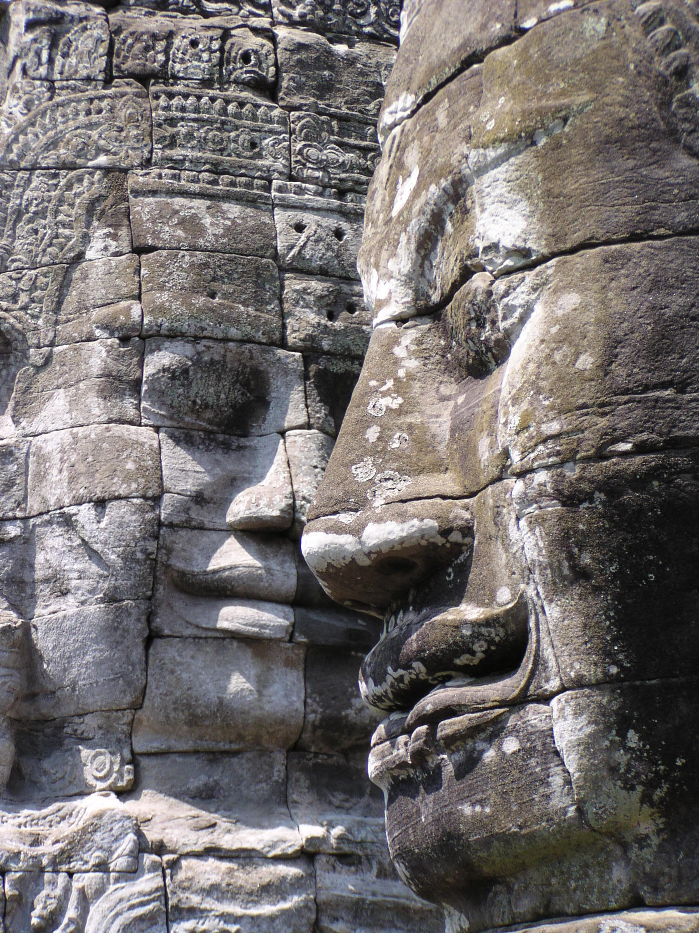
An enduring enigma of the great temple city of ancient Cambodia is the Bayon, the Buddhist state temple of king Jayavarman VII. An eminent group of scholars has recently produced a ground-breaking volume, Bayon, New Perspectives, in an attempt to resolve some of the abiding mysteries of the Bayon and its significance in the political, cultural, and religious history of ancient Cambodia. Join the publisher and five of the contributing scholars for a SOAS master class in which the issues raised by Bayon, New Perspectives will be addressed.
Participants: Claude Jacques, Hiram Woodward, Vittorio Roveda, Anne-Valerie Schweyer, Peter Sharrock
Free admission. Complimentary refreshments.
To register contact Dr Peter D Sharrock ps56@soas.ac.uk

