

2010-2011 PEER MENTORS

The UCR Medical and Health Careers Program provides information, resources, guidance, and support to undergraduates and recent graduates planning a career in the health professions through both individualized and group services beginning in the freshman year as students explore options and determine the profession(s) they are most likely to pursue. This support continues until students matriculate in health professions or other graduate programs. Critical to the success of this model and to creating a collaborative community is the Peer Mentor Program.

MHCP Peer Mentors work with individual and small groups of pre-health students during their first year in MHCP. Mentees are matched with peer mentors with the same health professions interest. Peer Mentors also work in collaboration with MHCP staff on programming and events. A 3-4 hour/week commitment is required.

Responsibilities and Expectations
- Attend mandatory Fall 2010 Peer Mentor orientation and training
- Participate in required biweekly Peer Mentor meetings/trainings
- Participate with mentees in MHCP events and activities
- Meet regularly with peer mentees
  - 3 times during the mentee’s first quarter and 2 times each quarter thereafter
- Submit biweekly report of student contacts
- Serve as a resource for mentees seeking health care related experience, summer program, general admission requirements, or other information to enhance preparation for application to HP programs
- Assist with MHCP programs and events, including a one hour a week commitment to staff the office front desk
- Serve as liaison to health professions focused student clubs and organizations

Requirements
- Undergraduate, degree seeking, pre-health professions student (any major)
- Sophomore or higher standing (must have successfully completed 20 units of health professions pre-requisite science courses)
- Minimum overall and science GPA 3.25
- Demonstrated strong interpersonal skills

APPLICATION DEADLINE IS 5 PM, APRIL 19, 2010
E-mail completed application to Gwen Hill, Medical and Health Careers Program mhcp@ucr.edu

Please enter: PM Application 2010-11 in the email subject field.

A selection committee will review applications and identify applicants to be interviewed. Selection will be based on qualifications and program needs. Interviews will be conducted throughout three weeks beginning the week of April 26.

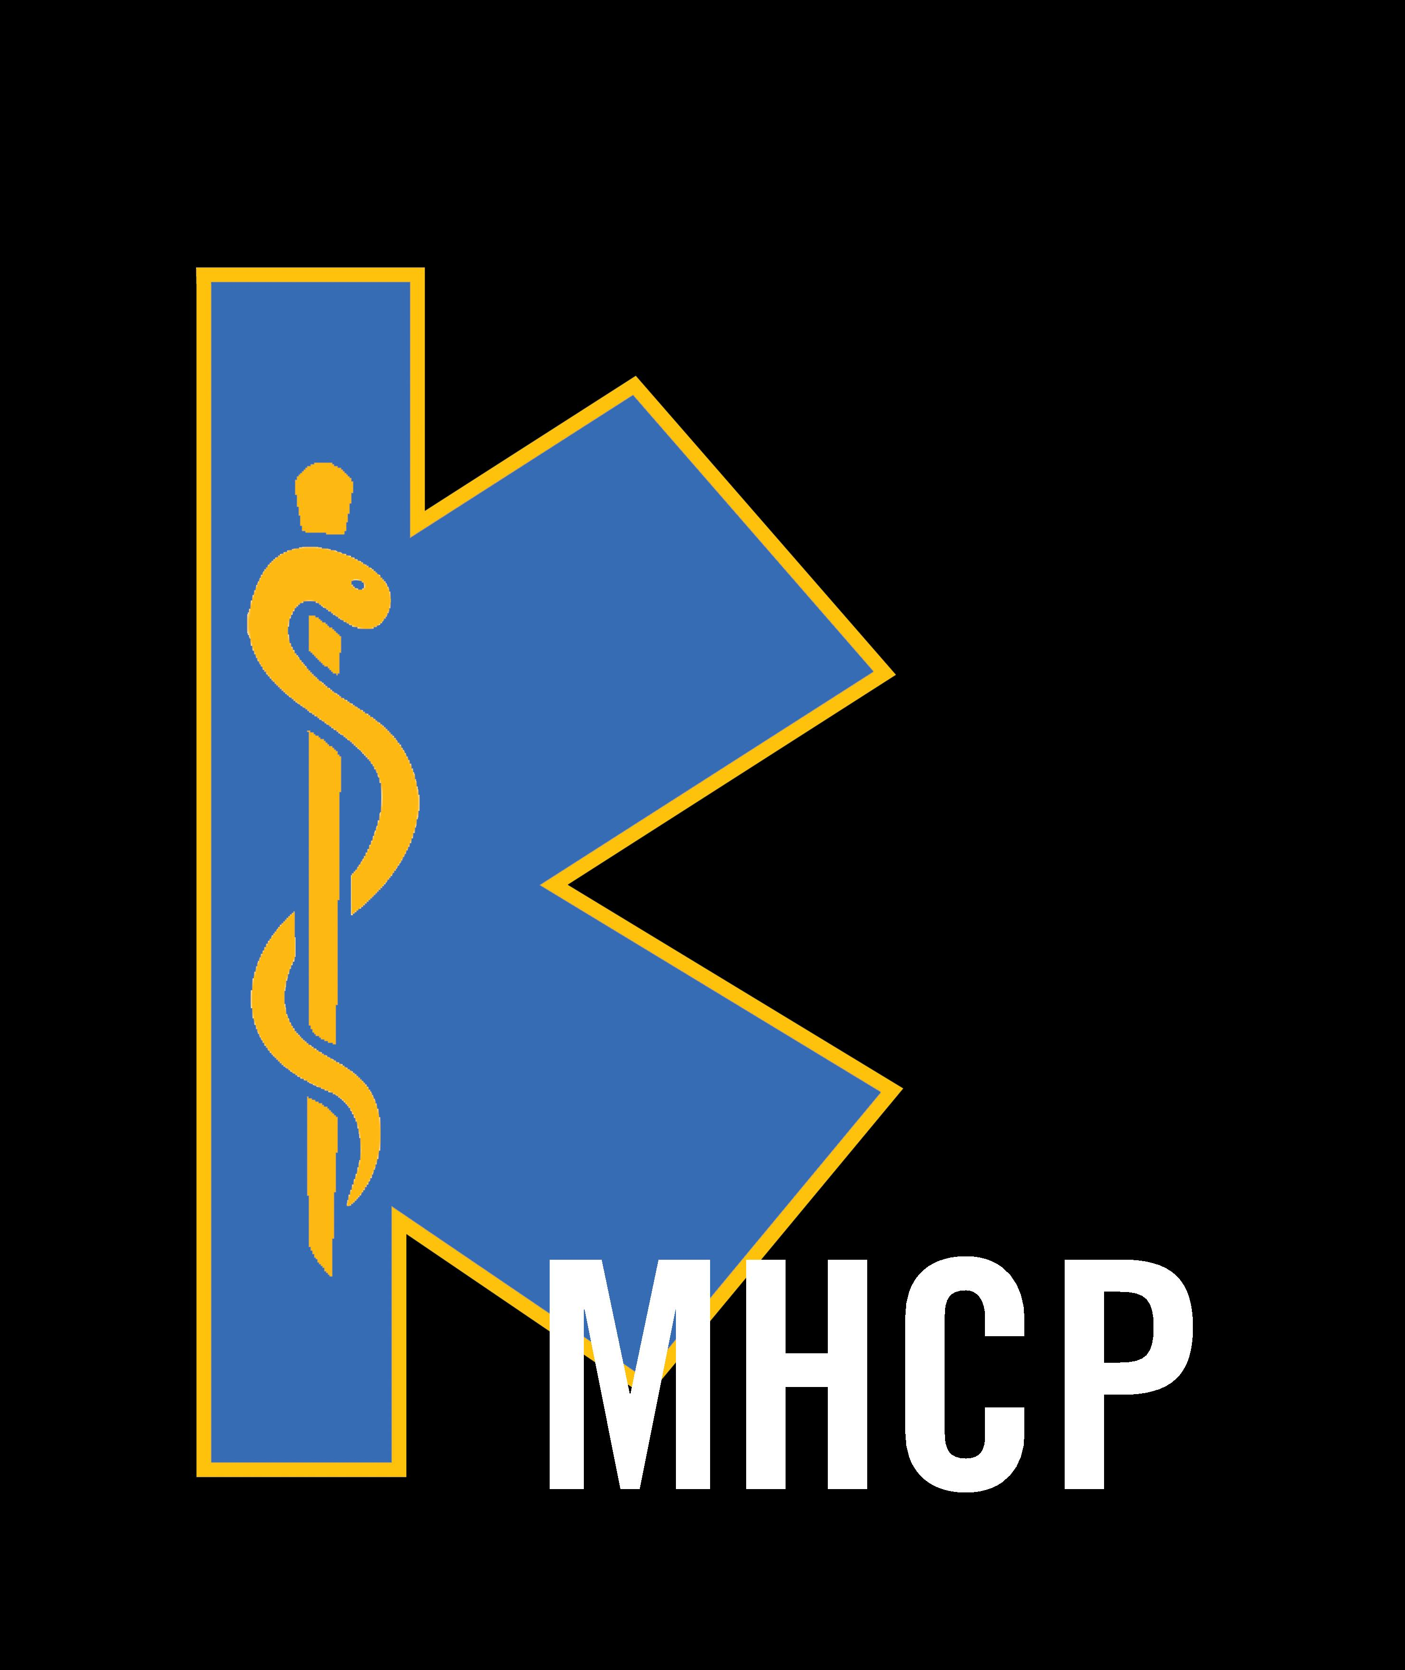

MHCP: MEDICAL AND HEALTH CAREERS PROGRAM

Peer Mentor Applicant Information
Full Name: |  |  |  |  |  |  |  |  |  |  |  |  |  |  |  |  |  |  |  |  |  | Date:
Last |  |  |  |  |  |  |  |  | First |  |  |  |  |  |  |  |  | M.I.
UCR Student ID:
UCR Major:
Phone: | ( ) |  |  |  |  |  |  |  |  |  | Cell Phone: |  |  | ( )
Cumulative GPA: |  |  |  |  |  |  | Science GPA:
Will you participate in the University Honors Program for the 2010-11 academic year? |  |  |  |  |  |  |  | YES |  | NO
Will you participate in the Medical Scholars Program for the 2010-11 academic year? |  |  |  |  |  |  |  | YES |  | NO
Class standing as of Fall 2010? |  |  |  |  |  |  |  | SO |  | JR |  | SR
Primary health profession goal: |  |  |  | Please choose from: Medicine, Pharmacy, Dentistry, Physician Assistant, Physical Therapy, Nursing, Optometry, Veterinary Med
Other health profession not listed:

References
Please provide contact info for two references. (Optional – You may request that your references send a brief e-mail supporting your application to ghill@ucr.edu)
Full Name: |  |  |  |  |  |  |  |  |  |  |  |  | Relationship:
Position/ Title: |  |  |  |  |  |  |  |  |  |  |  |  |  |  |  | Phone: |  |  |  | ( )
Email:
Full Name: |  |  |  |  |  |  |  |  |  |  |  |  | Relationship:
Position/ Title: |  |  |  |  |  |  |  |  |  |  |  |  |  |  | Phone: |  |  |  |  |  | ( )
Email:

Signature
I certify that my answers are true and complete to the best of my knowledge. I confirm that:
I will be available Fall 2010, Winter, 2011, and Spring 2011
I will commit to participate in peer mentor meetings held twice a month on Tuesday at 5:15pm during the year.
I will commit to spend one hour per week in the MHCP office front desk assisting with tasks.
I will be available for peer mentor training on Sunday and Monday, September 19 & 20, 2010.

Electronic Signature: (type name) |  |  |  |  |  |  |  |  |  |  |  |  |  |  |  |  |  |  |  | Date:

Essay Responses

Please use as much space as needed to answer the questions.

Please list and briefly describe ALL on AND off campus extracurricular activities that you have been involved with during your time at UCR, including paid jobs, volunteer work, research work, student organizations, or community service.
This information will help us to better understand how you can be a resource for others by referring to your own experiences.

There are important characteristics required of peer mentors. They include the ability to interact well with others, appreciate the unique circumstances and challenges faced by others, as well as the ability to develop approaches to help others address concerns.
Please share personal experiences that have required you to overcome obstacles, address weaknesses (academic or otherwise), or adjust your own expectations.

What will you contribute to the MHCP goal of establishing a collaborative and supportive environment for pre-health students?
Think broadly. These might include personality traits, computer skills, presentation abilities, or other possible contributions.

