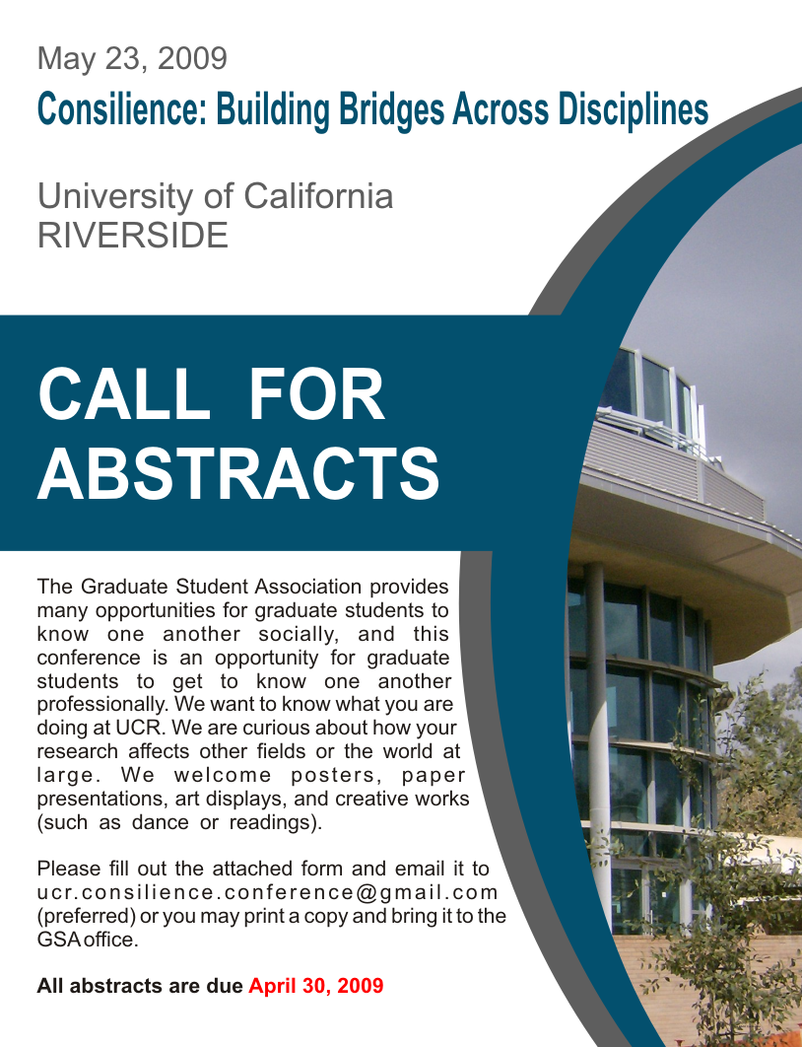
May 15, 2009
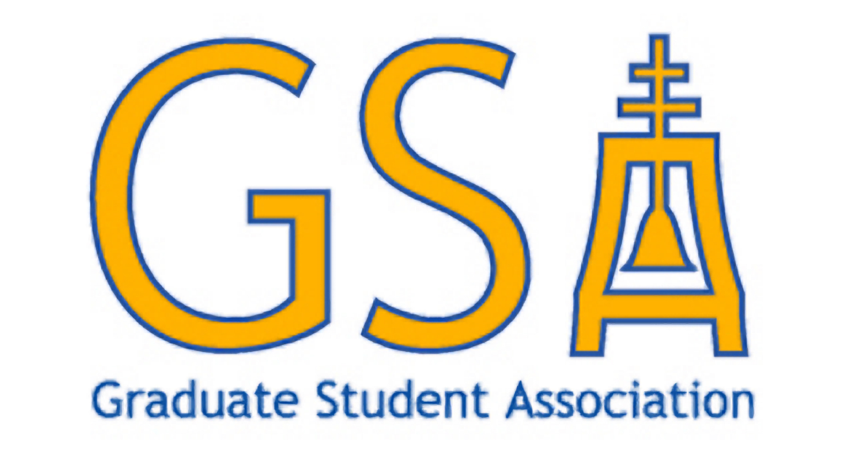
2009 GSA Conference Call for Abstracts

Complete this application, print and bring it to the GSA office
or email to: ucr.consilience.conference@gmail.com

Graduate students from all disciplines are invited to submit abstracts for
the University of California, Riverside Graduate Student Association (GSA)
Conference on May 23, 2009.
DEADLINE: May 15, 2009

Applicant Name:
E-mail: Phone Number:
Department: Type:
Title of Display/Presentation:
Keywords (max. 5 words):
Description/Abstract:

Please contract Rachel Neff with any questions via email at ucr.consilience.conference@gmail.com

