FALL 2008

NEW COURSE

MODERN ARABIC POETRY IN A MULTILINGUAL FRAME

In this reading intensive course we shall consider selected writings of Adunis (`Ali Ahmed Sa`id), Mahmoud Darwish, Abdelatif La`abi, and Etel Adnan, published originally in Arabic, French, and English. We shall attend to the diverse contexts which attend this poetic writing as we retain a focus upon the close and attentive reading of texts, keeping our ears open to the dissonance of poetic statement. Topics to be considered shall include language (idiom, statement, utterance, translation, repetition, rhythm) and history (loss, violence, mourning, inheritance, future, legacy), among others. No prior knowledge of the Arabic language or of Arabic poetry is required or presumed.

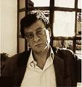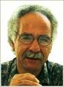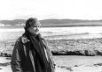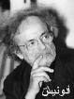

CPLT/ARLC 152
T/TH 11:10-12:30

Professor Jeff Sacks
jeffsacks@ucr.edu

