The UC-Riverside Department of English and the LGBIT Studies Minor
Present:

The Gregory Bredbeck Memorial Lecture Series Inaugural Lecture

Carolyn Dinshaw
Professor of English and Social & Cultural Analysis, New York University

Out of Sync: Three Tales of the Catskills

What does it feel like to be a body in time -- or out of time, or in the wrong time? In this talk Professor Dinshaw will explore experiences of time that are not linear and progressive but are, rather, non-synchronous. Situated in the Catskill Mountain range, Dinshaw picks up on the legendary temporalities of the area by looking at three weird chronic phenomena: Rip van Winkle's night of sleep that lasted 20 years; a nineteenth-century female hunter, "born too soon," who passed as a man; and an old gravestone that washed up on the banks of a flooded creek. She will discuss the ethics of addressing what Derrida calls the "non-contemporaneity with itself of the living present."

Thursday, February 28, HMNSS 1500 3:30 pm
Please join us for a reception immediately following in the English library, HMNSS 2211.
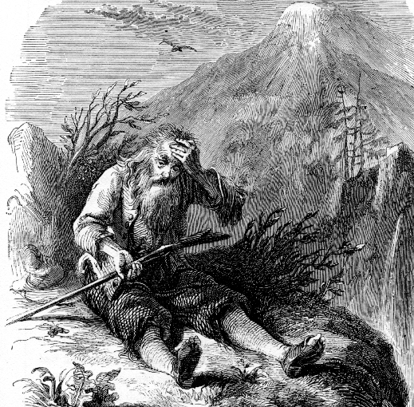

Open to the Public. Contact: Professor Andrea Denny-Brown andreadb@ucr.edu

