Please join the Department of English for a talk by:

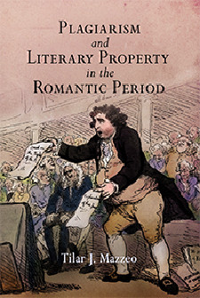
Tilar Mazzeo
"Tilar J. Mazzeo is Assistant Professor of English at Colby College (Maine) and, most recently, the author of _Plagiarism and Literary Property in the Romantic Period_ (U Penn, 2007)."

"Byron, Anonymity, and the
Natural Rights of Authors,"

"Under British law today, plagiarism can be prosecuted as a violation of an author's natural right of paternity. This talk traces the history of that metaphor back to its origins in early nineteenth- century legal culture and to the public fervor surrounding the poetry and public life of Lord Byron after 1816. In a legal and literary reconsideration of reception history, Mazzeo argues that Byron shaped the construction of authorship in often unexpected ways."

Tuesday, January 22nd
2:15-3:30 pm
English conference room
CHASS 2212
Light refreshments will be served.

