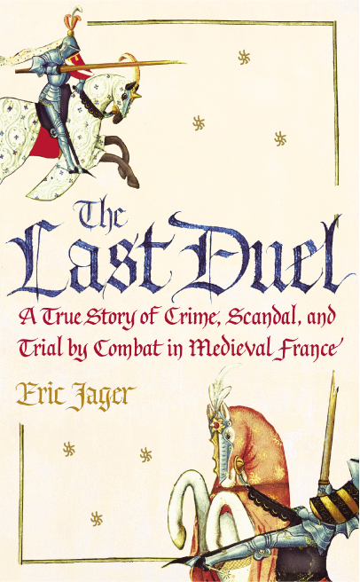The Mellon Workshop on

Medieval and Postmodern Legacies,
Presents a lecture by Eric Jager on

June 1, 2007 at

4:10 PM in

Humanities 1500

Free and Open to the Public

Contact: J. Ganim 21540

