The Mellon Workshop on Medieval Cultures and Postmodern Legacies and the Department of History Present:
ROBERT BARTLETT
University of St Andrews, Scotland

Illustrating Ethnicity in the Middle Ages

Date: Friday, May 11, 2007
Time: 4:00 PM
Location: HMNSS 1500
Admission: Free/ Contact: J. M. Ganim, Professor, English 2-1540, john.ganim@ucr.edu

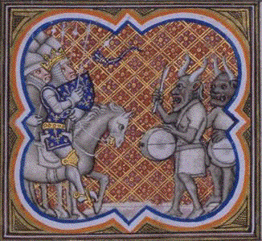

ROBERT BARTLETT is one of the most influential historians of his generation, known widely for his groundbreaking book, The Making of Europe: Conquest, Colonization and Cultural Change.. He currently holds the position of Wardlaw Professor of Mediaeval History.

