The 2007 Thomas More Lecture



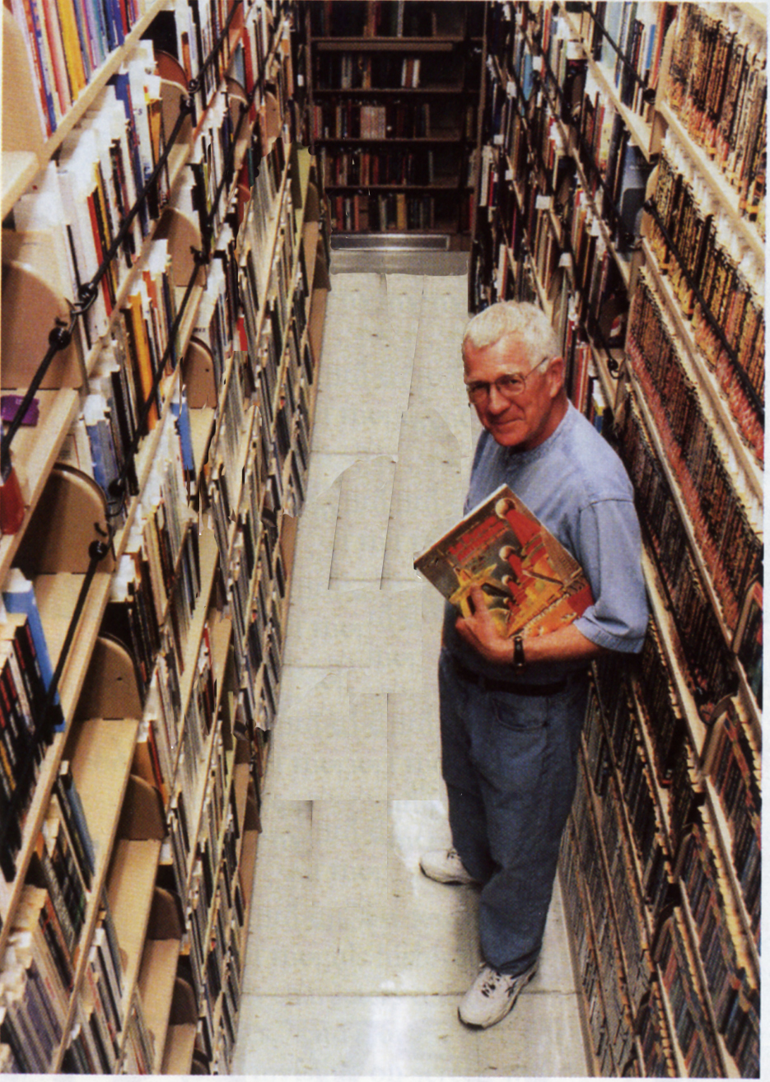
Dr. George Slusser is Eaton Curator-in-Residence in Special Collections, UCR Libraries, and a Professor Emeritus in the Department of Comparative Literature, the University of California, Riverside. The author or editor of twenty-eight books and more than 120 articles, and he is acclaimed as the leading literary critic in the genre of Science Fiction. In collaboration with the scholar Dr. Danièle Chatelain, Dr. Slusser has most recently published a translation and critical edition of Balzac's The Centenarian, published by Wesleyan UP.
George Slusser
Utopian Perplexities:
Science Fiction and Perfect Worlds

Wednesday, February 7, 2007  3:15 – 4:30 PM



Special Collections – 4th floor Rivera Library

(951) 827-3233

Refreshments will be served.

